Chapter 1:
Real-Time System (RTS) is defined as a system in which the time where the outputs are produced is significant.
The outputs must be produced within specified time bounds referred to as deadlines.
Inputs may come from sources such as sensors, switches, communication links, or a keyboard and outputs may go to actuators, alarms, motors, lamps, communication links, or displays.

Example of real time system:
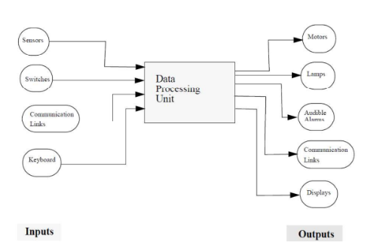
The system displays aircraft tracks obtained from radar sites. It accepts radar data on tracks locations, and operator inputs to establish tracks or to change the location of aspecified track. The system periodically extrapolates all aircraft locations and produces an output to a display containing all the current tracks. The system updates the aircraft tracks (maintained in a track database) from radar input data every 100ms and updates the output display every 500 ms.

Real-time systems are usually categorized as follows:
Hard RTS are those systems where it is absolutely imperative that responses occur within the specified deadlines.
Examples: are aircraft control, air traffic control, process control applications.
Soft RTS are those systems where response time are important but the system will still function correctly if deadlines are occasionally missed.
Examples: are communication systems using a time-out protocol. If an acknowledgment for a message was not received before the deadline a time-out occurs and the same message is resent again. Missing the deadlines here can be tolerated occasionally,however if deadlines are missed frequently resent messages will jam the bandwidth of the communication channel and the system will cease to perform.

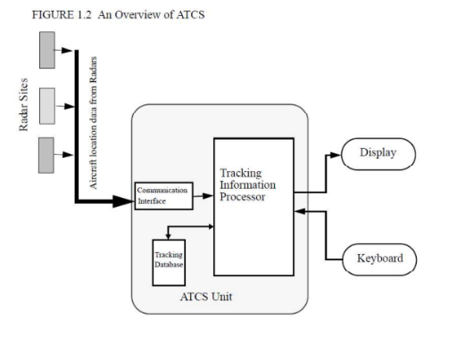What are the characteristics which distinguish real-time systems from others?
An RTS is used within a larger system to provide monitoring, control and computation.
Type of devices:
devices that act as the senses (e.g., heat sensors, or light sensors)
devices that act as the effect of physical changes (e.g., mechanical, electromechanical, and electronic actuators).
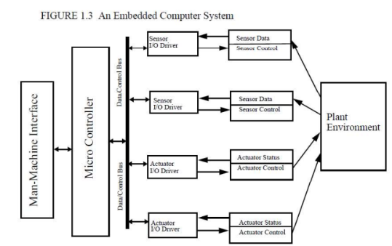
In figure 1.3 a block diagram of a typical embedded system is shown.
The system is usually built around a micro-controller used for executing various system monitoring and control functions. The system reads the input of various sensors, applies various filtering, calibration, and processing algorithms on the input data, and produces output data to various actuators. An operator interface is provided to allow for manual instructions. Testing and maintenance of the such systems can be performed by special devices such as In Circuit Emulators (ICE). An ICE is a device which monitors the real-time operations of a hardware micro-controller while executing the system software functions.
Engineering Applications of real-time systems
1. Metal industry applications (Mechanical and Manufacturing Engineering).
2. Electric utility monitoring and control applications (Electrical Power Engineering).
3. Water plants applications (Civil and Environmental Engineering).
4. Aviation and space applications (Aeronautical Engineering).
5. Data Communication Applications (Electrical and Computer Engineering).
6. Petrochemical applications (Chemical Engineering, Petroleum Engineering).

The following table shows several applications of RTSs and the response time range for each application.

Application | Response time range
Speech and Audio Systems | 100 ns - 10 ms
Flight Simulation | 1 - 1- micro sec
Robot controllers | 1 ms - 10 ms
Process control systems | 100 micro sec - 10 ns industrial automation
Medical Diagnosis and lab | 1 ms - 100 ms automation

Table 1: Response times or deadlines of several real-time applications.

- Timing constraint: constraint imposed on timing behavior of a job: hard or soft.
- Release Time: Instant of time job becomes available for execution. If all jobs are released when the system begins execution, then there is said to be no release time
- Deadline: Instant of time a job's execution is required to be completed. If deadline is infinity, then job has no deadline. Absolute deadline is equal to release time plus relative deadline
- Response time: Length of time from release time to instant job completes.

