Digital communication
Anas Riyadh
Part 2
Digital CW Modulation techniques.

Frequency Shift keying FSK
Phase shift keying PSK
Amplitude shift keying ASK

Typical Sources of Communication Data
Link Budget Analysis: Digital Modulation, Part 1
1. Analog Data Sources: Produces continuous-time output using a device that converts the real analog signal to electrical voltage.
A. Speech/Voice/Telephone.
B. Music/Sound.
C. Moving and static images.
D. And also: temperature, speed, time...
2. Digital Data Sources: Produces discrete-time output using a device that processes logical digital signals (binary, ASCII).
A. Computer files/Keyboards/Monitors/Printers.
B. E-mail sent over the internet.
C. Digital storage devices (Compact Discs, DVDs, etc...)
D. JPEG/MPEG files.
Digital continuous wave (CW) modulation techniques
When a digital signal is to be transmitted over a long distance, it needs CW modulation. The transmission media can be radio, cable or other type of chan. A sinusoidal carrier signal of some high frequency , Fo is used for modulation. The digital message signal modulates some carrier parameters like frequency, phase or amplitude. The result modulated signal has the carrier with some deviation in frequency. This deviation is called Bandwidth of the channel. Thus the channel has to transmit some range of frequencies or band. Such type of transmission digital signal after modulation is called bandpass transmission. The word bandpass is used because the range of frequencies does not start from ‘0’ Hz to W Hz. if it is like this. It called lowpass signal.

Digital CW modulation types
• When it is required to transmit digital signals on bandpass channel, the Amplitude, Frequency or Phase of the sinusoidal carrier is varied in accordance with the incoming digital signal.
• Since the digital signal is in discrete steps, the modulation of the carrier is also done in discrete steps.
• Hence this type of modulation(Digital Modulation ) is also called switching or signaling.
If the amplitude of the carrier is switched depending on the incoming digital signal, then it is called Amplitude Shift Keying ( ASK). This is similar to analog Amplitude Modulation(AM)
If the frequency of the carrier is switched depending on the incoming digital signal, then it is called Frequency Shift Keying ( FSK). This is similar to analog Frequency Modulation(FM)
If the Phase of the carrier is switched depending on the incoming digital signal, then it is called Phase Shift Keying ( PSK). This is similar to Analog Phase Modulation(PM).
In Digital modulations instead of transmitting one bit a time, two or more bits are transmitted simultaneously. This called M-ary transmission.

Modulation: Types and Techniques
Link Budget Analysis: Digital Modulation, Part 1
1. Analog Modulation: When the information-bearing message signal is continuous-time analog, then the modulation is called analog modulation.
Common analog modulation techniques:
A. AM: Amplitude modulation :
Message is carried in A(t). S(t)=A(t)cos(ω_{c}​t+ϕ₀​)
B. FM: Frequency modulation :
Message is carried in ω(t).S(t)=A₀​cos(ω(t)+ϕ₀)
C. PM: Phase modulation :
Message is carried in φ(t). S(t)=A₀​cos(ω_{c}t+ϕ(t))
2. Digital Modulation: When the information-bearing message signal is discrete-time digital, then the modulation is called digital modulation.
Common digital modulation techniques:
A. ASK: Amplitude Shift Keying :
Message signal changes the carrier’s amplitude.
B. FSK: Frequency Shift Keying :
Message signal changes the carrier’s frequency.
C. PSK: Phase Shift Keying :
Message signal changes the carrier’s phase.
D. QAM: Quadrature Amplitude Modulation: A combination of ASK and PSK.
3. For Binary (2-level) Digital Modulation (M = 2):
A. BASK: Binary Amplitude Shift Keying.
B. BFSK: Binary Frequency Shift Keying.
C. BPSK: Binary Phase Shift Keying.

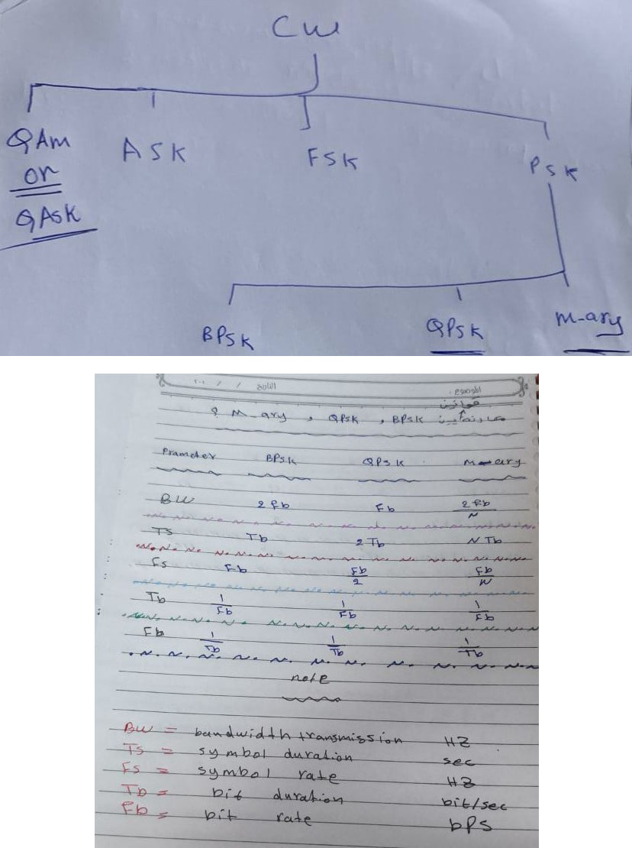
M = 2^{N}
To get Number of Bits
Type of Digital-to-Analog Modulations
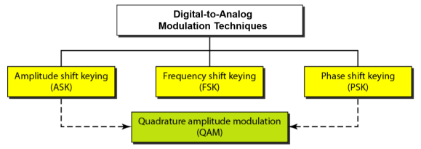
Bit rate is the number of bits transmitted per second: Rb=kRs​.
Baud rate is the number of signal elements transmitted per second: Rs=Rb/k.
In the analog transmission of digital data, if a signal unit is composed of k bits, then the bit rate is k times higher than baud rate. Baud rate determines the channel bandwidth required to transmit the modulated signal.

Digital Bandpass Modulation Techniques
Link Budget Analysis: Digital Modulation, Part 1
In digital communications, the modulating baseband message signal: m(t) is a binary or M-ary digital data stream. The carrier is usually a sinusoidal signal.
- Baseband digital message signal: m(t)
- Analog sinusoidal carrier signal:
A. Carrier signal: Ac​cos(2πfc​t+ϕc​)
- ASK: Amplitude Shift Keying.
A. Message signal changes the carrier's amplitude: Ac​(t).
- FSK: Frequency Shift Keying.
A. Message signal changes the carrier's frequency: fc​(t).
- PSK: Phase Shift Keying.
A. Message signal changes the carrier's phase: ϕc​(t).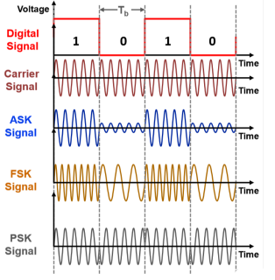
Coherent detection and non coherent detection Digital modulation techniques can be: - Coherent (synchronous ) Detection- in this type the local carrier generated at the receiver is phase locked with the carrier at the transmitter. The detection(Demodulation) is done by correlating received noisy signal and locally generated carrier.
Non Coherent (Envelop Detection)- in this type , the detection does not need receiver carrier to be phase locked with transmitter carrier. The advantages of such as a system is that the system become simple, but the drawback is that error probability increases.
The different digital modulation techniques are used for specific application areas.
The choice is made such that the transmitted power and channel bandwidth are best exploited.
Digital modulation – important requirements
Any digital modulation technique should satisfy following important requirements:
1) maximum data rate
2) Minimum probability of symbol error
3) Minimum transmitted power
4) Minimum channel bandwidth
5) Maximum resistance to interfering signal
6) Minimum circuit complexity
Advantages of digital carrier(CW) system over baseband digital transmission (directly without modulation)
I. The digital modulated signal (Passband) become a high frequency signal, so it can be transmitted over long distances with the help of standard communication media such as Radio channels, Cables, Fiber optic cables.
II. The result modulated signals are analog in nature. Hence all the types of analog channels can be used for transmission.
III. Because if modulation of analog carrier, multiplexing techniques can also be employed for bandwidth conservation.
IV. Baseband digital transmission mainly suffers from intersymbol interference and crosstalk. These problems are absent in Digital CW modulation
V. There are large number of digital modulation methods(techniques). These can be selected as per input signal and application.
VI. Baseband signal transmission needs fiber optic cable or co-axial cable to carry the signals. while CW modulated signals can be transmitted on Radio.

Binary Frequency Shift Keying (BFSK)
In this type of digital modulation, the frequency of the carrier is shifted according to the binary symbol. The amplitude and phase of the carrier stay constant.
That we have two different frequency signals according to binary symbols.
Let there be a frequency shift(difference) by Ώ, then we can write following equations.
if b(t) = ‘1’
if b(t) = ‘0’
Thus there is increase or decrease in frequency by Ώ
Since FH - FL = 2Fb, the outputs of filters do not overlap. The bandpass filters pass their corresponding main lobes without much distortion.
The outputs of filters are applied to envelop detectors. The outputs of detectors are compared by the comparator. If unipolar comparator is used, then the output of comparator is the bit sequence b(t)
Advantages and Disadvantages of BFSK
Even though the generation of BFSK is easier, it has many disadvantages compared to BPSK. First thing is that its bandwidth is greater than 4fb​, which is almost double the bandwidth of BPSK. The distance between the signal points is less in BFSK. Hence the error rate of BFSK is more compared to BPSK.
Introduction to Phase shift keying
Phase-shift keying (PSK) is a digital modulation technique which conveys data by changing (modulating) the phase of a constant frequency reference signal (the carrier wave)
This modulation is accomplished by varying the sine and cosine inputs at a precise time
The applications mainly include wireless LANs, bio-metric, contactless operations, along with RFID and Bluetooth communications, broadband modem (ADSL), satellite communications etc.

According to the number of phase shifts, these are mainly two types of PSK:
- Binary Phase Shift Keying, BPSK
- Quadrature Phase Shift Keying, QPSK

Binary Phase Shift Keying (BPSK)
- This is also known as 2-phase PSK or Phase Reversal Keying
- In this technique, the sine wave carrier takes two phase reversals such as 0∘ and 180∘
- BPSK is basically a Double Side Band Suppressed Carrier DSBSC modulation scheme, for message being the digital information

Quadrature Phase Shift Keying (QPSK)
- This is the phase shift keying technique, in which the sine wave carrier takes four phase reversals such as 0∘, 90∘, 180∘, and 270∘
- This technique can be further extended, PSK can be done by eight or sixteen values also, depending upon the requirement
- However, the PSK_{Q} signal's carrier is phase shifted by 90∘ before being modulated.
- The two BPSK signals are then simply added together for transmission and, as they have the same carrier frequency, they occupy the same portion of the radio frequency spectrum.
- Two sets of signals would be irretrievably mixed, the required 90∘ of phase separation between the carriers allows the sidebands to be separated by the receiver using phase discrimination.
QPSK Advantages and disadvantages
Advantages
- Provides very good noise immunity
- Provides low error probability
- Bandwidth is twice efficient as compared to BPSK modulation
- For the same BER, the bandwidth required by QPSK is reduced to half as compared to BPSK
- More efficient utilization of the available bandwidth of the transmission channel
- Carrier power almost remains constant
Disadvantages
- QPSK is not more power efficient modulation technique compared to other modulation types as more power is required to transmit two bits
- It is more complex in comparison to BPSK receiver due to four states needed to recover binary data information

Bandwidth of BPSK signal
The spectrum of the BPSK signal is centered around the carrier frequency Fo
if Fb=1/Tb, then for BPSK the maximum frequency in the baseband signal will be Fb, the spectrum of passband signal is centered around carrier frequency and extends from Fo- Fb to Fo +Fb Therefore Bandwidth (BW) of BPSK signal is,
BW = highest frequency – lowest frequency
= Fo+ Fb – (Fo – Fb)
BW = 2 Fb
Hence the minimum bandwidth of BPSK signal is equal to twice(2) the highest frequency contained in baseband signal
Drawbacks of BPSK: ambiguity in output signal
• The block diagram of BPSK receiver, shows that- to regenerate the carrier signal, we start by squaring b(t) 𝟐𝑷 Cos(2𝝅𝑭𝒐𝒕 + 𝜽)
• If the received signal is - b(t) 𝟐𝑷 Cos(2𝝅𝑭𝒐𝒕 + 𝜽) then the squared signal remains same as before.
• Therefore the recovered carrier is unchanged even if the input signal has change changed its sign.
• Therefore it is not possible to determine whether the received signal is equal to b(t) or – b(t)
• This result in Ambiguity in the output signal.
Quadrature Phase Shift Keying (QPSK)
In communication systems, there are two main resources:
i) transmission power
ii) Channel Bandwidth
- The aim of any communication system user is to reduce both of them
- We have seen that in BPSK, the signal( channel) bandwidth is 2 fb
- Hence, The channel bandwidth depends upon the bit rate or signalling rate fb
- If two or more bits are combined in same symbols , then the signalling rate is reduced. Therefore, the frequency of the carrier required is also reduced. This reduces the transmission bandwidth.
- Thus because of grouping of bits in symbols, the transmission channel bandwidth is reduced.
- In quadrature phase shift keying, two successive bits in the data sequence are grouping together.
- This reduces the bits rate of signalling rate (i.e. fb ) and hence reduces the bandwidth of the channel.
- In BPSK , we have seen that, the data either ‘1’ or ‘0’ , so there are two state or Symbols and when the symbol changes the level, the phase of the carrier is changed by 180 degree.
- Quadrature phase shift keying(QPSK) is a form of Phase Shift Keying in which two bits are modulated at once, selecting one of four possible carrier phase shifts (0, 90, 180, or 270 degrees). two successive bits are combined and this results Four distinct Symbols.
- When the symbol is changed to next symbol, the phase of the carrier is changed by 90 degree ( /2 radians). The following table shows these symbols and their phase shifts.
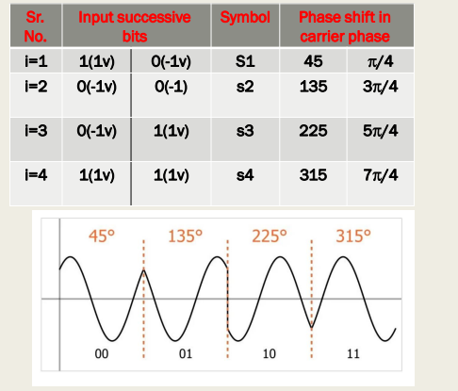
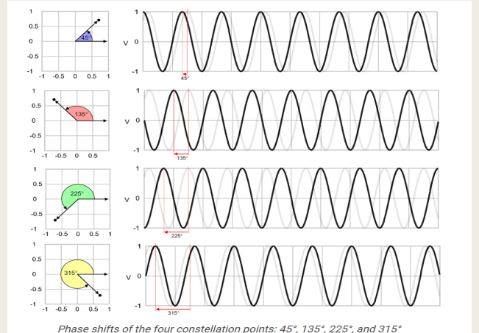

Ambiguity in the output:
that even if the received signal is negative, the recovered carrier remains unaffected because of the 4th power conversion of the signal. Therefore it will not be possible to determine whether the transmitted signals were positive or negative
[i.e. +be​(t) or −be​(t) and +bo​(t) or −bo​(t)].
This is phase ambiguity in output similar to BPSK.
This problem can be recovered by employing differential encoding and decoding of b(t).

Bandwidth of QPSK Signal
We have seen that the bandwidth of BPSK signal is equal to 2f_{b}​.
Here T_{b}=1/f_{b}​​ is the one bit period.
In QPSK the two waveforms be​(t) and bo​(t) from the baseband signals. One bit period for both of these signals is equal to 2Tb​. Therefore bandwidth of QPSK signal is,
BW=2x1/2T_{b}​ or BW=f_{b}
Thus the bandwidth of QPSK signal is half of the bandwidth of BPSK signal. Earlier we have seen that noise immunity of QPSK and BPSK is same. This shows that inspite of the reduction in bandwidth in QPSK, the noise immunity remains same as compared to BPSK. BW of QPSK can also be obtained by plotting
BW=Highest frequency - Lowest frequency in main lobe
=(1/Ts​ −(−1/Ts​​)) since carrier frequency f₀​ cancels out =2/T_{s}​
We know that T_{s}​=2T_{b}​
BW=2/T_{b​}​=> BW=1/T_{b} ​=f_{b}​
QPSK has some definite advantages and disadvantages as compared to BPSK and DPSK.
Advantages:
- For the same bit error rate, the bandwidth required by QPSK is reduced to half as compared to BPSK.
- Because of reduced bandwidth, the information transmission rate of QPSK is higher.
- Variation in OQPSK amplitude is not much. Hence carrier power almost remains constant.

Ex. In a QPSK system, the bit rate of NRZ stream is 10 Mbps and carrier frequency is 1 GHz. Find the symbol rate of transmission and bandwidth requirement of the channel. Sketch the power spectral density of the QPSK signal.
Sol.: (i) To obtain symbol rate and bandwidth
Bit rate fb​=10 Mbps
Bandwidth of the QPSK system is equal to bit rate.
Hence BW=fb​=10 MHz
Symbol duration and bit duration are related as, Ts​=2T_{b}​
Symbol rate=1/T_{s}​
=1/2T_{b}​
=f_{b}/2​​
=5 MHz

QPSK Advantages and disadvantages
Advantages
- Provides very good noise immunity
- Provides low error probability
- Bandwidth is twice efficient as compared to BPSK modulation
- For the same BER, the bandwidth required by QPSK is reduced to half as compared to BPSK
- More efficient utilization of the available bandwidth of the transmission channel
- Carrier power almost remains constant
Disadvantages
- QPSK is not more power efficient modulation technique compared to other modulation types as more power is required to transmit two bits
- It is more complex in comparison to BPSK receiver due to four states needed to recover binary data information
Bit rate, Bit Duration, Symbol duration, Symbol rate
- Bit rate (Fb) is the data rate in Mbps.
- Bit Duration (Tb) is the duration of a bit in seconds.
Tb = 1 / Fb
- A Symbol is a group of bits, i.e., 1, 2, 4, 8, 16, ... N
- Symbol Duration (Ts = N.Tb) in seconds.
- Symbol rate (Fs) is the number of symbols in 1 second.
Fs = 1 / Ts
= 1 / (N * Tb)
= Fb / N

Important Points:
- Bit rate or Data rate (Rb​) is the transmission of the number of bits per second.
- Symbol rate or Baud rate (Rs​) is the transmission of the number of symbols per second.
- Bit rate = (symbol rate) × (number of bits per symbol)
- Bandwidth of BPSK = 2Rb​ and Bandwidth of QPSK = Rb​
So, we can say that the Bandwidth of QPSK is half of the bandwidth of BPSK.

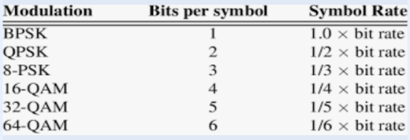

Introduction M-ARY PHASE SHIFT KEYING
- In BPSK, the output of modulator is one bit a time and it has two symbols.
- Hence whenever the symbol is changed, the phase shift is, phase shift in BPSK= 𝟐𝝅/number of symbols => BPSK= 𝟐𝝅/𝟐 = 𝝅 𝒐𝒓 𝟏𝟖𝟎 𝒅𝒆𝒈𝒓𝒆𝒆
- In QPSK two successive bits are combined to form 4 district symbols.
- Hence whenever the symbol is changed, the phase shift is, phase shift in QPSK = 𝟐𝝅/number of symbols => 2𝝅/𝟒 = 𝝅/2 or 90 degree
- This can extend further for ‘N’ bits in symbol. Then there will be 𝟐 𝑵 M possible symbols
- hence whenever the symbol is changed, the phase shift is, phase shift in M-ary PSK = 𝟐𝝅/number of symbols => M-ary PSK = 2 𝝅 𝑴
- the duration of each symbol will be, Ts= N Tb
- Since there are M – symbols, this method is called M- ary PSK
Bandwidth (BW) in M-ary PSK
The bandwidth in M-ary PSK is equal to the width of the main lobe, i.e.,
BW = Fs - (-Fs)
= 2Fs
= 2/Ts since Fs= 1/Ts
with Ts is the symbol duration and it is equal to
Ts = N Tb
hence, BW = 2 / N Tb with Tb=1/Fb
Hence BW = 2 / N(1/Fb) = 2 Fb /N

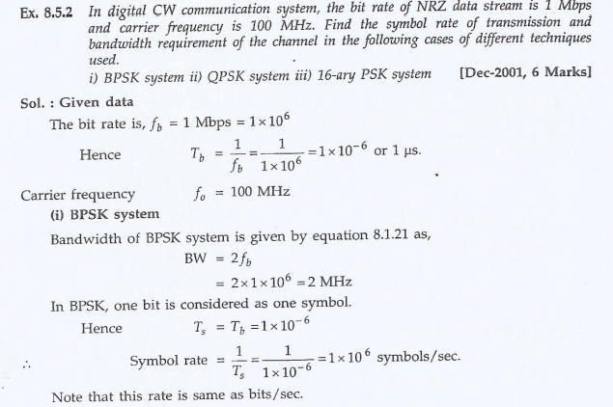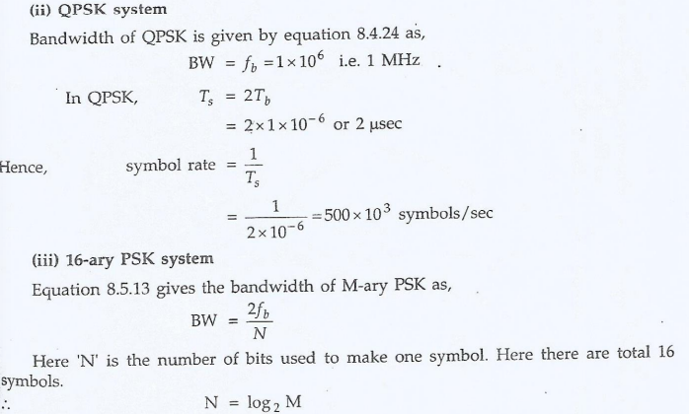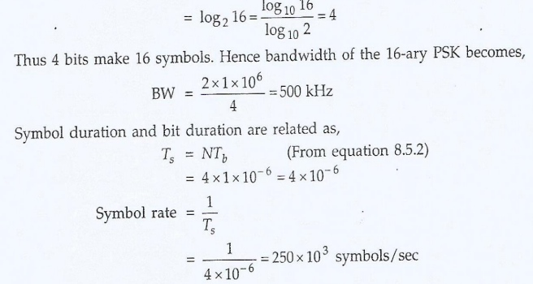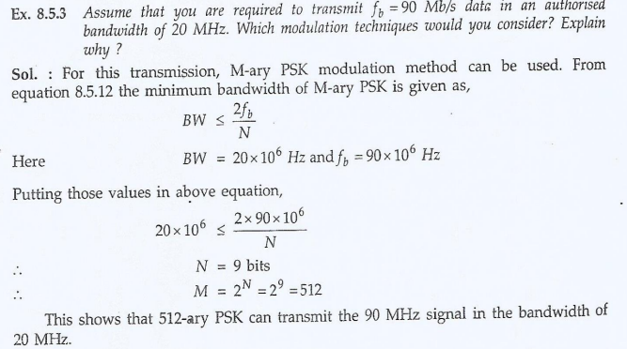
Amplitude Shift Keying ASK
- It is the simplest digital modulation technique.
- There is only one carrier and it is switched ON or OFF depending upon the input binary sequence.
- The output equation of ASK modulator, s(t) can be written as: s(t) = √2𝑃𝑠 Cos(2 Fo t) where √2𝑃𝑠 is constant carrier amplitude and Fo is the carrier frequency
- There are two symbols, one for “ 1” and other for “0”
- The symbol contain some complete cycles of carrier.
- To transmit “1” s(t) is transmitted
- While no signal(s(t)) transmitted for “0”
- Thus the ASK waveform looks like an ON- OFF of the signal. Hence it is also called ON – OFF Keying (OOK).

Quadrature Amplitude Shift Keying (QASK)
- We have seen in the phase shift keying modulation technique (BPSK,QPSK,M-ary) that the modulation depend on varying the phase of the carrier while the amplitude stay constant.
- Amplitude Shift Keying (ASK) is a digital modulation technique . It transmits the digital information by varying the amplitude of a carrier signal. In ASK, a high-amplitude carrier signal is used to represent a binary '1,' and a lowamplitude carrier signal represents a binary '0.'
- When the result symbols (after Modulation) draws as function of its phase (with all of them with constant carrier amplitude) , these results that all the symbol points lies on the circumstance of the circle.
- We have seen also in the preceding sections that the correct detection of the received signal depends upon the separation between the signal points in the signal space.
- So in the PSK modulation , the separation is not so high.
- If the amplitude of the carrier signal is also varied, then the symbol points will be inside the circle in addition to the circumstance.
- This will further increases the noise immunity of the system
- Such system involves Phase as well as Amplitude Shift Keying.
- It is called Quadrature Amplitude Phase Shift Keying (QASK )
- It also called Quadrature Amplitude Modulation or QAM
- It is a modulation scheme having wide range of application in real world which includes radio, television, and digital data transmission.
- It involves the superimposition of a carrier signal and a digital message signal. The carrier signal is often a high frequency sinusoidal waveform, which serves as the carrier for the digital information. The binary message signal, consisting of '1's and '0's, is used to control the amplitude of the carrier signal. The resultant signal formed after the superimposition of message and carrier is transmitted over the communication channel.
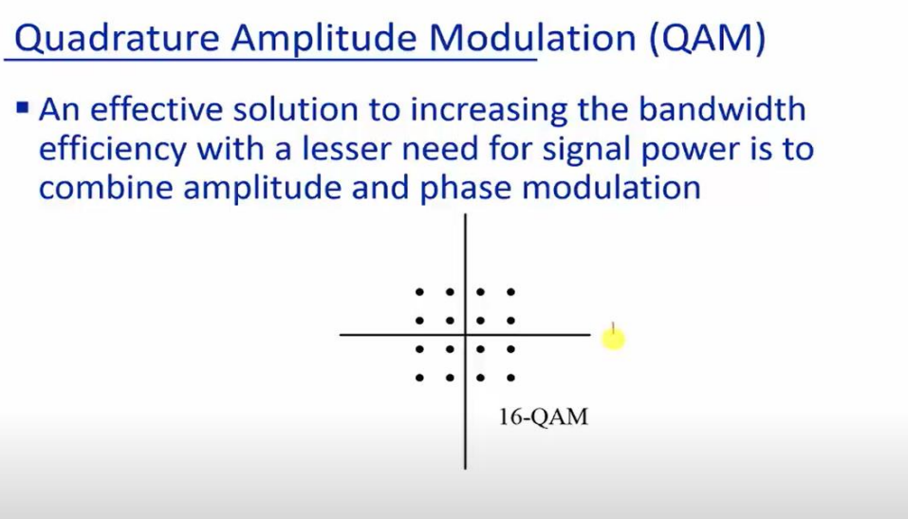
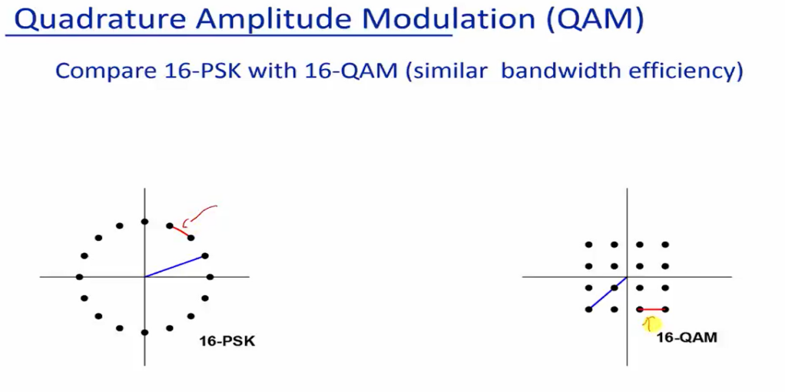

Bandwidth of QASK signal
From the plot of main lobe of QASK signal,
The bandwidth will be ,
BW= Fs – (-Fs ) = 2 Fs
= 2 /Ts since Fs= 1/Ts
= 2/(N Tb) since Ts= N Tb
= 2 Fb /N since Fb = 1/Tb
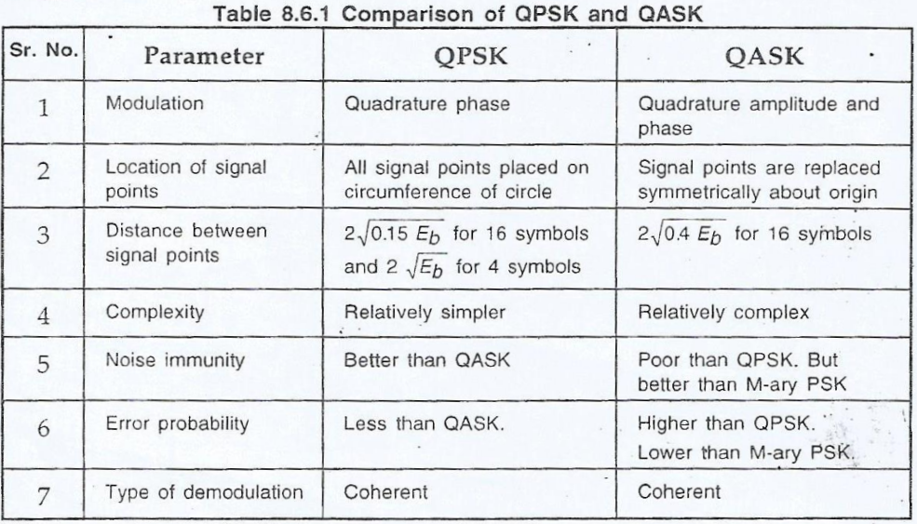
ASK – Demodulation
Demodulation in Amplitude Shift Keying (ASK) involves extracting the original digital message signal from the modulated carrier wave. The process reverses the modulation applied to the carrier signal. The demodulation of ASK can be performed through various methods, such as envelope detection or coherent detection.
Types Of ASK Demodulation
There are mainly two types of Demodulation which is performed namely envelope detection and coherent detection technique:
Envelope detection
Coherent detection

Advantages
There are various advantages of using ASK as a modulation technique.
• It is one of the simplest modulation techniques which makes it easy to implement in both analog and digital systems.
• It is a cost-effective modulation technique, which is one reason for its widespread use in various applications.
• It is compatible with various transmission media, including radio waves, optical fibers, and wired communication systems. • It is efficient in terms of bandwidth utilization as it only requires two levels of amplitude i.e. 0 and 1.
Disadvantages
• Susceptibility to Noise: ASK is more sensitive to noise and interference compared to other modulation techniques like Frequency Shift Keying (FSK) or Phase Shift Keying (PSK). Fluctuations in the amplitude caused by noise can lead to errors in data recovery at the receiver end.
• Bandwidth Inefficiency: ASK can be less bandwidth efficient compared to other modulation techniques. It requires more bandwidth because it uses changes in amplitude to encode data, which can limit the number of bits transmitted in a given bandwidth.
• Power Inefficiency: Transmitting signals at varying amplitudes requires more power compared to constant amplitude transmission. This can be a disadvantage in scenarios where power efficiency is critical.
• Limited Data Rate: ASK is generally limited in terms of achievable data rates compared to other modulation techniques. This limitation arises from the constraints on how fast the amplitude can be changed without distortion.
• Signal-to-Noise Ratio Sensitivity: ASK’s performance is highly dependent on the signal-to-noise ratio (SNR). As the ratio between the signal power and noise power decreases, the accuracy and reliability of data transmission can be significantly affected.
• Lack of Phase or Frequency Information: ASK only utilizes changes in amplitude to represent data, unlike other modulation techniques that use phase or frequency changes. This limitation might make it more vulnerable to certain types of interference and distortions

Applications
Here comes a wide range of application of ASK
• ASK is commonly used in wireless communication systems, such as keyless entry systems, remote controls, and radio frequency identification (RFID) tags.
• In optical fiber communication, ASK is used to transmit digital data over long distances.
• ASK is often used in digital broadcasting, including television and radio transmissions, for transmitting audio and video signals.
• ASK can be used for low to medium data rate communication, such as in binary data transmission over short distances.
• ASK is used in medical telemetry systems for monitoring and transmitting patient data.

Comparison of Digital Modulation techniques

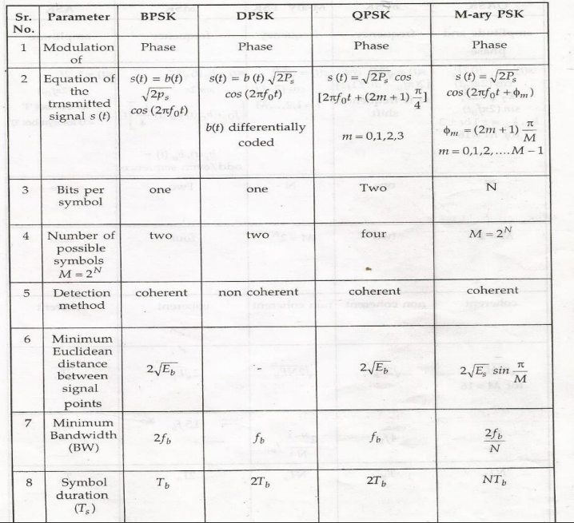

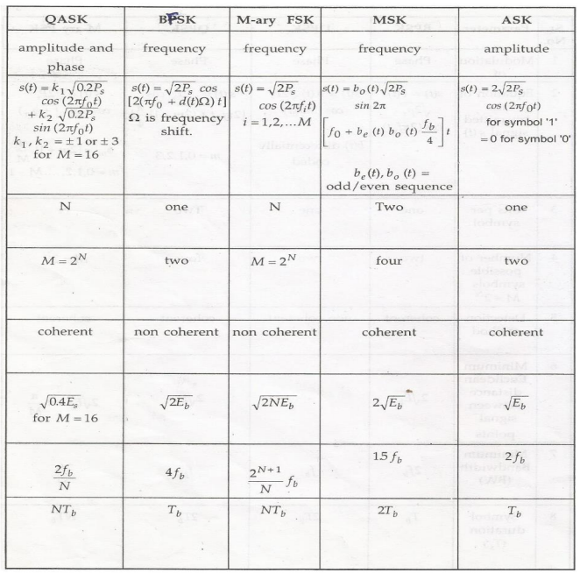

1. What is detection method called when the local carrier at the receiver is phase-locked with the transmitter carrier?
- A) Non-coherent Detection
- B) Envelop Detection
- C) Synchronized Detection
2. What is a major two requirements for any digital communication system? -----------------------------------------------------------------------------------------------------------
3. In BFSK the digital signal modulates the---------------------- ---------------- of the carrier
4. What is the nature of DCW modulation output -----------------------------------
5. DCW Modulation output suffer from symbol interference, Yes or No -----------------------
6. DCW Modulation output can be transmitted over Radio Channel, Why? ---------------------------------------------------------------------------------------------------------------
7. Digital modulation techniques vary the carrier in:
- A) Continuous steps
- B) Discrete steps
8. DCW Modulation used to transmits ---------------------------- signal for long distance
9. ASK results when digital signal keying the -------------------------------------of carrier
10. FSK results when digital signal keying the----------------------------------of the carrier
11. In QPSK, two successive bits are grouped into: --------------------------------------
12. the primary benefit of grouping bits into symbols in QPSK is
13. If the input bit rate to a QPSK IS 10 Mbps, the symbol rate will be---------------------------------------
14. If the input bit rate to a QPSK IS 10 Mbps, the BW will be-------------------------------------------------
15. What is the phase shift in QPSK for successive symbol, if the 1st one at 450 -----------------------------------------------------------------------------------------------------------------------------------------------------------------------------------------------------
16. . What type of modulation reduces both transmission power and channel bandwidth?
- a) Frequency Modulation
- b) Quadrature Phase Shift Keying
17. If the input bit rate to a BPSK IS 20 Mbps, the symbol rate will be---------------------------------------
18. If the input bit rate to a BPSK IS 10 Mbps, the BW will be-------------------------------------------------
19. Typical channels can be used to transmits the output signal of DCM, because ----------------------------------------------------------------------------------------------------------------------------------
20. the DCW modulation is used to transmit
a. Analog signal
b. Digital signal
c. Discrete Signal
21 . In BPSK receiver, the integration is done over one bit duration, while in QPSK, the integration is done over two bits duration -----------------------------------------------------------------------------------------------------------------------------------
22. For a 100 Mbps digital input to a BPSK system, Calculate Bit duration(Tb), Symbol Duration (Ts) , Symbol rate (Fs)

23. For a 250 Mbps digital input to a QPSK system, Calculate Bit duration(Tb), Symbol Duration (Ts) , Symbol rate (Fs)

Q1) Select the correct answer or fill in blank
- In QPSK the Symbol rate. Fs = —--Fb​
- In QPSK, if the first Symbol is at 45∘, The third one will be at =----
- PSK is particularly robust against which type of interference
a. Frequency Interference. b. Amplitude Interference. c. Phase Interference
- The symbol duration (Ts​) in M-ary PSK is related to the bit duration (Tb​) by:
a) Ts​=Tb​ b) Ts​=(Log2​M)Tb​ c) Ts​=M.Tb​
- The bandwidth of M-ary PSK compared to binary PSK is:
a) Higher b) Lower c) The same
- Why average transmitted power as M increases in M-ary PSK, remain constant?
- What is the primary factor limiting the practical implementation of very high M values in M-ary PSK?
a) Bandwidth availability
b) Transmitter power
c) Phase noise and synchronization
- Which Digital modulation type is more spectrally efficient than Binary PSK?
a) M-ary FSK (M > 2)
b) Frequency Modulation (FM)
c) BPSK
- In BPSK, QPSK the carrier is extracted from the received signal. WHY
- Which of following is disadvantage of BPSK
a. Constant output average power
b. High signal Bandwidth
c. complex system implementation
- In Digital Continuous Wave Modulation, the frequency of modulated signal depends on,
a. Bit rate b. Carrier frequency c. phase of the carrier
- In Digital Continuous Wave Modulation, the Modulated signal is:
  - Digital b. Discrete c. analog
Q2) A digital signal of bit rate (2) Mbps is to be transmitted by:
BPSK, QPSK, 32-ary PSK

For each type of Modulation, FIND:
 | Bit Duration (Tb​), | Symbol Duration (Ts​), | Symbol Rate (Fs​), | Signal Bandwidth
BPSK
QPSK
32-ary PSK

Here are 25 multiple-choice questions (MCQs) based on the provided document about Binary Phase Shift Keying (BPSK).
Each question includes the correct answer marked.
1. What does BPSK stand for?
- A) Binary Power Signal Keying
- B) Binary Phase Shift Keying
- C) Band Phase Signal Keying
- D) Binary Pulse Signal Keying
Answer: B) Binary Phase Shift Keying
2. The BPSK signal spectrum is centered around which frequency?
- A) Baseband Frequency
- B) Carrier Frequency
- C) Signal Frequency
- D) Sampling Frequency
Answer: B) Carrier Frequency
3. In BPSK, the maximum frequency in the baseband signal is equivalent to:
- A) 2Fo
- B) Fb
- C) Fo + Fb
- D) Fo
Answer: B) Fb
4.What is the minimum bandwidth of a BPSK signal?
- A) Fo
- B) Fb
- C) 2Fb
- D) Fo - Fb
Answer: C) 2Fb
5. How is the bandwidth (BW) of a BPSK signal calculated?
- A) BW = Fo - Fb
- B) BW = 2Fo
- C) BW = 2Fb
- D) BW = Fo / Fb
Answer: C) BW = 2Fb
6. A drawback of BPSK is the ambiguity in the output signal due to:
- A) Interference
- B) Signal Noise
- C) Carrier Recovery
- D) Input Signal Polarity
Answer: D) Input Signal Polarity
7. The received BPSK signal after squaring remains the same if the input signal changes its:
- A) Frequency
- B) Phase
- C) Signal
- D) Amplitude
Answer: C) Signal
8. BPSK modulation uses how many phases?
- A) 2
- B) 4
- C) 8
- D) Infinite
Answer: A) 2
9. Which mathematical operation is used to regenerate the carrier signal in the BPSK receiver?
- A) Squaring
- B) Differentiation
- C) Integration
- D) Modulation
Answer: A) Squaring
10. Why can't the BPSK receiver determine whether the signal is b(t) or -b(t)?
- A) Lack of sufficient bandwidth
- B) Ambiguity due to sign reversal 4
- C) Phase noise
- D) Interference
Answer: B) Ambiguity due to sign reversal
11. What happens to the squared signal in BPSK if the input signal changes its sign?
- A) It doubles in magnitude
- B) It remains the same
- C) It becomes zero
- D) It reverses phase
Answer: B) It remains the same
12. The phase difference between the two symbols in BPSK is:
- A) 45°
- B) 90°
- C) 180°
- D) 360°
Answer: C) 180°
13. BPSK is considered a simple form of:
- A) Frequency Modulation
- B) Amplitude Modulation
- C) Phase Modulation
- D) Pulse Modulation
Answer: C) Phase Modulation
14. What is the main advantage of BPSK?
- A) High spectral efficiency
- B) Noise immunity
- C) Simple implementation
- D) High data rate
Answer: C) Simple implementation
15. What is the disadvantage of BPSK?
- A) Low spectral efficiency
- B) High noise sensitivity
- C) Ambiguity in signal detection
- D) Complex circuitry
Answer: C) Ambiguity in signal detection
16. If the baseband frequency is 1 kHz, what is the bandwidth of the BPSK signal?
- A) 1 kHz
- B) 2 kHz
- C) 3 kHz
- D) 4 kHz
Answer: B) 2 kHz
17. The ambiguity in the BPSK signal is caused by:
- A) Phase noise
- B) Squaring of the signal
- C) Frequency drift
- D) Multipath fading
Answer: B) Squaring of the signal 6
18. Which frequency components define the spectrum of a BPSK passband signal?
- A) Fo - Fb to Fo + Fb
- B) 2Fo
- C) Fb to 2Fb
- D) Fo to 2Fo
Answer: A) Fo - Fb to Fo + Fb
19. The main goal of a BPSK demodulator is to:
- A) Recover the baseband signal
- B) Filter out noise
- C) Amplify the carrier signal
- D) Change the signal polarity
Answer: A) Recover the baseband signal
20. The polarity of the recovered signal in BPSK depends on:
- A) Signal amplitude
- B) Squaring operation
- C) Phase synchronization
- D) Bandwidth
Answer: C) Phase synchronization
21. BPSK is best suited for which type of communication?
- A) High-speed data
- B) Low-speed but reliable communication
- C) Multimedia transmission
- D) Ultra-wideband signals 7
Answer: B) Low-speed but reliable communication
22. In BPSK, a single bit is represented by:
- A) Multiple symbols
- B) One of two phases
- C) Amplitude variations
- D) Frequency shifts
Answer: B) One of two phases
23. What happens to the signal-to-noise ratio (SNR) when using BPSK? - A) It increases
- B) It decreases
- C) It remains constant
- D) It depends on bandwidth
Answer: A) It increases
24. The recovered carrier signal in BPSK can have ambiguity due to:
- A) Noise levels
- B) Signal amplitude
- C) Sign reversal of input signal
- D) Synchronization errors
Answer: C) Sign reversal of input signal
25. What happens to the carrier signal after squaring in the BPSK receiver?
- A) Its phase doubles 8
- B) It becomes noise-free
- C) It gets amplified
- D) It remains unchanged
Answer: D) It remains unchanged
Here are 25 multiple-choice questions (MCQs) with the correct answers based on the content of the document about CW modulation:
1. What does CW stand for in CW modulation?
- A) Carrier Wave
- B) Continuous Wave
- C) Constant Wave
- D) Cyclic Wave
Answer: B) Continuous Wave
2. Which modulation technique varies the amplitude of the carrier wave based on the digital signal?
- A) Frequency Shift Keying (FSK)
- B) Amplitude Shift Keying (ASK)
- C) Phase Shift Keying (PSK)
- D) None of the above
Answer: B) Amplitude Shift Keying (ASK)
3. What is the primary purpose of CW modulation for digital signals?
- A) Noise Reduction
- B) Long-distance transmission
- C) Bandwidth Compression
- D) Signal Amplification
Answer: B) Long-distance transmission
4. Which parameter of the carrier signal is modified in Frequency Shift Keying (FSK)?
- A) Amplitude
- B) Frequency
- C) Phase
- D) Bandwidth
Answer: B) Frequency
5. In digital modulation, what is the term used for transmitting multiple bits simultaneously?
- A) Multiplexing
- B) Discrete Transmission
- C) M-ary Transmission
- D) Bandpass Transmission
Answer: C) M-ary Transmission
6. Which of the following is not a type of CW modulation?
- A) ASK
- B) FSK
- C) PMK
- D) PSK
Answer: C) PMK
7. In a bandpass transmission, the bandwidth of the signal is defined as:
- A) W Hz
- B) 2W Hz
- C) Fo Hz
- D) W/2 Hz
Answer: B) 2W Hz
8. What is the detection method called when the local carrier at the receiver is phase-locked with the transmitter carrier?
- A) Non-coherent Detection
- B) Envelop Detection
- C) Coherent Detection
- D) Analog Detection
Answer: C) Coherent Detection
9. What is the key advantage of non-coherent detection?
- A) High accuracy
- B) Simplicity
- C) Reduced bandwidth
- D) Error-free transmission
Answer: B) Simplicity
10. Which technique suffers from a higher probability of symbol error? 11 - A) Coherent Detection
- B) Non-coherent Detection
- C) Bandpass Detection
- D) Synchronous Detection
Answer: B) Non-coherent Detection
11. What does CW stand for in CW modulation?
- A) Carrier Wave
- B) Continuous Wave
- C) Constant Wave
- D) Cyclic Wave
Answer: B) Continuous Wave
12. Which modulation technique varies the amplitude of the carrier wave based on the digital signal?
- A) Frequency Shift Keying (FSK)
- B) Amplitude Shift Keying (ASK)
- C) Phase Shift Keying (PSK)
- D) None of the above
Answer: B) Amplitude Shift Keying (ASK)
13. What is the primary purpose of CW modulation for digital signals?
- A) Noise Reduction
- B) Long-distance transmission
- C) Bandwidth Compression
- D) Signal Amplification
Answer: B) Long-distance transmission
14. Which parameter of the carrier signal is modified in Frequency Shift Keying (FSK)?
- A) Amplitude
- B) Frequency
- C) Phase
- D) Bandwidth
Answer: B) Frequency
15. In digital modulation, what is the term used for transmitting multiple bits simultaneously?
- A) Multiplexing
- B) Discrete Transmission
- C) M-ary Transmission
- D) Bandpass Transmission
Answer: C) M-ary Transmission
16. Which of the following is not a type of CW modulation?
- A) ASK
- B) FSK
- C) PMK
- D) PSK
Answer: C) PMK
17. In a bandpass transmission, the bandwidth of the signal is defined as:
- A) W Hz
- B) 2W Hz
- C) Fo Hz
- D) W/2 Hz
Answer: B) 2W Hz
18. What is the detection method called when the local carrier at the receiver is phase-locked with the transmitter carrier?
- A) Non-coherent Detection
- B) Envelop Detection
- C) Coherent Detection
- D) Analog Detection
Answer: C) Coherent Detection
19. What is the key advantage of non-coherent detection?
- A) High accuracy
- B) Simplicity
- C) Reduced bandwidth
- D) Error-free transmission
Answer: B) Simplicity
20. Which technique suffers from a higher probability of symbol error?
- A) Coherent Detection
- B) Non-coherent Detection
- C) Bandpass Detection
- D) Synchronous Detection
Answer: B) Non-coherent Detection
21. Baseband digital transmission suffers mainly from:
- A) Noise only
- B) Intersymbol interference and crosstalk
- C) Signal attenuation
- D) High circuit complexity
Answer: B) Intersymbol interference and crosstalk
22. Which media can be used to transmit CW modulated signals?
- A) Fiber optic cables
- B) Radio channels
- C) Coaxial cables
- D) All of the above
ءAnswer: D) All of the above
23. Digital modulation techniques vary the carrier in:
- A) Continuous steps
- B) Discrete steps
- C) Random intervals
- D) None of the above
Answer: B) Discrete steps
24. What is the main reason to use digital CW modulation over baseband transmission?
- A) Higher bandwidth
- B) Resistance to interference
- C) Simplicity
- D) Long-distance transmission capability
Answer: D) Long-distance transmission capability
25. Which factor is not an important requirement for digital modulation techniques?
- A) Maximum data rate
- B) Maximum symbol error probability
- C) Minimum channel bandwidth
- D) Minimum transmitted power
Answer: B) Maximum symbol error probability
Here are 25 multiple-choice questions (MCQs) with the correct answers based on the content of the document about Quadrature Phase Shift Keying (QPSK):
1. What does QPSK stand for?
- A) Quadrature Pulse Shift Keying
- B) Quadrature Phase Shift Keying
- C) Quadratic Phase Signal Keying
- D) Quadrature Pulse Signal Keying
Answer: B) Quadrature Phase Shift Keying
2. Which two resources are important in communication systems?
- A) Frequency and Bandwidth
- B) Transmission Power and Channel Bandwidth
- C) Signal Power and Frequency
- D) Bandwidth and Noise
Answer: B) Transmission Power and Channel Bandwidth
3. In QPSK, two successive bits are grouped into:
- A) One symbol
- B) Two symbols
- C) Three symbols
- D) Four symbols
Answer: A) One symbol
4. What is the primary benefit of grouping bits into symbols in QPSK?
- A) Increased data rate
- B) Reduced bandwidth
- C) Increased power consumption
- D) Improved signal noise ratio
Answer: B) Reduced bandwidth
5. The channel bandwidth in BPSK is typically equal to:
- A) fb
- B) 2fb
- C) 4fb
- D) 1.5fb
Answer: B) 2fb
6. How many distinct symbols are present in QPSK?
- A) 2
- B) 3
- C) 4
- D) 8
Answer: C) 4
7. What is the phase shift in QPSK for each symbol?
- A) 90°
- B) 180°
- C) 45°
- D) 60°
Answer: A) 90°
8. In QPSK, the phase change for a single symbol is equivalent to:
- A) π radians
- B) π/2 radians
- C) π/4 radians
- D) 2π radians
Answer:B) π/2 radians
9. Combining two successive bits in QPSK reduces the:
- A) Noise
- B) Signaling rate (fb)
- C) Symbol duration
- D) Carrier amplitude
Answer: B) Signaling rate (fb)
10. What happens to the bandwidth when the signaling rate is reduced in QPSK?
- A) It increases
- B) It remains constant
- C) It decreases
- D) It becomes zero
Answer: C) It decreases
11. In QPSK, the phase of the carrier changes by how many degrees for each symbol?
- A) 30°
- B) 45°
- C) 90°
- D) 180°
Answer:C) 90°
12. The table in QPSK shows symbols and their corresponding:
- A) Frequencies
- B) Bandwidth
- C) Phase shifts
- D) Amplitude levels
Answer: C) Phase shifts
13. The bandwidth requirement of a QPSK system with a 1 GHz carrier is approximately:
- A) 0.005 GHz
- B) 0.01 GHz
- C) 0.1 GHz
- D) 0.5 GHz
Answer: B) 0.01 GHz
14. What is the bandwidth in MHz of the QPSK system with the given lobe width?
- A) 1 MHz
- B) 10 MHz
- C) 100 MHz
- D) 1 GHz
Answer: B) 10 MHz
15. The reduction in signaling rate in QPSK is due to:
- A) Increased amplitude
- B) Combining successive bits
- C) Higher transmission power
- D) Reduced carrier frequency
Answer: B) Combining successive bits
16. How many lobes are shown in the QPSK spectrum?
- A) One
- B) Two
- C) Three
- D) Four
Answer: B) Two
17. The main lobe in the QPSK spectrum is centered around:
- A) 0 Hz
- B) ±1 GHz
- C) 1 MHz
- D) ±2 GHz
Answer: B) ±1 GHz
18. What type of modulation reduces both transmission power and channel bandwidth?
- A) Amplitude Modulation
- B) Frequency Modulation
- C) Quadrature Phase Shift Keying
- D) Binary Phase Shift Keying
Answer: C) Quadrature Phase Shift Keying
19. Which of the following is reduced when two bits are grouped into one symbol in QPSK?
- A) Data rate
- B) Noise
- C) Transmission bandwidth
- D) Signal amplitude
Answer: C) Transmission bandwidth
20. What does grouping bits into symbols help achieve in QPSK?
- A) Higher error rate
- B) Simplified transmission
- C) Reduced bit rate
- D) Increased noise immunity
Answer: C) Reduced bit rate
21. What is the relationship between the bandwidth and the signaling rate in QPSK?
- A) Bandwidth is proportional to the signaling rate
- B) Bandwidth is independent of the signaling rate
- C) Bandwidth decreases as signaling rate increases
- D) Bandwidth is twice the signaling rate
Answer: A) Bandwidth is proportional to the signaling rate
22. In QPSK, the four possible symbols correspond to how many unique bit combinations?
- A) 2
- B) 3
- C) 4
- D) 8
Answer: C) 4
23. What is the primary difference between BPSK and QPSK?
- A) Number of phase shifts
- B) Amplitude variation
- C) Number of lobes in the spectrum
- D) Carrier frequency
Answer: A) Number of phase shifts
24. The reduction of transmission power and bandwidth in QPSK leads to:
- A) Decreased efficiency
- B) Increased noise
- C) Improved performance
- D) Simplified modulation
Answer: C) Improved performance
25. QPSK uses a phase change of 45° between symbols to:
- A) Increase data rate
- B) Enhance bandwidth
- C) Represent four distinct symbols
- D) Reduce power consumption
Answer: C) Represent four distinct symbols
Multiple-Choice Questions (MCQs) on Phase Shift Keying (PSK)
1. What does PSK stand for?
a) Phase Synchronization Keying
b) Pulse Shift Keying
c) Phase Shift Keying
d) Power Signal Keying
Correct Answer: c) Phase Shift Keying
2. Which modulation scheme does PSK primarily use?
a) Frequency Modulation
b) Amplitude Modulation
c) Phase Modulation
d) Pulse Code Modulation
Correct Answer: c) Phase Modulation
3. In PSK, information is transmitted by changing the _____ of the carrier signal.
a) Amplitude
b) Frequency
c) Phase
d) Bandwidth
Correct Answer: c) Phase
4. Which of the following is a commonly used type of PSK?
a) QAM
b) FSK
c) QPSK
d) ASK
Correct Answer: c) QPSK
5. How many bits per symbol does QPSK transmit?
a) 1
b) 2
c) 4
d) 8
Correct Answer: b) 2
6. Which of the following is an advantage of QPSK?
a) Requires high bandwidth
b) Low noise immunity
c) Higher data rate than BPSK
d) Uses higher power than BPSK
Correct Answer: c) Higher data rate than BPSK
7. Which of the following modulation schemes provides better spectral efficiency?
a) BPSK
b) QPSK
c) 8-PSK
d) 16-PSK
Correct Answer: d) 16-PSK
8. In a QPSK modulator, how many different phase shifts are used?
a) 2
b) 4
c) 8
d) 16
Correct Answer: b) 4
9. Which component is essential in a PSK demodulator?
a) Voltage Amplifier
b) Phase Detector
c) Low Pass Filter
d) Oscillator
Correct Answer: b) Phase Detector
10. What is the primary disadvantage of PSK?
a) Low bandwidth efficiency
b) Complex receiver design
c) High power requirement
d) Poor phase stability
Correct Answer: b) Complex receiver design
11. QPSK is also known as:
a) 2-PSK
b) 4-PSK
c) 8-PSK
d) 16-PSK
Correct Answer: b) 4-PSK
12. Why is QPSK preferred over BPSK in communication systems?
a) Lower bandwidth efficiency
b) Higher noise susceptibility
c) Higher data rate for the same bandwidth
d) Requires higher transmission power
Correct Answer: c) Higher data rate for the same bandwidth
13. Which factor is used to distinguish different symbols in PSK?
a) Amplitude
b) Phase
c) Frequency
d) Wavelength
Correct Answer: b) Phase
14. What happens to the signal in BPSK modulation?
a) The phase shifts by 45°
b) The phase shifts by 90°
c) The phase shifts by 180°
d) The amplitude is modulated
Correct Answer: c) The phase shifts by 180°
15. What is a significant drawback of increasing the number of phase shifts in PSK?
a) Increased power efficiency
b) Increased noise immunity
c) Increased receiver complexity
d) Decreased bandwidth requirement
Correct Answer: c) Increased receiver complexity
16. Which of the following techniques is used to improve PSK performance in noisy channels?
a) Increasing bandwidth
b) Error correction coding
c) Using FM instead
d) Reducing transmission power
Correct Answer: b) Error correction coding
17. Which modulation type requires more complex hardware, QPSK or BPSK?
a) BPSK
b) QPSK
Correct Answer: b) QPSK
18. How does Differential PSK (DPSK) differ from conventional PSK?
a) It uses frequency shifts instead of phase shifts
b) It encodes data in the difference between consecutive signals
c) It requires an amplitude modulated carrier
d) It transmits more bits per symbol
Correct Answer: b) It encodes data in the difference between consecutive signals
19. Which of the following PSK types provides the highest data rate?
a) BPSK 28
b) QPSK
c) 8-PSK
d) 16-PSK
Correct Answer: d) 16-PSK
20. What is the effect of noise on PSK systems?
a) Reduces phase shifts
b) Causes phase errors leading to incorrect symbol detection
c) Increases bandwidth
d) Reduces frequency variation
Correct Answer: b) Causes phase errors leading to incorrect symbol detection
21. Which PSK variant is used in Wi-Fi and LTE networks?
a) BPSK
b) QPSK
c) 16-QAM
d) 64-QAM
Correct Answer: b) QPSK
22. How does QPSK compare to 8-PSK in terms of noise resilience?
a) QPSK is less resilient
b) QPSK is more resilient
c) Both have equal resilience
d) Noise does not affect PSK systems
Correct Answer: b) QPSK is more resilient
23. Why is PSK widely used in digital communication?
a) High spectral efficiency
b) High power consumption
c) Simple demodulation
d) Requires large bandwidth
Correct Answer: a) High spectral efficiency
24. What is the main challenge in designing a PSK demodulator?
a) Maintaining frequency stability
b) Correctly detecting phase changes
c) Generating high power signals
d) Adjusting amplitude levels
Correct Answer: b) Correctly detecting phase changes
25. Which component helps in synchronizing the phase in a PSK demodulator?
a) PLL (Phase-Locked Loop)
b) Mixer
c) Low-pass filter
d) Oscillator
Correct Answer: a) PLL (Phase-Locked Loop)

