Summary of Digital

Digital Communication
Anas riyadh
part1

Name | Symbol | Equivalent
tera | T | 10¹²
giga | G | 10⁹
mega | M | 10⁶
kilo | K | 10³
milli | m | 10⁻³
micro | u | 10⁻⁶
nano | n | 10⁻⁹
pico | p | 10⁻¹²

Chapter 1: introduction

Signals are analog in nature, when the communication needs to be established over a distance, then the analog signals are sent by using different techniques for effective transmission.

Why convert signal analog to digital?
When used analog signals for long distance communications, which suffer from many losses such as distortion, interference, and other losses. Including security breach.
In order to overcome these problems,The signals are digitized using different techniques. The digitized signals allow the communication to be more clear and accurate without losses.
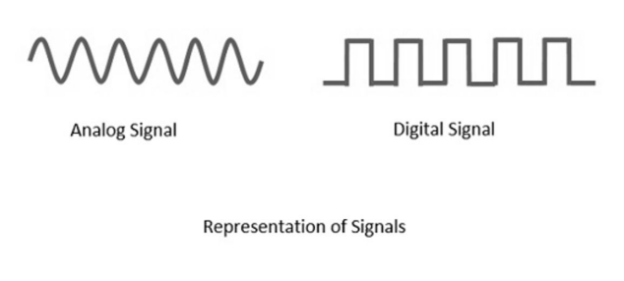

Advantages of Digital communication
The advantages is 14, We classifications the advantages by four group:
- Errors and distortions (5):
- The effect of distortion, noise, and interference is much less in digital signals as they are less affected.
- The occurrence of cross-talk is very rare in digital communication.
- The probability of error occurrence is reduced by employing error detecting and error correcting codes.
- Spread spectrum technique is used to avoid signal jamming.
- The signal is un-altered as the pulse needs a high disturbance to alter its properties, which is very difficult.

- Component build(3):
- Digital circuits are more reliable.
- Digital circuits are easy to design and cheaper than analog circuit.
- The hardware implementation in digital circuits, is more flexible than analog.

- security(2):
- Signal processing functions such as encryption and compression are employed in digital circuits to maintain the secrecy of the information
- Many of the digital circuits have almost common encoding techniques and hence similar devices can be used for a number of purposes

- Signal properties and specifications(4):
- Combining digital signals using Time Division Multiplexing (TDM) is easier than combining analog signals using Frequency Division Multiplexing (FDM).
- The configuring process of digital signals is easier than analog signals.
- Digital signals can be saved and retrieved more conveniently than analog signals.
- The capacity of the channel is effectively utilized by digital signals.

Elements of Digital Communication
(مهم)
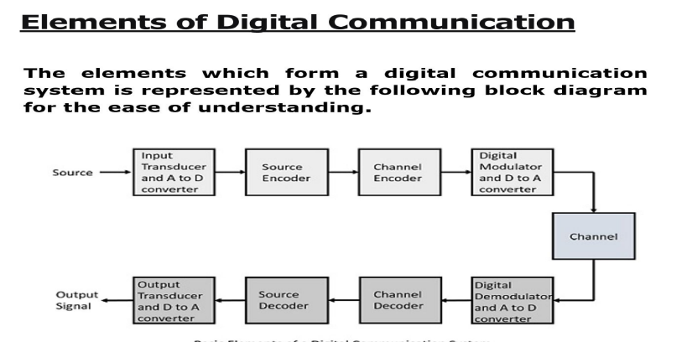

Element of digital communication system:
- Source Encoder
The source compresses the data into minimum number of bits. This process helps in effective utilization of the bandwidth. It removes the redundant bits (unnecessary excess bits, .i.e., zeroes) encoder
- Channel Encoder
The channel encoder, does the coding for error correction. During the transmission of the signal, due to the noise in the channel, the signal may get altered and hence to avoid this, the channel encoder adds some redundant bits to the transmitted data. These are the error correcting bits.

- Digital Modulator
The signal to be transmitted is modulated here by a carrier. The signal is also converted to analog from the digital sequence, in order to make it travel through the channel or medium.

- Channel
The channel or a medium, allows the analog signal to transmit from the transmitter end to the receiver end.
- Digital Demodulator
This is the first step at the receiver end. The received signal is demodulated as well as converted again from analog to digital. The signal gets reconstructed here.
- Channel Decoder
The channel decoder, after detecting the sequence, does some error corrections. The distortions which might occur during the transmission, are corrected by adding some redundant bits. This addition of bits helps in the complete recovery of the source output.

- Source Decoder
The resultant signal is once again digitized by sampling and quantizing so that the pure digital output is obtained without the loss of information. The source decoder recreates the source output.

- Output Transducer
This is the last block which converts the signal into the original physical form, which was at the input of the transmitter. It converts the electrical signal into physical output (Example: loud speaker).

- Output Signal
This is the output which is produced after the whole process. Example − The sound signal received.

Chapter 2:sampling
Sampling Theorem
- The modern communication systems are digital.

- The analog signal(continues- time signal) to be transmitted by digital communication system should be converted to Digital form (Discrete-time signal).

- The first step in this direction, is to take samples from original signal (Discretization ).

Ho - many samples must be taken?, in order to good signal representation and ability of original signal reconstruction ?
This problem is solved by a mathematical tool known as Sampling theorem, a continuous – time signal may be completely represented and recovered from its samples taken uniformly to reconstruct the original signal completely.

the sampling theorem may be stated as under:
A continuous – time signal may be completely represented in its samples and recovered back , If the sampling frequency is Fs ≥ 2 Fm
Fs is the sampling frequency.
Fm is the maximum frequency present in the signal.

Signal sampling theorem
Proof: consider a continus time signal x. The spectrum of x(t)⁽¹⁾ is a band limited to fm Hz i.e. the spectrum of x is zero for |𝔀|>𝔀m⁽⁵⁾.

Sampling of input signal x(t) can be obtained by multiplying x(t)⁽¹⁾ with an impulse train s(t)⁽³⁾ of period Ts⁽²⁾. the output of multiplier is a discrete signal called sampled signal which is represented with y(t)⁽⁴⁾.
(مهم)
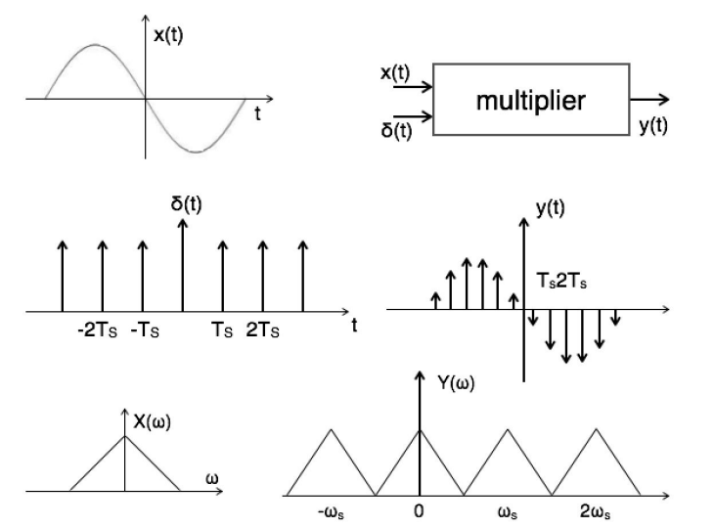
(1)
(2)
(3)
(4)
(5)
(6)

Here you can observe that the sampled signal takes the period of impulse. The process of sampling can be explained by the following mathematical expression:

Sampled signal y(t) = x(t).s(t) ……(1)

Aliasing effect
- The overlapped region in case of under sampling represents aliasing effect which can be removed by:
- Considering Fs ≥2Fm
- By using anti aliasing filters

Few points about Sampling Theorem
- Nyquist Rate and Spectrum Repetition: When the sampling frequency Fs​ is greater than twice the maximum signal frequency Fm (i.e., Fs>2Fm), the spectrum of the sampled signal repeats periodically without overlapping. This ensures that each cycle of the signal is isolated in frequency.
- Infinite Spectrum of Sampled Signals: The spectrum of a sampled signal theoretically extends to infinity. This is due to the periodic repetition of the spectrum across the frequency domain when sampling is performed.
- Recovery of Original Spectrum: The original signal spectrum, centered at ω=0 with a maximum frequency Wm​, can be perfectly reconstructed by passing the sampled signal through an ideal low-pass filter with a cutoff frequency Wm​.
- Non-Overlapping Condition (Fs>2Fm​): If the sampling frequency Fs​ is greater than 2Fm​, the successive cycles of the sampled signal's spectrum do not overlap, allowing perfect reconstruction of the original signal without aliasing.
- Nyquist Rate (Fs=2Fm​): When Fs​ is exactly 2Fm​, the successive cycles of the spectrum touch but do not overlap. This is the minimum sampling rate required to avoid overlap and ensure reconstruction.
- Aliasing (Fs<2Fm​): If Fs​ is less than 2Fm​, the successive cycles of the sampled spectrum overlap, causing aliasing. In this case, the original spectrum cannot be extracted or reconstructed without distortion.
- Condition for Distortion-Free Reconstruction: For accurate and distortion-free reconstruction of the original signal, the sampling frequency must meet or exceed twice the maximum signal frequency, i.e., Fs≥2Fm​ (known as the Nyquist Criterion).

Nyquist rate and Nyquist Interval
- Sampling rate is the number of samples per second
- Sampling interval is the distance in time between successive samples.
- Nyquist rate is the sampling frequency when Fs = 2 Fm and is also called minimum sampling rate.
- Nyquist Interval is the interval of Nyquist sampling frequency and is also called maximum sampling Interval.
- Ts = 1 /(2Fm) or Ts=$\frac{1}{Fs}$

Example -1 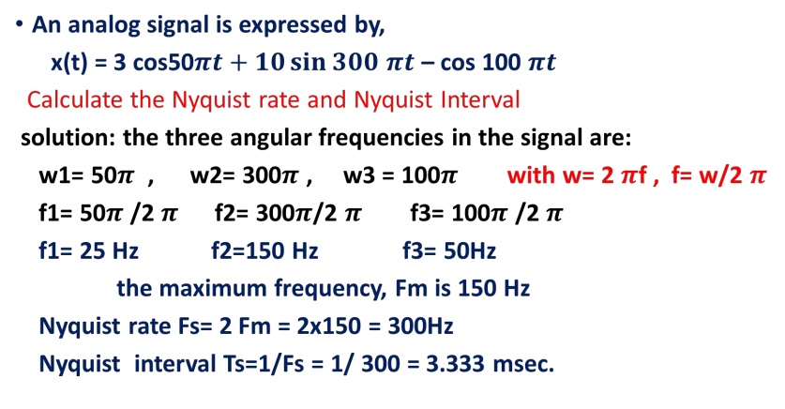
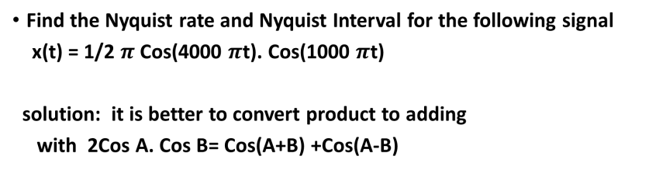
Example -2
x(t) = $\frac{1}{2}$π[$\frac{1}{2}${cos(4000πt + 1000πt)
+ cos( 4000πt - 1000πt ) } ]
= $\frac{π}{4}${ cos ( 5000πt ) } + $\frac{π}{4}${ cos ( 3000πt ) }

∴ fs = 2fm → fm = $\frac{fs}{2}$
→ fm₁ = $\frac{5000 πt}{2}$= 2500Hz , fm₂ = $\frac{3000 πt}{2}$ = 1500 Hz

∴ T_{s} = $\frac{1}{fs}$

T_{s1} = $\frac{1}{fs1}$ → T_{s1} = $\frac{1}{2500Hz}$ = 4 x 10⁻⁴sec

T_{s2} = $\frac{1}{fs2}$ → T_{s2} = $\frac{1}{1500Hz}$ = 6.666 x 10⁻⁴sec

Example:
Suppose that an analog signal is given as
x(t) = 5 cos (2π.1000t), for t>0, is sampled at the rate of 8,000Hz.
- Sketch the spectrum for the original signal.
- Sketch the spectrum for the sampled singal for 0 to 20kHz.
Sol:
- Since the analog signal is sinusoid with a peak value of 5 and frequency of 1,000 Hz, we can write the sine wave using Eulers identity:
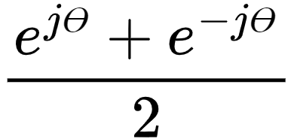
∴ cos Ө =

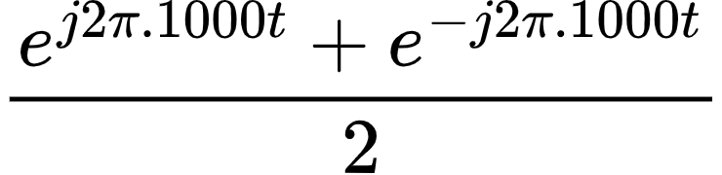
5 cos(2π x 1000t) = 5.( )
2.5e^{j2π.1000t} + 2.5e^{-j2π.1000t}
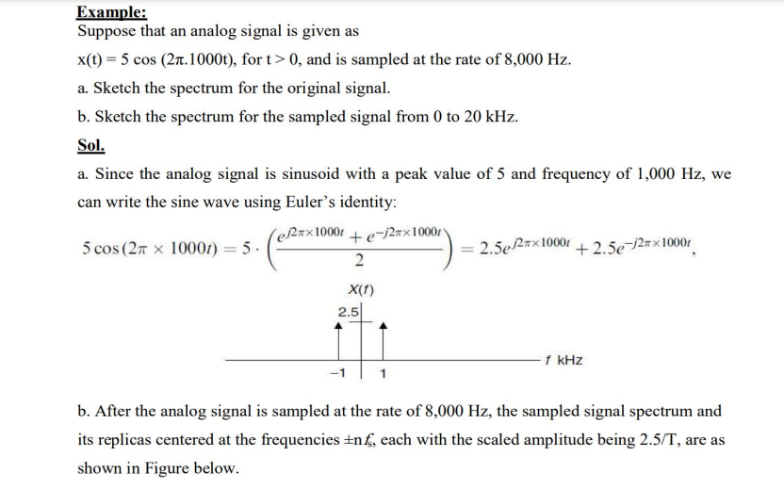
- After the analog signal is sampled at the rate of 8,000Hz, the sampled signal spectrum and its replicas centered at the frequencies ±nf_{s}, each with the scaled samplitude being 2.5/T, are as shown in figure below.
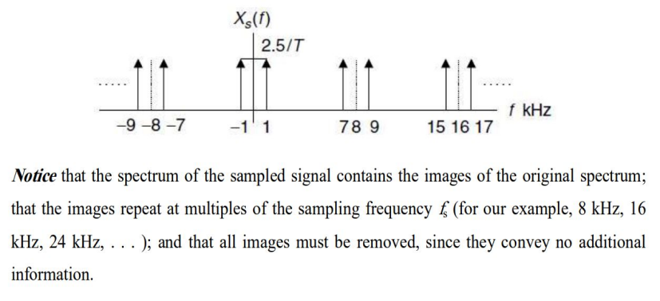
Notice that the spectrum of the sampled signal contains the images of the original spectrum;
That the images repeat at multiples of the sampling frequency f_{s} (for our example, 8kHz, 16kHz, 24kHz, ….); and that all images must be removed, since they convey no additional information.

For benefit about Eulers identity :
e^{jӨ} = cos Ө + j sin Ө and e^{-jӨ} = cos Ө - j sin Ө
Adding 2 cos Ө = e^{jӨ} + e^{-jӨ}
or cos Ө =

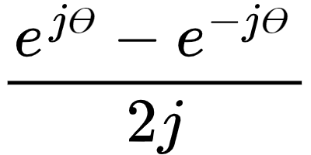
Subtracting 2 jsin Ө = e^{jӨ} - e^{-jӨ}

or sin Ө =

Reconstruction Filter (Low Pass Filter)
- The low pass filter is that type of filter which passes only low frequencies up to a specified cut-off frequency and rejects all other frequencies above cut-off frequency.
- The ideal LPF has sharp – change in response at cut-off frequency
- The practical LPF has amplitude response decrease slowly to zero.
- It has transition band.

Effect of Under Sampling : ALIASING
- When a continuous - time band – limited signal is sampled at a rate lower than Nyquist rate Fs < 2Fm, then the successive cycles of the spectrum of the sampled signal overlap with each other.
- Aliasing: is the phenomenon in which a high frequency component in the frequency spectrum of the signal takes identity of a lower frequency
- It is clear that because of the overlap due to aliasing phenomenon, it is not possible to recover original signal from sampled signal by low pass filtering since the spectral components in the overlap regions add and hence the signal is distorted.
- To decide a sampling frequency is problem.?
Therefore , a signal is first passed through a low pass filter which blocks all the frequencies which are above Fm Hz. This process is known as band limiting of the original signal.
- low pass filter is called pre alias filter because it is used to prevent aliasing effect.

To avoid aliasing:
- - Prealias filter must be used to limit band of frequencies of frequencies of the signal to Fm Hz.
- - Sampling frequency “ Fs” must be selected such that Fs > 2 Fm.

Sampling of Bandpass Signals
- The sampling theorem for bandpass signal X(t) whose maximum bandwidth is 2W can be completely represented into and recovered from its samples if it is sampled at minimum rate of twice the bandwidth.

First month Question
a-
Q1/Draw block diagram for the transmitter part of the digital communication system and explain the function of one its components?
Source Encoder
The source compresses the data into minimum number of bits. This process helps in effective utilization of the bandwidth. It removes the redundant bits (unnecessary excess bits, .i.e., zeroes) encoder

Q2/ Explain the sampling process in time domain by equations and signal diagram?
Go to Signal sampling theorem

Q3/An analog signal, x(t) = 10 cos (2𝛑 2000t) is to be sampled at Nyquist rate.
- Sketch the spectrum of original signal
sol/ Since the analog signal is sinusoid with a peak value of 10 and frequency of 2,000 Hz, we can write the sine wave using Eulers identity:
∴ cos Ө =

10 cos(2π x 2000t) =

10.( $\frac{e^{j2πx2000t} + e^{-j2πx2000t} }{2}$)
5e^{j2π.2000t} + 5e^{-j2π.2000t}
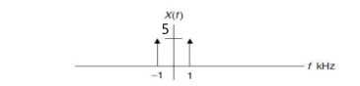
b.What is its Nyquist rate and Nyquist interval
sol/ ∴ fs = 2fm
→ fs = 2* 2000= 4000Hz
∴ T_{s} = $\frac{1}{fs}$ → T_{s1} = $\frac{1}{4000Hz}$ = 25msec

C.sketch the spectrum for the sampled signal from 0 to 10kHz
sol/ After the analog signal is sampled at the rate of 10,000Hz, the sampled signal spectrum and its replicas centered at the frequencies ±nf_{s}, each with the scaled samplitude being 5/T, are as shown in figure below.
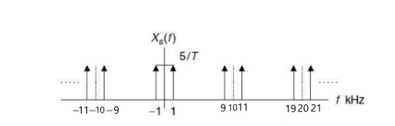

b-
Q1/Draw block diagram for the receiver part of the digital communication system and explain the function of one of its components?
Output Signal
This is the output which is produced after the whole process. Example − The sound signal received.

Q2/ Explain the sampling process in frequency domain by equations and signal diagram?
Go to Signal sampling theorem

Q3/An analog signal, x(t)= 10 cos (2π 4000t) is to be sampled at Nyquist rate.
a.Sketch the spectrum of original signal?
sol/ Since the analog signal is sinusoid with a peak value of 10 and frequency of 4,000 Hz, we can write the sine wave using Eulers identity:
∴ cos Ө =

10 cos(2π x 4000t) =

10.( $\frac{e^{j2πx4000t} + e^{-j2πx4000t} }{2}$)
5e^{j2π.4000t} + 5e^{-j2π.4000t}
b. What is its Nyquist rate and Nyquist interval?
sol/ ∴ fs = 2fm → fm₁ =2*4000 = 8000Hz
∴ T_{s} = $\frac{1}{fs}$
→ T_{s1} = $\frac{1}{8000Hz}$ = 0.125msec

C.sketch the spectrum for the sampled signal from 0 to 16 kHz?
sol/ After the analog signal is sampled at the rate of 16,000Hz, the sampled signal spectrum and its replicas centered at the frequencies ±nf_{s}, each with the scaled samplitude being 5/T, are as shown in figure below.
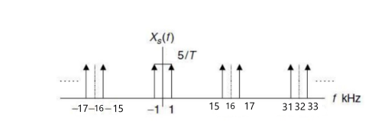

قوانين فصل 2
Fs = 2 Fm or Fs=$\frac{1}{Ts}$ , used for:
sampling theorem or Nyquist rate is also called minimum sampling rate.

Ts = 1 /(2Fm) or Ts=$\frac{1}{Fs}$ , used for:
Nyquist Interval is also called maximum sampling Interval.
Fs is the sampling frequency.
Fm is the maximum frequency
Eulers identity = cos Ө =$\frac{e^{jӨ}+e^{-jӨ}}{2}$

Chapter 3:Sampling techniques
(رسومات في هذا فصل للتوضيح الي عليك تعرف شون تمثل كل نوع)

They are three types
- Ideal sampling or instantaneous sampling or impulse sampling which is shown in study of sampling theorem. The sampling function is train of impulses S(nTs). The width of samples ꞇ is approaches zero. Hence the transmitted power is negligible and the method is impracticable. The CKT is known as the SWITCHING SAMPLER.
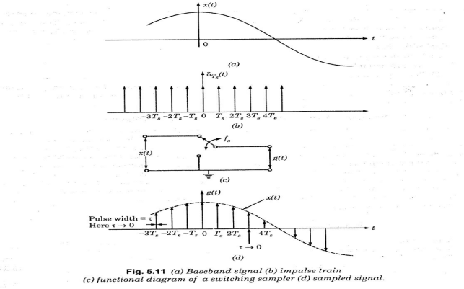

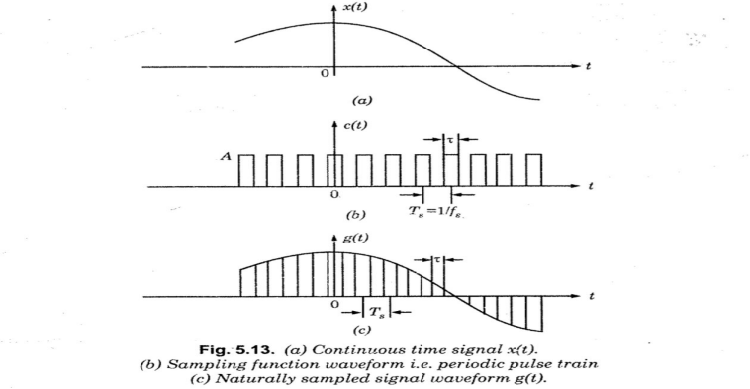
- Natural sampling or chopper sampling, The sampling function in this type is a train of periodic pulses of width and frequency equal to Fs Hz. also should consider the pulse has a finite width, It is practical method but is hard also called practical sampling.

- Flat Top Sampling or Rectangular pulse sampling this is also a practically possible sampling method called practical sampling. it is very easy to get flat top samples the top of the samples remains constant and equal to instantaneous value of baseband signal x(t) at the start of sampling. The duration of each sample is and sampling rate is equal to Fs = 1/Ts.The CKT used to generate this type is called Sample and Hold CKT.
Flat top sampled method:
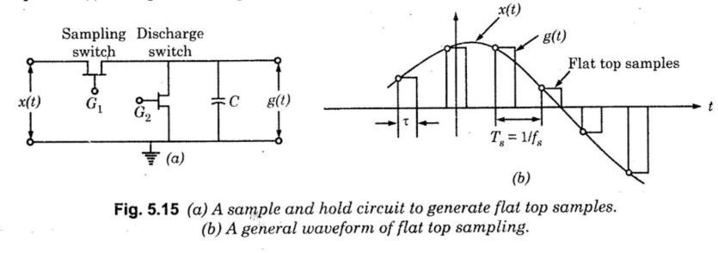
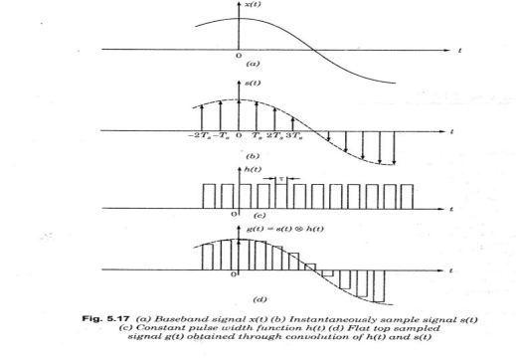
Flat sampling method:
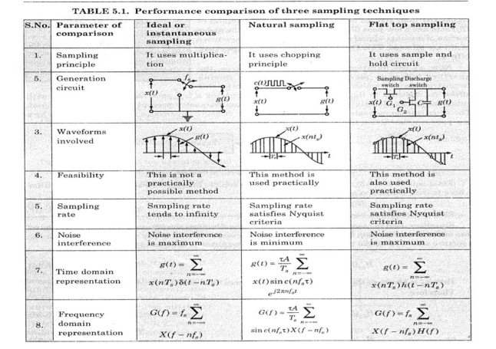
Performance comparison of three sampling techniques

Chapter 4 :Analog pulse Modulation Methods

A continuous time signal x(t) to be transmitted, is sampled by a pulse train at frequency Fs sufficiently above the highest frequency present in X(t), The amplitude of the modulating signal x(t) modulates one parameter of the pulse train.

The parameters are : Amplitude, Duration (width) and position.
- If the modulating signal modulate the amplitude of the pulse train then the modulation type is called Pulse Amplitude Modulation PAM
- If the modulating signal Modulate the Duration of the pulse train then the modulation type is called Pulse Duration Modulation PDM
- If the modulating signal Modulate the position of the pulse train then the modulation type is called Pulse Position Modulation PPM

Different types of analog pulse modulation techniques (للاطلاع)
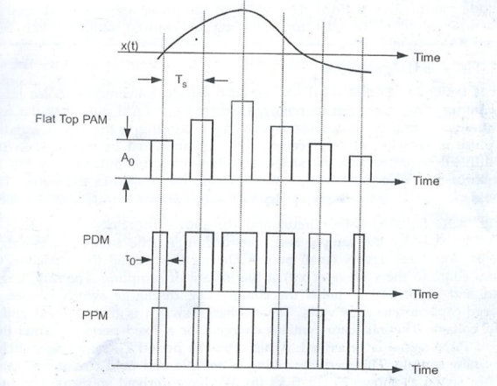
Pulse Amplitude Modulation PAM
- the amplitudes of regularly spaced rectangular pulses vary with the instantaneously sample values of a continuous message signal in a one to one fashion.
- The width of the pulse remains fixed.
- Both types of practical sampling, flat top sampling or Natural sampling can be used to generate PAM signal.

Flat Top Sampled PAM
- It is better to use Flat Top PAM , because during transmission noise interferes the top of pulses. This noise interreference can be removed easily if the PAM pulse has flat top.
- Sample and hold circuit is used to generate the flat top PAM

Transmission Bandwidth of PAM signal
- The pulse duration “ꞇ” is supposed to be very small compared to time period Ts between the two samples.
- If the maximum frequency in the signal x(t) is Fm then by sampling theorem: (اشتقاق فقط للاطلاع)
  - Fs ≥ 2Fm
  - Ts ≤ 1 /(2Fm)
  - Fs = 1/Ts
  - And ꞇ = Ts = 1/(2Fm)
- If ON and Off time of the pulse is same , then frequency of the PAM pulse Becomes:
  - fmax=1/(ꞇ + ꞇ )=> 1/(2 ꞇ )
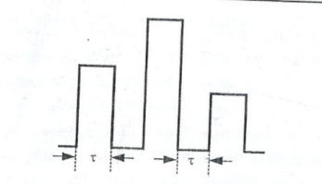
- Bandwidth required for transmission of PAM signal will be equal to maximum frequency Fmax given by above equation
  - BT ≥ F max hence BT ≥ 1/(2 ꞇ )
  - Since ꞇ =1/(2Fm)
  - BT ≥ 1/(2 ꞇ ) = Fm
  - Transmission bandwidth of PAM signal : BT = Fm

Disadvantages of PAM
- The bandwidth needed for transmission of PAM signal is very very large compared to its maximum frequency content.
- The amplitude of PAM pulses varies according to modulating signal, therefore interference of noise is maximum for the PAM signal and this noise cannot be removed very easily.
- Since amplitude of PAM signal varies , this also varies the peak power required by the transmitter with modulating signal.

Pulse Duration and Pulse Position Modulation
- Pulse Position Modulation (PPM) and Pulse Duration Modulation(PDM) or (PWM) both modulate the time parameter of the pulses.
- PPM has fixed width pulses where as width of PDM pulses varies.
- Both the methods are of constant amplitude.

Generator of PPM and PDM, Block Diagram and Waveform
(للاطلاع)
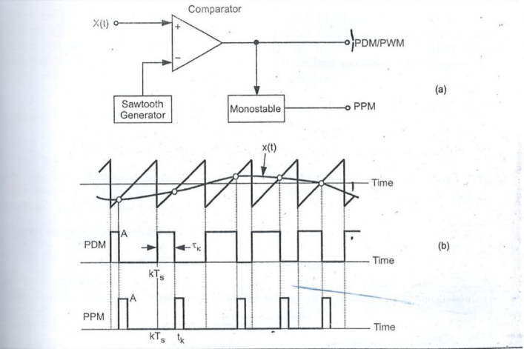

Transmission bandwidth of PDM and PPM

• Both PPM and PDM needs a sharp rise time and fall time for pulses in order to
preserve the message information.

• Rise time should be very – very less than Ts
tr << Ts
And Transmission Bandwidth, BT should be,

BT ≥ $\frac{1}{2tr}$

tr​: Rise time of the pulse
Ts​: Symbol (sampling) period

Thus the transmission band width of PPM and PDM is higher than PAM

Comparison of PAM & PPM & PDM
Feature | Pulse Amplitude Modulation | Pulse width/Duration Modulation | Pluse Position Modulation
Waveform | 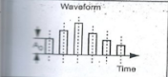 | 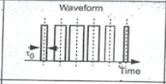 | 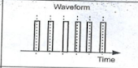
Amplitude | Proportional to amplitude of modulating signal | Width proportional to amplitude of modulating signal | Position proportional to amplitude of modulating signal
Bandwidth | Depends on rise time and width of pulse | Depends on rise time of pulse | Depends on rise time of pulse
Instantaneous Power | Varies | Varies | Remains constant
Noise Interference | High | Minimum | Minimum
System Complexity | Complex | Simple | Simple
Similarity | Similar to amplitude modulation | Similar to frequency modulation | Similar to phase modulation

Examples
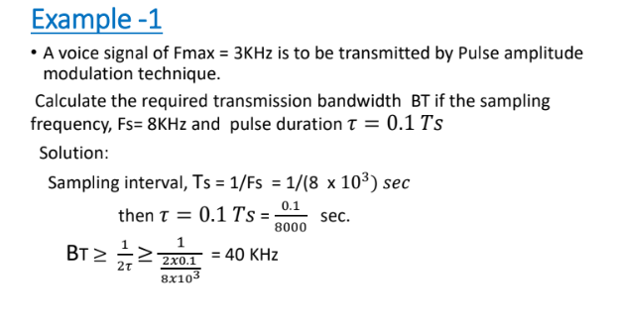

EX2:
Sketch the naturally sampled pam waveform that results from sampling a 1 khz sine wave of peak value equal 5 at 4 khz rate. A cso sketch the flat top sampled waveform. Take duty cycle ($\frac{ꞇ}{Ts}$ = $\frac{1}{5}$)
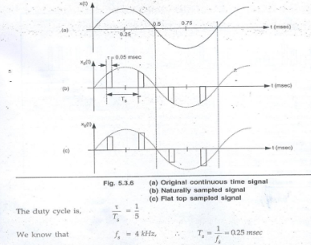
Solution :
The equation for given waveform x(t),
x(t) = 5 sin(2ℼ1000t)=5sin(2ℼ*1*10³t)
؞ T_{o} = $\frac{1}{fo}$ = $\frac{1}{1000}$ = 1x10⁻³sec = 1msec.
We have sample duration = t_{o} = 0.25 msec.
Sample interval T_{s} , $\frac{ꞇ}{Ts}$ = $\frac{1}{5}$
؞ $ꞇ$ = T_{s} x $\frac{1}{5}$ = 0.25 x $\frac{1}{5}$ = $\frac{0.25}{5}$ = 0.05 msec.
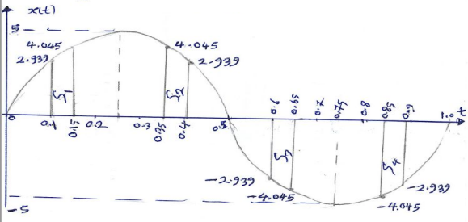

sample | Ts.s msec | X(t) | Ꞇ | x(t)
1 | 0.1 | x(t) = 5sin(2π*10³*0.1*10⁻³)  = 5sin(2π*0.1)  = 5sin(0.2π)  =2.939 | 0.1+0.05  =0.15 | x(t)=5sin*  (2𝜋*0.15)  =5sin(0.3𝜋)  =4.045
2 | 0.1+0.25  = 0.35 | x(t) = 5sin(2π*0.35)  = 5sin(0.7π)  =4.045 | 0.35+  0.05=  0.4 | x(t)=5sin*  (2𝜋*0.4)  =2.939
3 | 0.1+0.5  = 0.6 | x(t) = 5sin(2π*0.6)  = 5sin(1.2π)  =-2.939 | 0.6+0.05  =0.65 | x(t)=5sin*  (2𝜋*0.65)  =5sin(1.3𝜋)  =-4.045
4 | 0.1+0.75  = 0.85 | x(t) = 5sin(2π*0.85)  = 5sin(1.7π)  =-4.045 | 0.85+  0.05  =0.9 | x(t)=5sin*  (2𝜋*0.9)  =5sin(1.8𝜋)  =-2.939

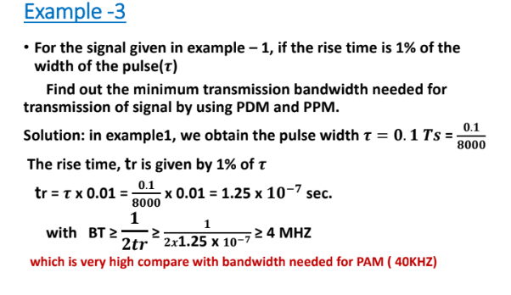

قوانين فصل 4:
fmax​=$\frac{1}{2ꞇ}$

minimum required bandwidth :
BT​=Fm​

Transmission bandwidth of PDM and PPM
BT=$\frac{1}{2tr}$

Chapter 5 :MULTIPLEXING
Multiplexing may be defined as a technique which allows many signals (users) to share a communication channel simultaneously.
There are two major types of multiplexing:
- Frequency Division Multiplexing ( FDM )
- Time Division Multiplexing ( TDM )

Frequency Division Multiplexing (FDM)
- FDM : this technique permits a fixed frequency band to every user in the complete channel Band.
- It mainly used for modulated signal broadcasting, TV broadcasting

Time Division Multiplexing (TDM)
- In PAM, PPM and PDM, the pulse is present for a short duration and for most of the time between the two pulses, no signal is present.
- This free space between the pulses can be occupied by pulses from other channels.
- This is known as Time Division Multiplexing TDM
- Thus, TDM makes maximum utilization of the transmission channel.

Comparison TDM with FDM
- In FDM , All the signals are transmitted simultaneously over same communication channel, and the signals occupy frequency slots.
- In TDM, signals to be multiplexed are transmitted sequentially one after the other.
- Each signal occupy a short time slot.
- In TDM the complete bandwidth of the communication channel is available to each signal be transmitted.
- Conceptual Diagram
- Concept of Frame in TDM
Frame is the time period required to transmit all the signals once on the transmission channel.
Each frame is completed in Ts seconds
- The TDM system can be used to multiplex analog or digital signals.
Concepts - Conceptual Diagram -Frame(للاطلاع)
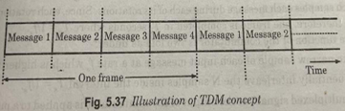Concept of Frame in TDM
- Frame is the time period required to transmit all the signals once on the transmission channel.
- Each frame is completed in Ts seconds
- The TDM system can be used to multiplex analog or digital signals.
A PAM/TDM SYSTEM
THIS SYSTEM COMBINES THE CONCEPTS OF PAM & TDM(صور تالية مهمة)
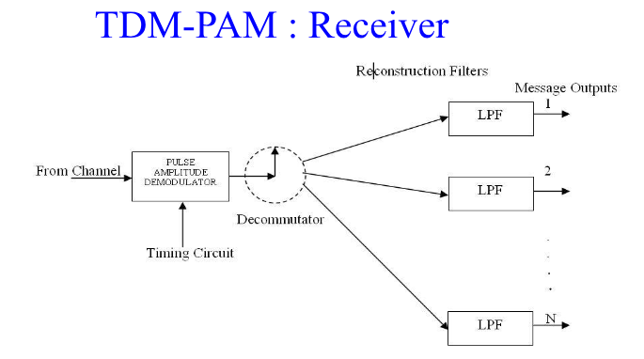
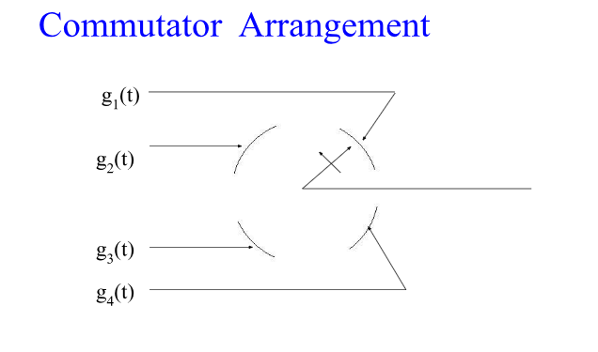

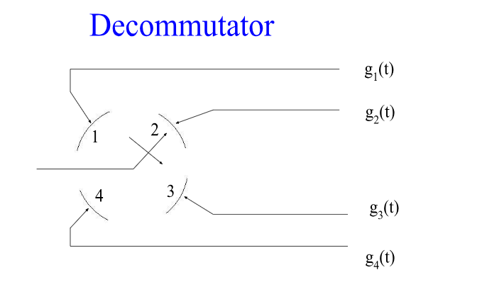
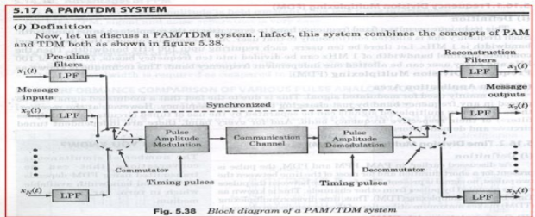

Working principle
- The multiplexer is s single pole rotating switch or commutator.
- It can be mechanical or electronic switch rotate at Fs rotation per second
- As the switch arm rotates, it is going to make contact with the points 1,2,3or N for a short time
- If there are N signals connected to these contact points, hence the switch arm will connect these N input signals one by one to the communication channel.
- Hence, the rotating switch samples each message during each of its rotations
- Since each rotation corresponds to one frame, therefore, one frame is completed in Ts second where Ts=1/Fs
- Hence the function of the commutator is two:
- To take narrow sample of each input message at a rate Fs
- To sequentially interleave the N samples inside the interval Ts=1/Fs.
(صور تالية للاطلاع)
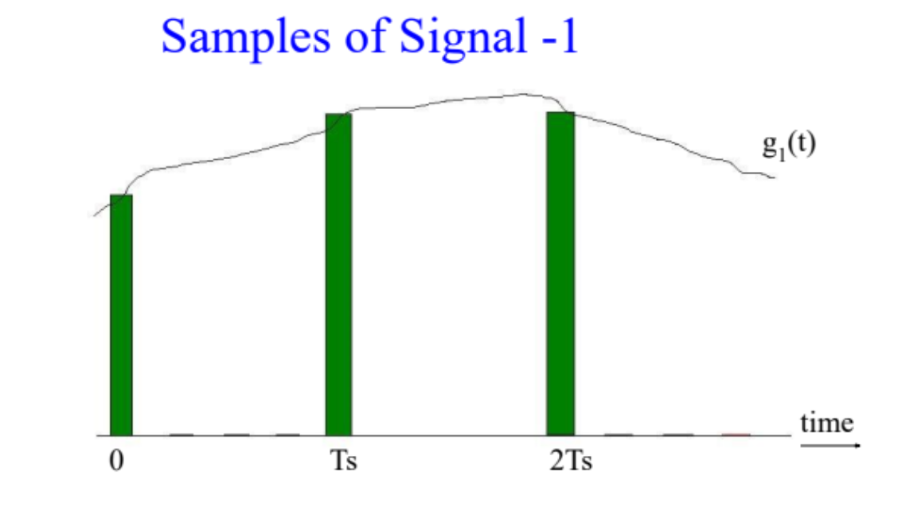
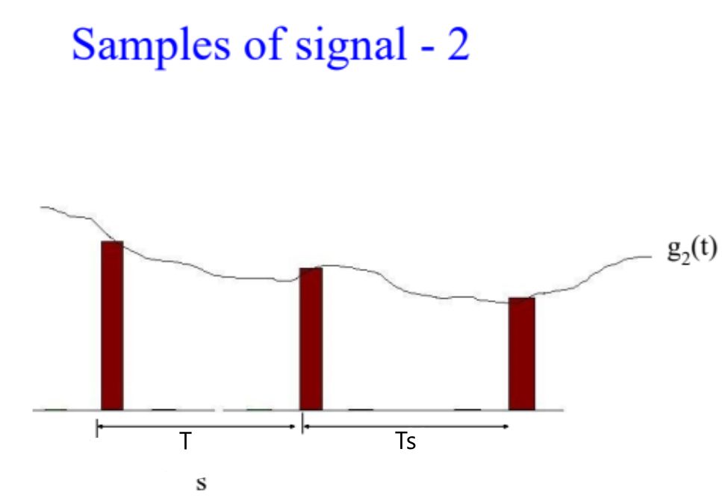
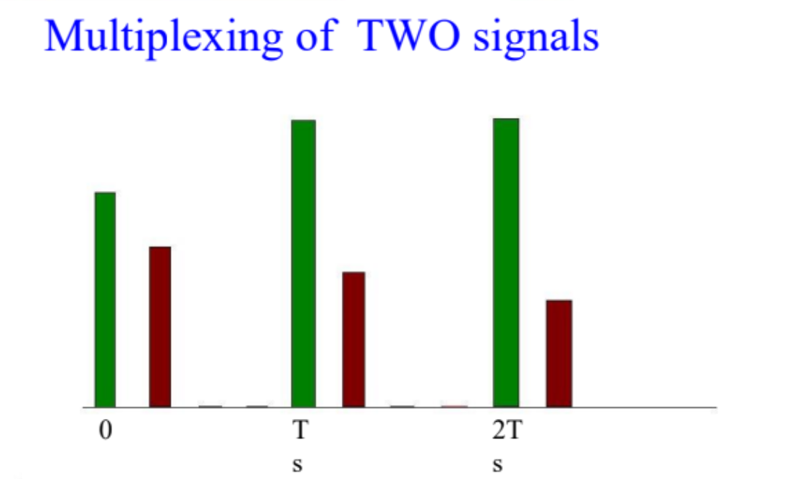

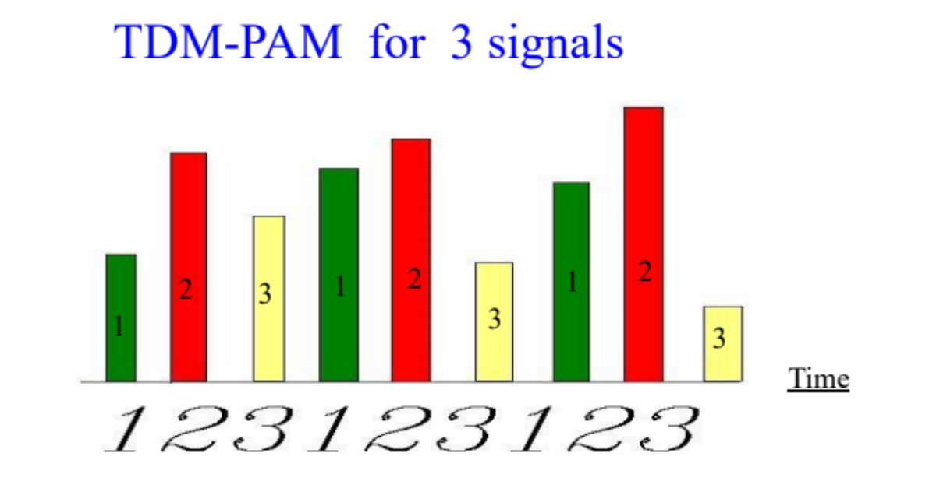

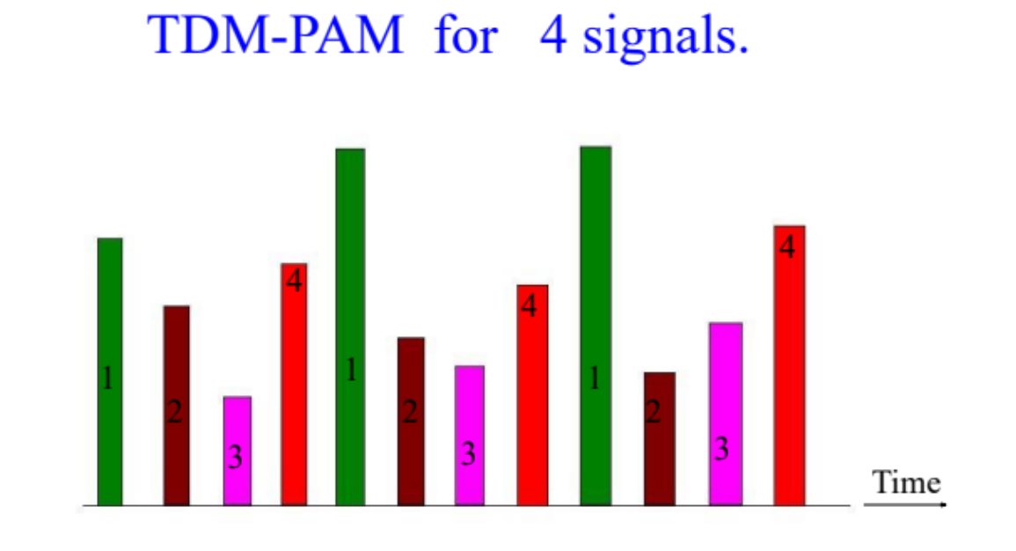

Signaling rate (r)

1. Signaling Rate (r):
- The signaling rate is the number of pulses transmitted per second.
- Signaling Rate (baud)=$\frac{Bit Rate (bps)​}{Bits per Symbol}$
- Given Fm​ as the maximum frequency of the input signals X1​ to Xn​, the sampling frequency Fs​ must satisfy the Nyquist criterion, so Fs​>2Fm​.
- The commutators rotate at Fs​ rotations per second. Each rotation corresponds to one complete frame, which includes samples from all N input signals.

2. Frame and Pulse Definitions:
- 1 Rotation of Commutator: This corresponds to one frame that contains one sample from each of the N input signals.
- 1 Frame Period (Ts​): The duration of one frame is Ts=$\frac{1}{Fs}$​ seconds.
- Number of Pulses in One Frame: Each frame contains N pulses, one from each input signal.

3. Pulse to Pulse Spacing:
- The pulse-to-pulse spacing within a frame is given by:
Pulse to pulse spacing = $\frac{Ts}{N}$ = $\frac{1}{NFs}$
4. Pulse Duration:
- The duration of each pulse is equal to the pulse-to-pulse spacing:
Pulse duration=$\frac{1}{NFs}$​

5. Signaling Rate Calculation:
- The number of pulses transmitted per second can be calculated as:
Signaling rate (r)= $\frac{1}{Pulse duration}$= NFs pulses per second

6. Minimum Condition for Fs​:
- Since Fs ≥ 2Fm​ (by Nyquist sampling theorem), the signaling rate becomes:
r ≥ 2NFm pulses per second

7. Transmission Bandwidth of PAM/TDM Channel:
- The minimum transmission bandwidth BW for a PAM-TDM system is half the signaling rate:
BW= $\frac{1}{2}r$
Substituting the minimum signaling rate r:
BW≥$\frac{1}{2}$(2NFm)=NFm

Synchronization and its Signification in PAM/TDM system
- The multiplexed PAM signals can be received properly if and only if the transmitter and receiver commutators are synchronized to each other in terms of the speed and the position.
- In order to ensure synchronization, a marker pulse is introduced at the end of each frame in the transmitted signals.
- The amplitude of this pulse is kept higher than the maximum permissible amplitude of the multiplexed signals
- At the receiver, the received signal is compared with a DC reference level.
- The comparator responds to only the marker pulse to produce pulse.
(للاطلاع)
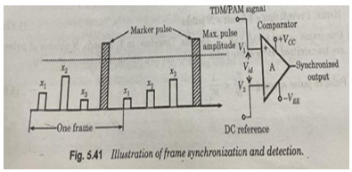
Crosstalk in a PAM/TDM system
- Crosstalk basically means interference between adjacent signals
- It is an unwanted coupling of information from one channel to other.
- To prevent crosstalk, a guard time Tg, is introduced between the adjacent TDM signals.
Important points
Salient Features and Drawbacks of TDM
- Salient Features
- Full available channel Bandwidth can be utilized for each signal
- Intermodulation distortion is absent
- TDM circuitry is not very complex
- The problem of crosstalk is not sever
- Drawbacks
- synchronization is essential for proper operation
- Due to slow narrowband fading, all the TDM signals may get wiped out

Examples
(جميع رسومات مهمة بدء من هنا الى فصل سادس PCM)
Example 5.9: to analog signals x₁(t) and x₂(t) are to be transmitted over a common channel by means of time division multiplexing (TDM). The highest frequency of x₁ (t) is 4 kHz and that of x₂(t) is 4.5 kHz. What will be the minimum value of permissible sampling rate?

Solution: The highest frequency component of the composite signal consisting of x₁ (t) and x₂(t) is 4.5 kHz. Therefore, the minimum value of permissible sampling rate will be,
f_{s(min)} = 2 x 4.5kHz = 9 kHz Ans.

Example 5.10: a signal x₁(t) is bandlimited to 3 kHz. There are three more signals x₂ (t), x₃ (t)
And x₄(t) which are bandlimited to 1 kHz each. These signals are to be transmitted by a TDM system.

1. Design a TDM scheme where each signal is sampled at its Nyquist rate
2. What must be the speed of the commutator
3. Calculate the minimum transmission bandwidth of the channel.
Solution:
(i)Table 5.3 shows different message signals with corresponding Nyquist rates.

S.No. | Message signal | Bandwidth | Nyquist rate
1. | x₁(t) | 3 kHz | 6 kHz
2. | x₂(t) | 1 kHz | 2 kHz
3. | x₃(t) | 1 kHz | 2 kHz
4. | x₄(t) | 1 kHz | 2 kHz

If the sampling commutator rotates at the rate of 2000 rotations per second then the signals x₂(t),x₃(t) and x₄(t) will be sampled at their Nyquist rate. But, we have to sample x₁ (t) also at its Nyquist rate which is three times higher than that of the other three. In order to achieve this, we should sample x₁ (t) three times in one rotation of the commutator. Therefore, the commutator must have atleast 6 poles connected to the signals as shown in figure 5.44.
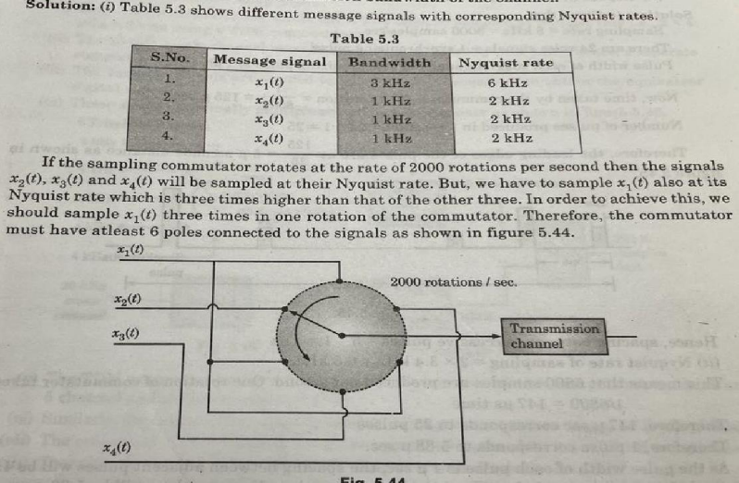
Fig. 5.44.
(ii) The speed of rotation of the commutator is 2000 rotation/sec.
(iii)Number of samples produced per second is calculated as under:
x₁ (t) produces 3 x 2000 = 6000 samples/sec.
x₂(t),x₃(t)and x₄(t) produce 2000 samples/sec. Each.
Therefore, number of samples per second = 6000 + (3 x 2000) = 12000 samples/sec.
؞ Signaling rate = 12000 samples/sec.
(iv) The minimum channel bandwidth will be
BW = $\frac{1}{2}$ (signaling rate) = 12000/2 = 6000Hz Ans.

Example
Twenty- four voice signals are sampled uniformly and then Time Division Multiplexed.
the sampling operation uses flat – top samples with 1 μs. Duration. the multiplexing operation includes provision for synchronization by adding an extra pulse of appropriate amplitude and 1 μs. Duration.
The highest frequency component of each voice signal is 3.4 KHz.
(i) Assuming a sampling rate of 8kHz, calculate the spacing between successive pulses of the multiplexed signal.
(ii) Repeat (i) assuming the use of Nyquist rate sampling.
Solution: (i) Given that
Sampling rate = 8kHz = 8000 samples/sec.
There are 24 voice signals + 1 synchronizing pulse.
Pulse width of each voice channel and synchronizing pulse is 1 us.
Now, time taken by the commutator for 1 rotation = 1/8000 = 125u sec.
Number of pulses produced in 1 rotation = 24 + 1 = 25
Therefore, the leading edges of the pulses are at 125/25 = 5u seconds distance as shown in figure 5.45.
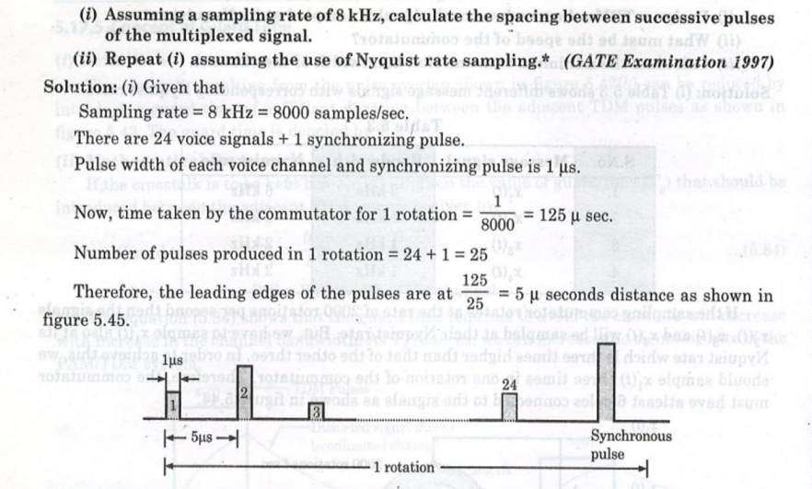
Hence, spacing between successive pulses = 5 - 1 = 4 us
(ii) Nyquist rate of sampling = 2 x 3.4 kHz = 6.8 kHz.
This means that 6800 samples are produced per second. One rotation of commutator takes
1/6800 = 147us time Therefore, 147 u sec corresponds to 25 pulses Therefore, 1 pulse corresponds to 5.88 u sec.
As the pulse width of each pulse is 1 u sec. The spacing between adjacent pulses will be 4.88 u sec and if we assume ꞇ=0 then the spacing between the adjacent pulses will be 5.88 u sec.
Examples 5.12. Six message signals each of bandwidth 5 kHz are time division multiplexed and transmitted. Determine the signaling rate and the minimum channel bandwidth of the PAM/TDM channel.

Solution: The number of channels N=6.
Bandwidth of each channel, f_{m} = 5 kHz
Therefore, minimum sampling rate = 2 x 5 kHz = 10 kHz.
Signaling rate = Number of bits per second
= 6 x 10 kHz = 60 K bits/sec. Ans.
Minimum channel bandwidth to avoid cross talk in PAM/TDM is,
BW = Nf_{m} = 6 x 5 kHz = 30 kHz Ans.

Example 1:
The following signals are sampled each at its Nyquist rate and multiplexed and
transmitted by using TDM:
S1(t) bandlimited to 1.8 KHz
S2(t) bandlimited to 3.6 KHz
S3(t) bandlimited to 0.6 KHz
S4(t) bandlimited to 0.6 KHz
S5(t) bandlimited to 0.6 KHz

Solution: number of pieces
Fs for S1(t)= 2*fmax =2*1.8=3.6KS/sec 3
Fs for S2(t)= 2*fmax =2*3.6=7.2KS/sec 6
Fs for S3(t)= 2*fmax =2*0.6=1.2KS/sec 1
Fs for S4(t)= 2*fmax =2*0.6=1.2KS/sec 1
Fs for S5(t)= 2*fmax =2*0.6=1.2KS/sec 1
The sum of pieces= 12
12/3=4, 12/6=2, 12/1=12
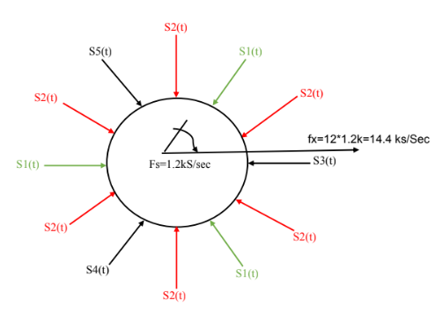
Ts=1/1.2
Tx= (1/1.2)/12 = 1/14.4msec
Fx= 14.4 K S/sec
BW= 1⁄2 fx = 1⁄2 * 14.4 = 7.2KHz
Other solution:
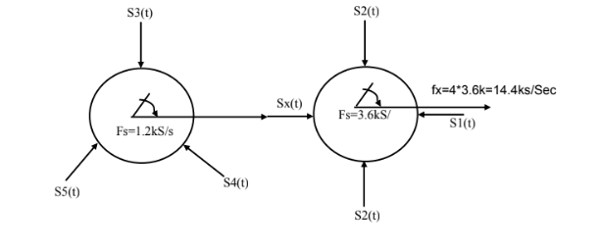
Ts=1/3.6
Tx= (1/3.6)/4 = 1/14.4msec
Fx= 14.4 K S/sec (Or Fx= Fs* number of pieces= 3.6*4 = 14.4 KS/sec )
BW= 1⁄2 fx = 1⁄2 * 14.4 = 7.2KHz

Example 2:
The following signals are sampled each at its Nyquist rate and multiplexed and
transmitted by using TDM:
S1(t) bandlimited to 4.8 KHz
S2(t) bandlimited to 2.4 KHz
S3(t) bandlimited to 0.6 KHz
S4(t) bandlimited to 0.6 KHz
S5(t) bandlimited to 0.6 KHz
S6(t) bandlimited to 0.6 KHz

Solution: number of pieces
Fs for S1(t)= 2*fmax =2*4.8=9.6KS/sec 8
Fs for S2(t)= 2*fmax =2*2.4=4.8KS/sec 4
Fs for S3(t)= 2*fmax =2*0.6=1.2KS/sec 1
Fs for S4(t)= 2*fmax =2*0.6=1.2KS/sec 1
Fs for S5(t)= 2*fmax =2*0.6=1.2KS/sec 1
Fs for S6(t)= 2*fmax =2*0.6=1.2KS/sec 1
The sum of pieces= 16
16/8=2, 16/4=4, 16/1=16

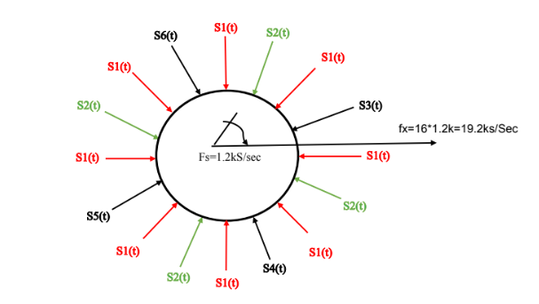
Fx= Fs* number of pieces= 1.2*19 = 19.2 KS/sec
BW= 1⁄2 fx = 1⁄2 * 19.2= 9.6 KHz
Other solution
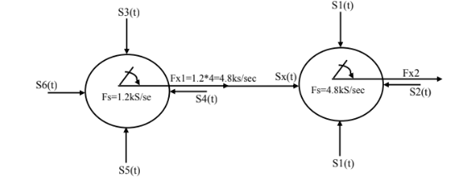
Fx2= 4.8*4=19.2KS/sec
BW= 1⁄2 fx2 = 1⁄2 * 19.2= 9.6 KHz

Example 3:
The following 36 channels are to be multiplexed using TDM:
1 channel sampled at 8KHz
1 channel sampled at 4KHz
18 channel sampled at 1KHz
16 channel sampled at 0.125KHz
Solution:
First, we notice that every channel was sampled which mean that the above frequencies given are Fs.

To solve this example, we have 16 channels sampled at 0.125KHz will sub-commutation firstly.
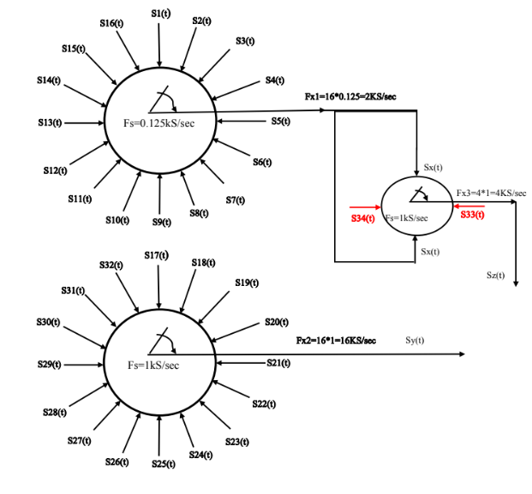
If we looking at the remaining signals and the produced signals from the above
TDM system we have:

number of pieces
1 channel sampled at 8KHz [Sa(t)] 2
1 channel sampled at 4KHz [Sb(t)] 1
1 channel sampled at 16KHz [Sy(t)] 4
1 channel sampled at 4KHz [Sz(t)] 1
The sum of pieces = 8
8/2=4 , 8/1=8 , 8/4=2
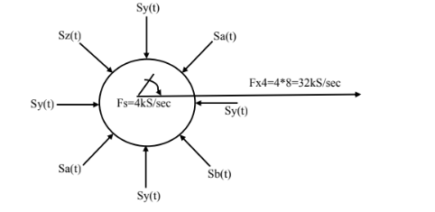
BW= 1⁄2 fx4 = 1⁄2 * 32= 16 KHz

If the above example was modified to be, Design TDM system to transmit these channels:

1 channel sampled at 8KHz
18 channel sampled at 1KHz
16 channel sampled at 0.125KHz

The solution would be the as the first part of the previous example, the difference would be in the second part:

number of pieces
1 channel sampled at 8KHz [Sa(t)] 2
1 channel sampled at 16KHz [Sy(t)] 4
1 channel sampled at 4KHz [Sz(t)] 1
The sum of pieces = 7

We notice that the summation of pieces divisible with remainder. To solve this problem, we add an additional channel which called ground (GND) to the other
channels so the sum of pieces =8

number of pieces
1 channel sampled at 8KHz [Sa(t)] 2
1 channel sampled at 16KHz [Sy(t)] 4
1 channel sampled at 4KHz [Sz(t)] 1
1 channel GND 1
The sum of pieces = 8

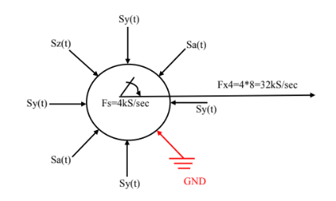
BW= 1⁄2 fx4 = 1⁄2 * 32= 16 KHz
Sampling and TDM Quiz

Four (4) sinusoidal signals (in phase):
x₁(t) = 1 sin (2π1000t), x₂(t) = 3 sin(2π1000t)
x₃(t) = 6 sin (2π1000t), x₄(t) = 9 sin(2π1000t)
are sampled and Time Division Multiplexed at Fs= 4KHZ
The four signal are connected to a commutator with the sequence that:
The first one at 45º, the second at 135º, the third at 225º and the fourth at 315º
The synchronization is done by adding a mark pulse at 345.6º
The contact time for each signal and mark generator is 0.01 msec.

Solve for:
1. Sketch the TDM system scheme
2. Find the value of each sample (at beginning and end)
3. Draw the time diagram of sampled signal
4. Find the signaling rate and bandwidth of the multiplexed signal.

sol:
Ts = $\frac{1}{Fs}$ =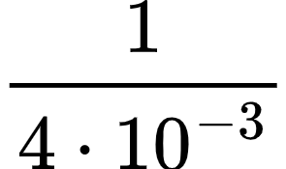 = $\frac{1}{4}$ * 10⁻³
T = 0.25 msec
S₁ = $\frac{45}{360}$ * 0.25m = 0.03125m
X₁ (t) = 1 sin(2ℼ*10³*0.03125 * 10⁻³)
= 1 sin (2ℼ* 0.03125)
X₁ (t) =0.19499 → S₁

S₂=$\frac{135}{360}$ * 0.25m = 0.09375msec
X₂(t) =3sin (2ℼ*10³*0.09375*10⁻³)
X₂(t) =3sin (2ℼ*0.09375)
X₂(t) =1.665 → S₂

S₃=$\frac{225}{360}$ * 0.25m = 0.15625msec
X₃(t) =6sin (2ℼ*10³*0.15625*10⁻³)
X₃(t) =6sin (2ℼ*0.15625)
X₃(t) =4.987 → S₃

S₄=$\frac{315}{360}$ * 0.25m = 0.20625msec
X₄(t) =9sin (2ℼ*10³*0.20625*10⁻³)
X₄(t) =9sin (2ℼ*0.20625)
X₄(t) =8.66 → S₄

S₅ marker = $\frac{345.6}{360}$* 0.25m = 0.25msec
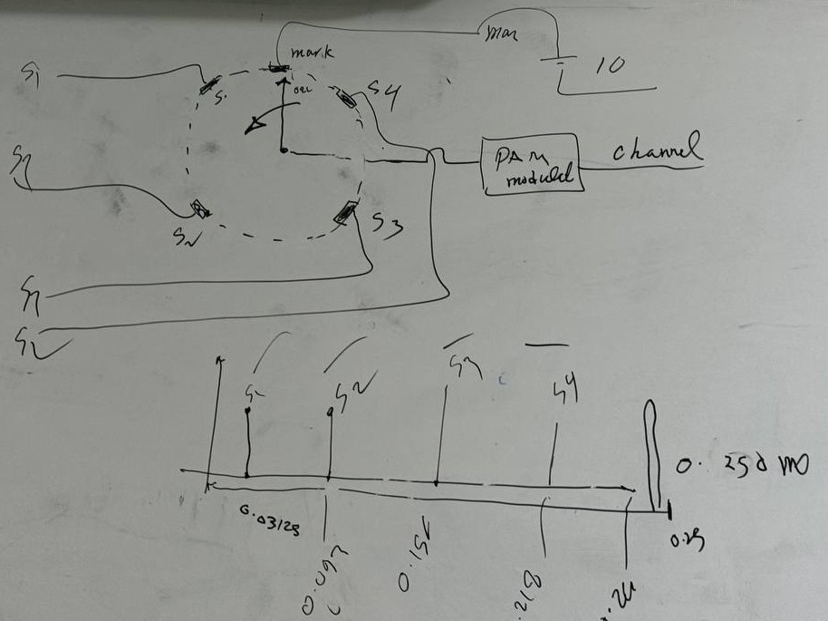
Ts = 0.25m
Tx=$\frac{Ts}{N}$ = 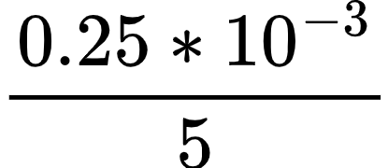 = 0.05m
r= $\frac{1}{Tx}$ = 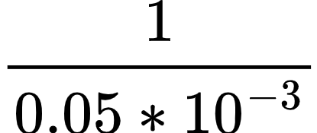 = 20k
Bus = $\frac{1}{2}$ r = $\frac{1}{2}$ 20k = 10khz

Sampling and TDM Quiz
Four (4) sinusoidal signals (in phase):
x1(t)= 2 sin (2𝝅 1000t), x2(t) = 4 sin(2𝝅 1000t)
x3(t)= 6 sin (2𝝅 1000t), x4(t) = 8 sin(2𝝅 1000t)
are sampled and Time Division Multiplexed at
Fs= 4KHZ
The four signal are connected to a commutator with the sequence that:
The first one at 45º, the second at 135º, the third at 225º and the fourth at 315º The synchronization is done by adding a mark pulse at 345.6º
The contact time for each signal and mark generator is 0.01 msec.

Solve for:
1. Sketch the TDM system scheme
2. Find the value of each sample (at beginning and end) 3. Draw the time diagram of sampled signal
4. Find the signaling rate and bandwidth of the multiplexed signal.
Since Fs= 4KHZ then Ts = 1/4x10³ sec. = 0.25 msec.
The commutator complete 1 revolution within this time. ( 360ºin 0.25 msec. )

The commutator start contact x1(t) at t=( 45/360 ) *0.25 = 0.03125 msec.
The time for each degree = 0.25 /360 msec.

The commutator end contact x1(t) at t = 0.03125 + 0.01 = 0.04125 msec.
The same for x2(t), x3(t) and x4(t)
For mark pule, it starts at t= (345.6/360) x 0.25 = 0.24 msec. It ends at t =0.24 +0.01 = 0.25
Signal | Start time (msec.) | End time (msec.)
X1(t) | 0.03125 | 0.04125
X2(t) | 0.21875 | 0.22875
X3(t) | 0.15625 | 0.16625
X4(t) | 0.21875 | 0.22875
Mark pulse | 0.24 | 0.25

قوانين فصل خامس
Signaling Rate (baud) = $\frac{Bit Rate (bps)​}{Bits per Symbol}$
Pulse to pulse spacing = $\frac{Ts}{N}$
Pulse duration=$\frac{1}{NFs}$​
Signaling rate (r)= $\frac{1}{Pulse duration}$= NFs pulses per second
r ≥ 2NFm pulses per second
minimum transmission = BW= $\frac{1}{2}r$

Chapter 6 : PULSE DIGITAL
MODULATION or PULSE CODE MODULATION
To transport an information signal from one point to another over a communication channel, we can use digital or analog techniques.

The use of digital communication offers several advantages as compared with to analog communication. such as:
- ruggedness to channel noise
- flexible operation of the system
- common format for all information source
- security of information during the transmission.

To transmit analog signal by digital communication system , the signal has to undergo an analog to digital conversion.

In PAM the analog signal is converted from analog form( analog in amplitude and time ) to signal discrete in time and analog in amplitude.

To completely conversion of analog signal to digital one, addition process called waveform coding technique is required.

Pulse Code Modulation PCM
The process of coding sampled signal ( conversion to digital form) can be done by Pulse Code Modulation (PCM)

In, PCM the message signal pass through three process:
a. sampling - conversion of analog signal ( in both amplitude and time ) to a signal discrete in time analog in amplitude
b. Quantization - conversion of signal analog amplitude to discrete by rounding off the analog amplitude to nearest one of a finite set of allowable values known as quantization levels.
c. Encoding - conversion of discrete amplitudes(quantized) to digital form (0,1)
(مهم)
Figure 4.21 Components of PCM encoder
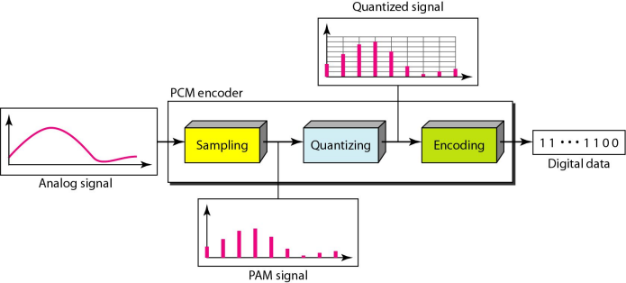

Sampling (اعادة سريعة)
is the process of converting a continuous-time analog signal into a discrete-time signal by taking measurements at specific intervals. According to the sampling theorem, the sampling frequency Fs​ must be at least twice the maximum frequency Fm​ of the signal (Fs≥2Fm​) to accurately capture the signal without losing information.
- Sampling Interval (Ts​): The time between each sample, calculated as Ts=$\frac{1}{Fs}$. This is the interval at which the analog signal is sampled.
- Sampling Frequency (Fs​): The rate at which samples are taken, defined as Fs=$\frac{1}{Ts}$​.
- Sample Amplitude: The amplitude of each sample depends on the signal's value at the exact time of sampling. While the signal becomes discrete in time, its amplitude remains analog (continuous values).
Types of Sampling:
- Ideal Sampling: Uses an impulse at each sampling instant to measure the signal.
- Natural Sampling: A short-width pulse captures the amplitude of the signal, varying with time.
- Flattop Sampling: Similar to natural sampling but holds the sampled value constant, resulting in a "step" effect.
Pulse Amplitude Modulation (PAM):
The process of sampling and holding the amplitude is known as PAM, where the signal retains analog (non-integer) amplitude values.
Quantization
- Sampling: Creates a series of pulses with varying amplitude values that lie between a minimum and a maximum. The amplitude can take any value within this range, making it continuous.
- Need for Quantization: To represent these amplitude values digitally, they must be mapped to a finite set of known values, since infinite values cannot be handled by digital systems.
- Dividing the Range: The amplitude range from the minimum to the maximum is divided into L zones, each with a height Δ given by:
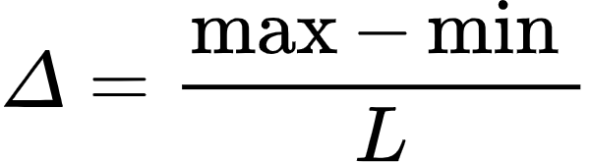
- Quantization Levels: Each zone is assigned a midpoint, which serves as the quantized value. A sample that falls within a particular zone is approximated to the midpoint of that zone.

Encoding
Converting of the quantized samples amplitude to binary.
q = 2^{v}
V : Bits per sample ( Encoding word length).
q : The number of bits per samples determine the number of quantization levels.

Example:( رسم مهم)
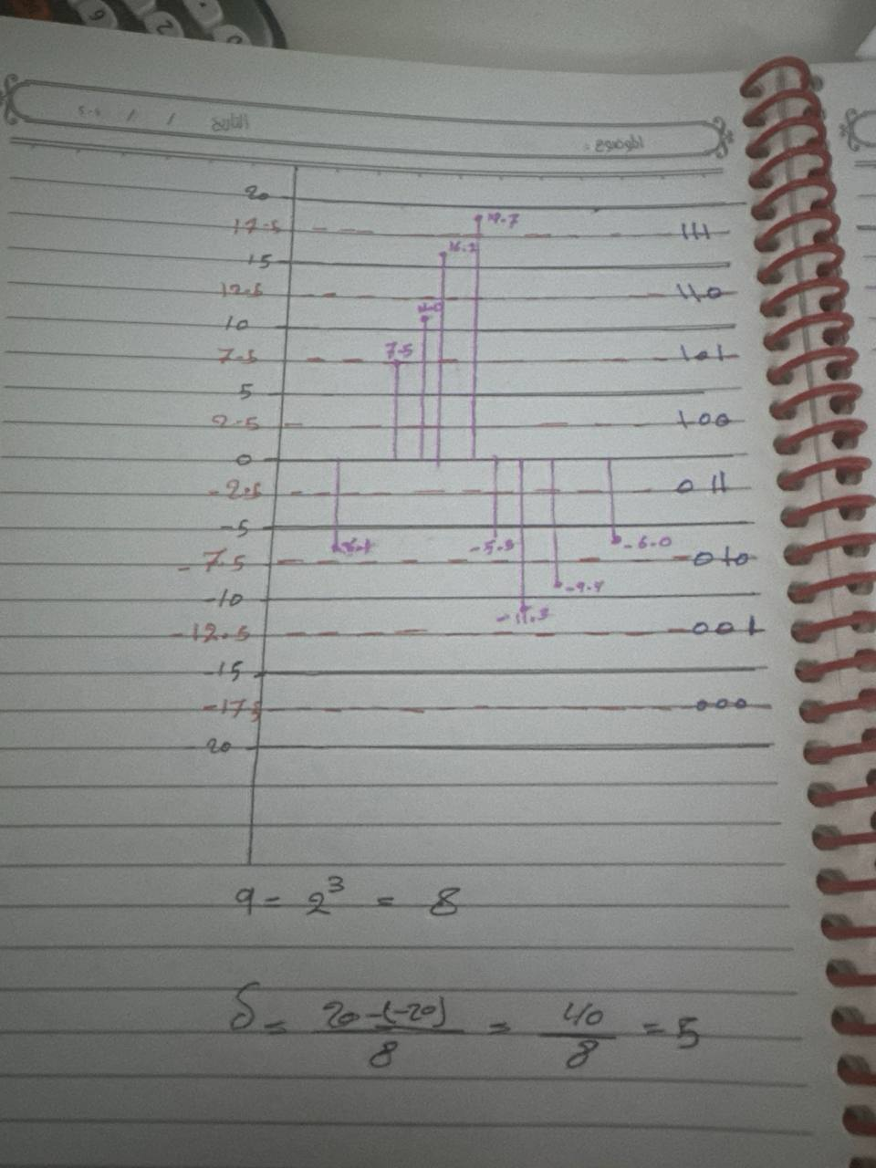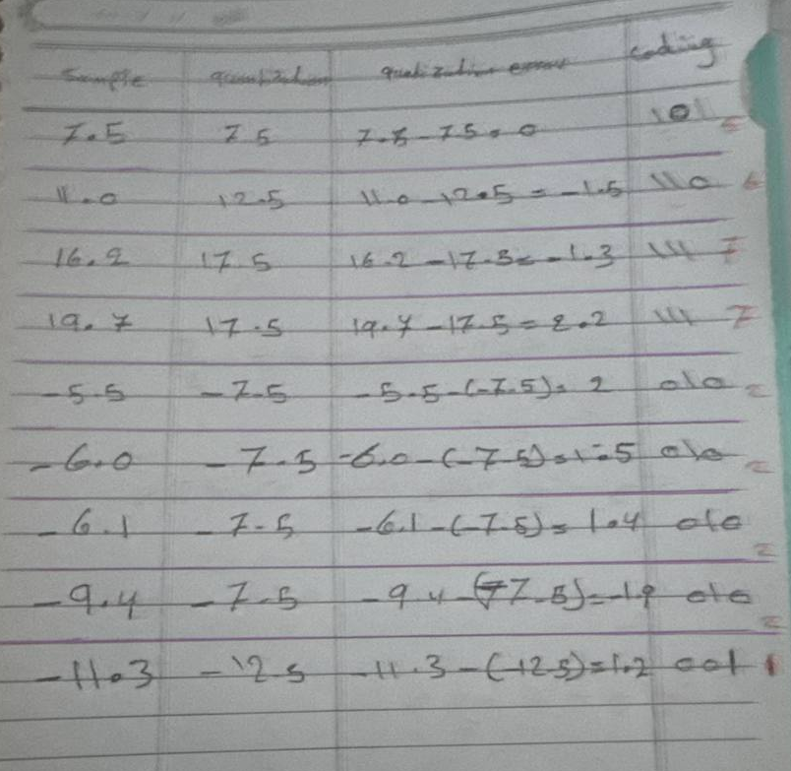
There are some applications of PCM (pulse code modulation) :
- satellite transmission system.
- It is used in space communication.
- It is used in telephony.
- The compact disc (CD) is a recent application of PCM.

قوانين فصل سادس
q = 2^{v}
V : Bits per sample ( Encoding word length).
q : The number of bits per samples determine the number of quantization levels.

X(t) = Am sin(2𝞹*Fm)
ex:
X(t) = 4sin(2𝞹*2000)
Am =4
Fm = 2 *10³

Chapter 7 : Pulse code generator/receiver
PCM generator
What is PCM?
Pulse Code Modulation (PCM) is a method used to convert analog signals (like audio or video) into digital signals. This digital format makes it easier to transmit, store, and process information.

How does a PCM generator work?
- Bandlimiting:
  - The analog signal x(t) is first passed through a low-pass filter.
  - This filter limits the signal's frequency range to a maximum of 'W' Hertz.
  - This step is crucial to prevent aliasing, a distortion that can occur during sampling.
- Sampling:
  - A sample-and-hold circuit takes snapshots of the filtered signal at regular intervals.
  - The sampling rate, Fs, must be at least twice the maximum frequency 'W' (Nyquist-Shannon sampling theorem).
  - This ensures that the original signal can be accurately reconstructed from the sampled values.

- Quantization:
  - The sampled values, which are still analog, are converted into digital values.
  - A quantizer divides the signal's amplitude range into 'Q' discrete levels.
  - Each sample is assigned to the nearest quantization level, introducing a small amount of error called quantization error.
- Encoding:
  - The quantized values are then encoded into binary code.
  - Each binary code represents a specific quantization level.
The Output:
- The output of the PCM generator is a digital bitstream.
- This bitstream can be transmitted over various channels or stored digitally.
(للاطلاع)
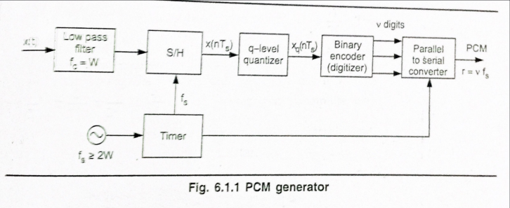

Quantization Error in PCM
- Quantization error occurs because the quantizer can only represent a finite number of levels.
- The error is the difference between the original analog sample and the quantized value assigned to it.
- In the given example, the input signal x(nTs) can take any value between -45 and +45.
- The quantizer has 8 fixed levels: ±δ/2, ±3δ/2, ±5δ/2, and ±7δ/2.
- The step size δ determines the distance between adjacent levels.
- If the input sample falls exactly on one of the quantization levels, there is no error.
- However, if the input sample lies between two levels, it is assigned to the nearest level, resulting in quantization error.
Maximum Quantization Error:
- The maximum quantization error occurs when the input sample is halfway between two levels.
- In this case, the error is half the step size δ/2.
- So, the maximum quantization error is ±δ/2.
Illustration from the Image:
- If x(nTs) = 45, the quantizer assigns it to the nearest level, which is 7δ/2. The error is δ/2.
- If x(nTs) = -45, the quantizer assigns it to the nearest level, which is -7δ/2. Again, the error is δ/2.
Reducing Quantization Error:
- To reduce quantization error, we can increase the number of quantization levels. This makes the step size smaller, resulting in finer granularity and less error.
- However, increasing the number of levels also increases the number of bits required to represent each level, which can lead to higher data rates.
Maximum quantization error = $ɛ$max = [$\frac{Ꟙ}{2}$ ]
(للاطلاع)
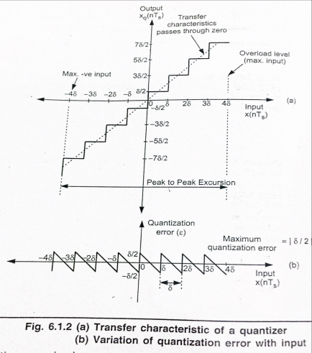
Transfer characteristic of a quantizer and variation of quantization error with input
Calculating Signaling Rate:
- Bits per Sample: Each sample is represented by 'v' bits.
- Bits per Second (Signaling Rate):
  - To calculate the total number of bits transmitted per second, we multiply the number of samples per second (Fs) by the number of bits per sample (v).
  - Signaling Rate (r) = Fs * v
PCM Transmission Bandwidth:
This is the minimum bandwidth required to transmit the PCM signal without significant distortion.
Relationship between BT and r:
the transmission bandwidth (BT) should be at least half the signaling rate (r). This is because the bandwidth of a signal is related to its highest frequency component.
Deriving the Formula:(اول ثلاث نقاط لاطلاع ورابع حفظ)
- Transmission Bandwidth: BT ≥ 1/2 * r
- Substituting r = Fs * v => BT ≥ 1/2 * (Fs * v)
- Applying the Sampling Theorem (Fs ≥ 2W) => BT ≥ 1/2 * (2W * v)
- Simplifying: BT ≥ W * v

PCM Receiver
A PCM receiver is designed to convert a digital bitstream back into an analog signal. Here's a breakdown of the receiver's components and their functions:
- Regenerator:
  - Reshapes the received signal to its original form.
  - Removes noise and interference that may have been added during transmission.
- Serial-to-Parallel Converter:
  - Converts the serial bitstream into parallel data.
  - Each parallel word represents a quantized sample.
- Digital-to-Analog Converter (DAC):
  - Converts the digital code representing each sample into an analog voltage.
  - A sample-and-hold circuit is often used to maintain the voltage level until the next sample is converted.
- Low-Pass Filter:
  - Removes high-frequency components introduced by the quantization process.
  - Reconstructs the original analog signal from the discrete samples.

Limitations and Considerations:
- Quantization Error:
  - The quantization process at the transmitter introduces a fundamental limitation.
  - It's impossible to perfectly reconstruct the original analog signal due to the loss of information during quantization.
  - The quantization error can be reduced by increasing the number of quantization levels (Q).

- Trade-offs:
  - Increasing the number of quantization levels (Q) requires more bits per sample (v).
  - More bits per sample lead to a higher signaling rate (r) and wider transmission bandwidth (BT).
  - This trade-off between signal quality and bandwidth must be carefully considered.

PCM receiver and reconstruction waveform(للاطلاع)
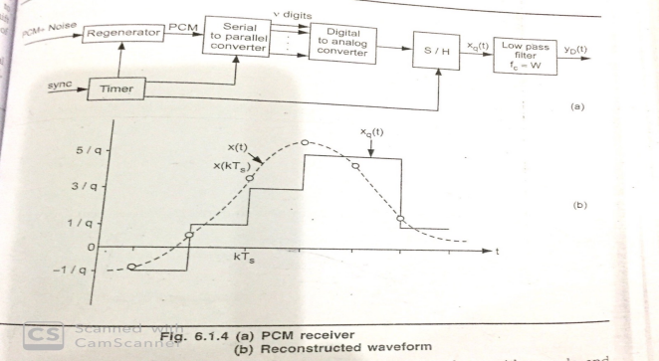

Quantization in PCM with example
The PCM signal is generated by carrying out following basic operations:
1. Band limiting (using LPF)
2. Sampling
3. Quantizing
4. Encoding
Two fundamental processes are involved in the generation of a PCM signal: sampling , quantization and encoding.

Sampling is Time discretization and quantization is Amplitude discretization.
In PCM, conversion of analog signal to digital signal is done in Three steps
▪ Sampling
▪ Quantization and encoding
Below figure shows sampling step: (للاطلاع)
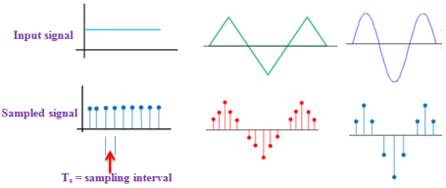

Sampling theorem
Ts = 1/Fs with Fs ≥ 2 Fm
Quantization is the process of rounding of the sample value to the nearest quantization level.
Remember that number of quantization levels is predefined according to allocated bit per sample ( n or v)
If n = number of bits used to represent the sample
Then, q = number of quantization levels = 2^{n}
^{and, Log q = log (}2^{n ) = n Log 2}
n = Log q/Log2
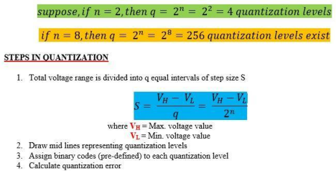
(رسومات Quantization مهمة)
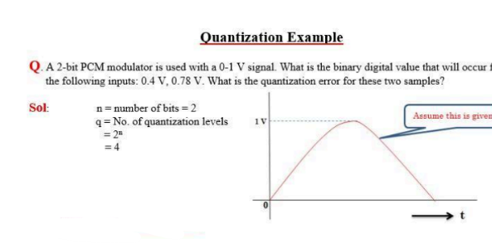
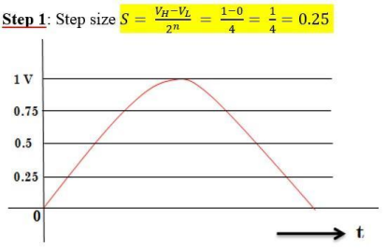
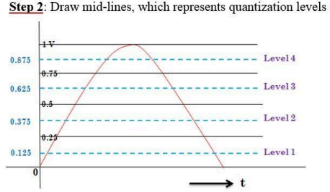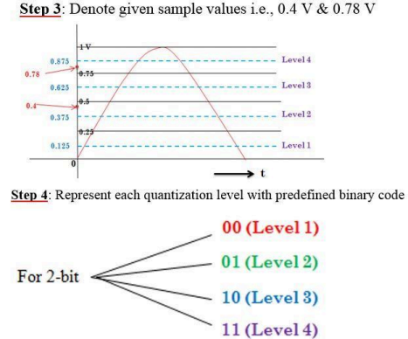
Quantizing 0.4 V sample value:
See that level 2 is near to 0.4 V. So, for sample voltage 0.4 V, 01 code is transmitted.
Quantization error e = 0.4 – 0.375 = 0.025 V
Quantizing 0.78 V sample: Level 4 is nearest to 0.78 V. So, digital code 11 is transmitted.
Quantization error e = 0.875 -0.78 = 0.095 V
NOTE:
Quantization process introduces a certain amount of error or distortion.
This error known as quantization noise and is minimized by increasing the number of quantization levels. But increasing number of quantization levels increases number of bits to represents each sample and hence increases bit rate and cost of transmission.

قوانين فصل سابع
Maximum quantization error = $ɛ$max = [$\frac{Ꟙ}{2}$ ]
Signaling Rate (r) = Fs * v
BT = W * v
W ≤ $\frac{fs}{2}$
q = 2^{n}

Chapter 8: QUANTIZATION NOISE
AND SIGNAL TO NOISE
RATIO

What is Quantization?
Quantization involves mapping a continuous range of signal amplitudes into discrete levels during signal digitization. This introduces a small error known as quantization error (denoted as ε).
General equation for Signal to Noise ratio =$\frac{signal power}{noise power}$
Signal to Quantization Noise ratio = $\frac{S}{N}$=$\frac{Signal power}{Error Noise power}$
- To find above ratio, It is required to find a mathematical expression for both signal power and quantization – error power
- If the Signal power , S denoted by P,
- then it required to find a mathematical expression for the quantization Noise power,

Amplitude Range of the Signal (X(nTs)):
The original continuous signal has an amplitude range from −Xmax to +Xmax+.
- Total range: 2Xmax.

Step Size (δ) Derivation:
- The step size (δ) between consecutive quantization levels is derived as:
δ= $\frac{Xmax - (-Xmax)}{q}$
Uniform Distribution Assumption:
if the step size (δ) is sufficiently small, it is reasonable to assume that the quantization error (ε) will be uniformly distributed.
Maximum Quantization Error:
the maximum quantization error (εmax) as half the step size:
εmax = δ/2
This means that the error will never exceed this value in magnitude.
Error Range:
The error will lie within the range:
-δ/2 ≤ ε_{max} ≤ δ/2
Calculating Noise Power:
The noise power is given by:
Noise power = 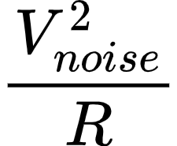
where V²_{noise} is the mean square value of the noise voltage and R is the resistance.
Signal to Quantization Noise Ratio :
S/N = Signal power / Noise power
S/N = $\frac{3P}{{x^{2}}_{max}}$ 2^{2v}

Expressing the singal to noise ratio in decibels,
($\frac{S}{N}$)dB = 10 log₁₀ ($\frac{S}{N}$)dB since power ratio
≤ 10 log₁₀[3 x 2^{2v}]
≤ (4.8 + 6v) dB

Thus,
Signal to quantization noise ratio for normalized values of power ‘P’ and amplitude of input x (t)

: ($\frac{S}{N}$)dB ≤ (4.8) + 6v)dB

قوانين فصل ثامن
Signal to noise Ratio in PCM - Equation
case | Normal equation | dB Equation
General  $\frac{S}{N}$ = $\frac{signal power}{noise power}$ | $\frac{3P}{{x^{2}}_{max}}$ 2^{2v}
Normalized values of power P and amplitude of input x(t) | $\frac{S}{N}$ ≤ 3 x 2^{2v} | ≤ (4.8 + 6v) dB
Sinusoidal input signal | 1.5 x 2^{2v} | = 1.8 + 6v db

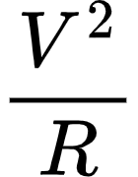
Signal power p=

Noise power = 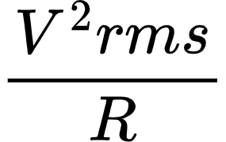

V²rms =$\int_{-∞}^{∞}{}$E² PDF dE or V²rms = 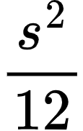

PDF = $\frac{1}{b -a }$ 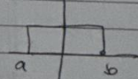

S² = 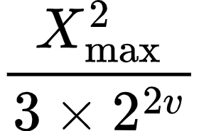

Ꟙ=$\frac{2x_{max}}{q}$

Expressing signal to noise power ratio in dB,
($\frac{S}{N}$)dB = 10 log₁₀ ($\frac{S}{N}$) dB
Chapter 9: PCM Quantization noise and S/N
Ex.6.1.1: Derive the expression for signal to quantization noise ratio for PCM system that employs linear quantization technique. Assume that input to the PCM system is a sinusoidal signal.
Or
A PCM system uses a uniform quantizer followed by a v bit encoder. Show that rms signal to quantization noise ratio is approximately given by (1.8 + 6v)dB.

Sol: Assume that the modulation signal be a sinusoidal voltage, having peak amplitude Am. Let this signal cover the complete excursion of representation levels.
The power of this signal will be,
P = $\frac{V^{2}}{R}$ Here V = rms value
= [A_{m} / √2]²
When R=1, the power P is normalized, i.e.,
Normalized power: P = $\frac{{Am}^{2}}{2}$ with R = 1 in above equation.
؞ signal to quantization noise ratio is given by equation 6.1.27 as,
$\frac{S}{N}$ = $\frac{3P}{{x^{2}}_{max}}$ x 2^{2v}
Here P = $\frac{{Am}^{2}}{2}$ and x_{max} = A_{m}
Putting these values in the above equation,
$\frac{S}{N}$ = $\frac{3 x \frac{{Am}^{2}}{2}}{{Am}^{2}}$ x 2^{2v} = $\frac{3}{2}$ x 2^{2v} = 15 x 2^{2v}
Expressing signal to noise power ratio in dB,
($\frac{S}{N}$)dB = 10 log₁₀ ($\frac{S}{N}$)
= 10 log₁₀ (15 x 2^{2v})
= 10 log₁₀ (15) + 10 log₁₀ 2^{2v}
= 1.76 + 2v x 10 x 0.3
Thus,
($\frac{S}{N}$)dB in PCM : ($\frac{S}{N}$)dB = 1.8 + 6v; for sinusoidal signal

Ex.6.1.2: A Television signal with a bandwidth of 4.2 MHZ is transmitted using binary PCM. The number of quantization levels is 512.
Calculate,
i) Code word length
ii) Transmission bandwidth
iii) Final bit rate
iv) output signal to quantization noise ratio.

Sol.: The bandwidth is 4,2 MHZ, means highest frequency component will have frequency of 4.2 MHZ,
w= 4.2MHZ
Quantization levels q = 512
i) number of bits and quantization levels are related in binary PCM as,
Q = 2^{v}
512 = 2^{v}
Log 512 = v log 2
Or v = $\frac{log 512}{log 2}$
= 9 bits
Thus the code word length is 9 bits
ii) from equation 6.1.8 the transmission channel bandwidth is given as,
B_{T} ≥ 37.8 MHZ
iii) The final bit rate will equal to signaling rate. From equation 6.1.5 signaling rate is given as,
R = v f_{s}
Sampling frequency f_{s} ≥ 2W by sampling theorem.
f_{s} ≥ 2 x 4.2 MHz since W = 4.2 MHz
f_{s} ≥ 8.4 MHz
Putting this value of ‘f_{s}’ in equation for signaling rate,
r = 9 x 8.4 x 10⁶
= 75.6 x 10⁶ bits/sec
From equation 6.1.6 transmission bandwidth is also obtained as,
B_{T} ≥ $\frac{1}{2}$ r
≥ $\frac{1}{2}$ x 75.6 x 10⁶ bits/sec
Or B_{T} ≥ 37.8 MHz which is same as the value obtained earlier.
iv) The signal to noise ratio
($\frac{S}{N}$)dB ≤ (4.8 + 6v) dB by equation
≤ 4.8 + 6v x 9
≤ 58.8 dB
Ex.6.1.3:The bandwidth of signal input to the PCM is restricted to 4 kHz. The input varies from -3.8 V to + 3.8 V and has the average power of 30 mW. The required signal to noise ratio is 20 dB. The modulator produces binary output. Assume uniform quantization.
i) Calculate the number of bits required per sample.
ii) outputs of 30 such PCM coders are time multiplexed. What is the minimum required transmission bandwidth for the multiplexed signal?
Sol.:The given value of signal to noise ratio is 20 dB.
($\frac{S}{N}$)dB = 10 log₁₀ ($\frac{S}{N}$) = 20dB
$\frac{S}{N}$ =100
i) From equation 6.1.27, the signal to quantization noise ration is given as,
$\frac{S}{N}$ = $\frac{3P}{{x^{2}}_{max}}$ x 2^{2v}
Here x_{max} = 3.8V , P = 30mW and $\frac{S}{N}$ =100
100 = $\frac{3 x 30 x 10^{-3} 2^{2v}}{(38)^{2}}$
V = 6.98 bits
= 7 bits
ii) The maximum frequency is,
W = 4 kHz
The transmission bandwidth is given by equation 6.1.8 as, B_{T} ≥ vW
Since there are 30 PCM coders which are time multiplexed, the transmission bandwidth will be,
B_{T} ≥ 30 x v.W
≥ 30 x 7 x 4 kHz
≥ 840 kHz
Signaling rate is two times the transmission bandwidth as given by equation:
Signaling rate r = 840 x 2 bits/sec = 1680 bits/sec

Ex.6.1.4:The information in an analog signal voltage waveform is to be transmitted over PCM system with an accuracy of ± 0.1 % (full scale). The analog voltage waveform has a bandwidth of 100 Hz and an amplitude range of -10 to +10 volts.
a)Determine the maximum sampling rate required.
b) Determine the number of bits in each PCM word.
C)Determine minimum bit rate required in the PCM singal.
d)Determine the minimum absolute channel bandwidth required for the transmission of the PCM singal.
Sol.:Here an accuracy is given as ±0.1%. That is quantization error should be ±0.1%, or the maximum quantization error should be ±0.1%.
Or ɛ_{max} =±0.1%= ±0.001
From equation 6.1.2 the maximum quantization error for an uniform quantizer is given as,
ɛ_{max} = |$\frac{Ꟙ}{2}$|
Or |$\frac{Ꟙ}{2}$|= 0.001
That is Step size $Ꟙ$ = 2 x 0.001 = 0.002
From equation 6.1.10, the step size, number of levels and maximum value of the signal are related as,
$Ꟙ$ = $\frac{2x_{max}}{q}$ here |x_{max}| = 10 volts
Putting values of $Ꟙ$ and X_{max,}
0.002 = $\frac{2 x 10}{q}$ or q = $\frac{20}{0.002}$ = 10,000
That is the number of levels are 10,000.
a)The maximum frequency in the singal is 100Hz
W = 100Hz
By sampling theorem, minimum sampling frequency should be, f_{s} ≥ 2w
≥ 2x 100 ≥ 200Hz

b) we know that minimum 10,000 levels should be used to quantize the singal. If binary PCM is used, then number of bits for each samples can be calculaated as,
q = 2^{v}
Here, q = number of levels
V = bits in PCM,
10,000 = 2^{v}
log₁₀ 10,000 = v log₁₀ 2
Or v = $\frac{log 10,000}{log 2}$ = 13.288
Or v = 14 bits
c) from equation 6.1.5 the bit rate or signaling rate is given as,
R = v f_{s}
= 14 x 200
≥ 2800 bits per second.
d) the transmission channel for PCM is given by equation 6.1.6 as,
B_{T} ≥ $\frac{1}{2}$ r
≥ $\frac{1}{2}$ x 2800
≥ 1400 Hz

Ex.6.1.5:A PCM system uses a uniform quantizer followed by a 7-bit binary encoder. The bit rate of the system is equal to 50x 10⁶ bit/sec.
- What is the maximum message bandwidth for which the system operates satisfactorily?
- Determine the output signal to quantization noise ratio when a full load sinusoidal modulation wave of frequency 1 MHz is applied to the input.
sol.:a) let us assume that the message bandwidth be W Hz. Therefore sampling frequency should be,
f_{s} ≥ 2W
The number of bits v = 7 bits
From equation 6.1.5 the signaling rate is given as,
r = v.f_{s}
r ≥ 7 x 2W
50 x 10⁶ ≥ 14W
W ≤ 3.57 MHz
Thus the maximum message bandwidth is 3.57MHz
b) The modulating wave is sinusoidal. For such signal, the signal to quantization noise ratio is given by equation 6.1.34 as,
($\frac{S}{N}$)dB = 4.8 + 6v
= 1.8 + 6 x 7 (putting for v =7)
= 43.8 dB

Ex.6.1.6:The information in an analog waveform with maximum frequency f_{m} = 3KHz is to be transmitted over an M-level PCM system where the number of pulse levels is M =16. The quantization distortion is specified not to exceed 1% of peak to peak analog signal.
i)what is the maximum number of bits per sample that should be used in this PCM system?
ii)what is the minimum sampling rate and what is the resulting bit transmission rate?
Sol.:i)Since the number of levels given here are M=16,
q = M = 16
Then bits and levels in binary PCM are related as,
q =2^{v} v = bits
16 = 2^{v}
Or v = 4
ii) since f_{m} = W = 3 kHz
Minimum f_{s} ≥ 2W by sampling theorem
f_{s} ≥ 2 x 3 kHz
≥ 6 kHz
Bit transmission rate or signaling rete is given by equation 6.1.5 as,
r = v f_{s}
≥ 4 x 6 x 10³
≥ 24 x 10³ bits per second

Ex.6.1.7: A signal of bandwidth 3.5kHz is sampled quantized and coded by a PCM system. The Coded signal is then transmitted over a transmission channel of supporting a transmission rate of 50 k bits/sec. Calculate the maximum signal to noise ratio that can be obtained by this system.
The input signal has peak to peak value of 4 volts and rms value of 0.2v.
Sol.:The maximum frequency of the signal is 3.5 kHz,
W = 3,5kHz
Therefore sampling frequency will be
f_{s} ≥ 2W
≥ 2 x 3.5 kHz
≥ 7 kHz
The signaling rate is given by equation 6.1.5 as,
r = v f_{s}
Putting values of r = 50 x 10³ bits/sec and f_{s} 7 x 10³ Hz in above equation
50 x 10³ ≤ v.7x10³
v ≥ 7.142 bits
v = 8 bits
The rms value of the signal is 0.2V. Therefore the normalized signal power will be,
Normalized signal power = $\frac{(0.2)^{2}}{1}$
[ R = 1 for normalized power ]
P = 0.04w
The maximum signal to noise ratio is given by equation 6.1.27 as,
$\frac{S}{N}$ = $\frac{3P}{{x^{2}}_{max}}$ x 2^{2v}
Putting the values of p = 0.04, v = 8 and x_{max} = 2 in above equation,
$\frac{S}{N}$ = $\frac{3 x 0.04 x 2^{2x8}}{4}$ = 1966.08 = 33dB

Ex.6.1.10:A 7 bit PCM system employing uniform quantization has an overall signaling rate of 56 k bits per second. Calculate the signal to quantization noise ratio that would result when its input is a sine wave with peak to peak amplitude equal to 5. Calculate the dynamic range for the since wave inputs in order that the signal to quantization noise ratio may be less than 30 dBs. What is the theoretical maximum frequency that this system can handle?
Sol.:The number of bits in the PCM system are
v = 7 bits
Assume that 5 V peak to peak voltage utilizes complete range of quantizer. Then froom equation 6.1.34 we can find the signal to quantization noise ratio as,
($\frac{S}{N}$) dB = 1.8 + 6v dB
= 1.8 + 6 x 7
= 43.8 dB
By equation 6.1.5 signaling rate is given as,
r = v f_{s}
Putting r = 56 x 10³ bits/second and v = 7 bits in above equation we get,
56 x 10³ = 7 . f_{s}
Sampling frequency, f_{s} = 8 x 10³ Hz
By sampling theorem, f_{s} ≥ 2W
Maximum frequency that can be handled is given as,
W ≤ $\frac{fs}{2}$
≤ $\frac{8000}{2}$
W ≤ 4000 Hz

Ex.6.1.11: The bandwidth of TV video plus audio signal is 4.5MHz. If the signal is converted to PCM bit stream with 1024 quantization levels, determine the number of bits/sec generated by the PCM system. Assume that the signal is sampled at the rate of 20% above nyquist rate. If above linear PCM system is converted to companded PCM, will the output bit rate change?justify.
Sol.:The given data is,
W = 4.5MHz
q = 1024 levels
THe nyquist rate = 2W = 2x 4.5 = 9 MHz
The sampling rate is 20% above the nyquist rate.
Sampling rate, f_{s} = 1.2 x 9 = 10.8 MHz
We know that quantization levels q and number of bits v are related as,
q = 2^{v}
1024 - 2^{v}
v = 10 bits
The number of bits/sec generated by PCM system is called bit rate of signaling rate.
Signaling rate, r = v f_{s}
= 10 x 10.8 x 10⁶ bits/sec
= 108 x 10⁶ bits /sec
The output bit rate doesnot change if liner PCM is converted into companded PCM. companded PCM is used to improve the signal to noise ratio.

Second month exam
A-
Q1/ a 3-bit PCM is used to convert a sinusoidal signal given by:
x(t) =2sin(2𝞹2000t). In to a binary form
The sampling is done at twice (2) Nyquist rate and first sample is taken at t=0.01msec Draw the signal and its samples and for each sample, find the value of:
- Samples value 2.quantized value
3.quantization error 4.sample code
sol/
f_{o} = 2k , A_{m} = 2 , ؞T_{o} = $\frac{1}{f_{o}}$ => $\frac{1}{2}$ k = 0.5msec, f_{m} = 2000t,
X_{max} = 2
f_{s} =2F_{N} =>2(2fm)=>f_{s}=4f_{m} => f_{s} =4x2=8k sample/sec
T_{s} = $\frac{1}{f_{s}}$ => T_{s} = $\frac{1}{8}$ = 0.125msec
T_{s} = 0.01 —> s₁ = 2sin(2𝞹2000*0.01*10⁻³) = 0.250
T_{s} = 0.01+0.125=0.135 —> s₂ = 2sin(2𝞹2000*0.135*10⁻³) = 1.984
T_{s} =0.135+0.125=0.260 —>
s₃ = 2sin(2𝞹2000*0.260*10⁻³) = -0.250
T_{s} = 0.260+0.125=0.395—>
s₄ = 2sin(2𝞹2000*0.385*10⁻³) = -1.984
؞ v=3,q=2^{v} =>q=2³ => q=8
Ꟙ=$\frac{2x_{max}}{q}$=> Ꟙ=$\frac{2x2}{8}$=0.5v
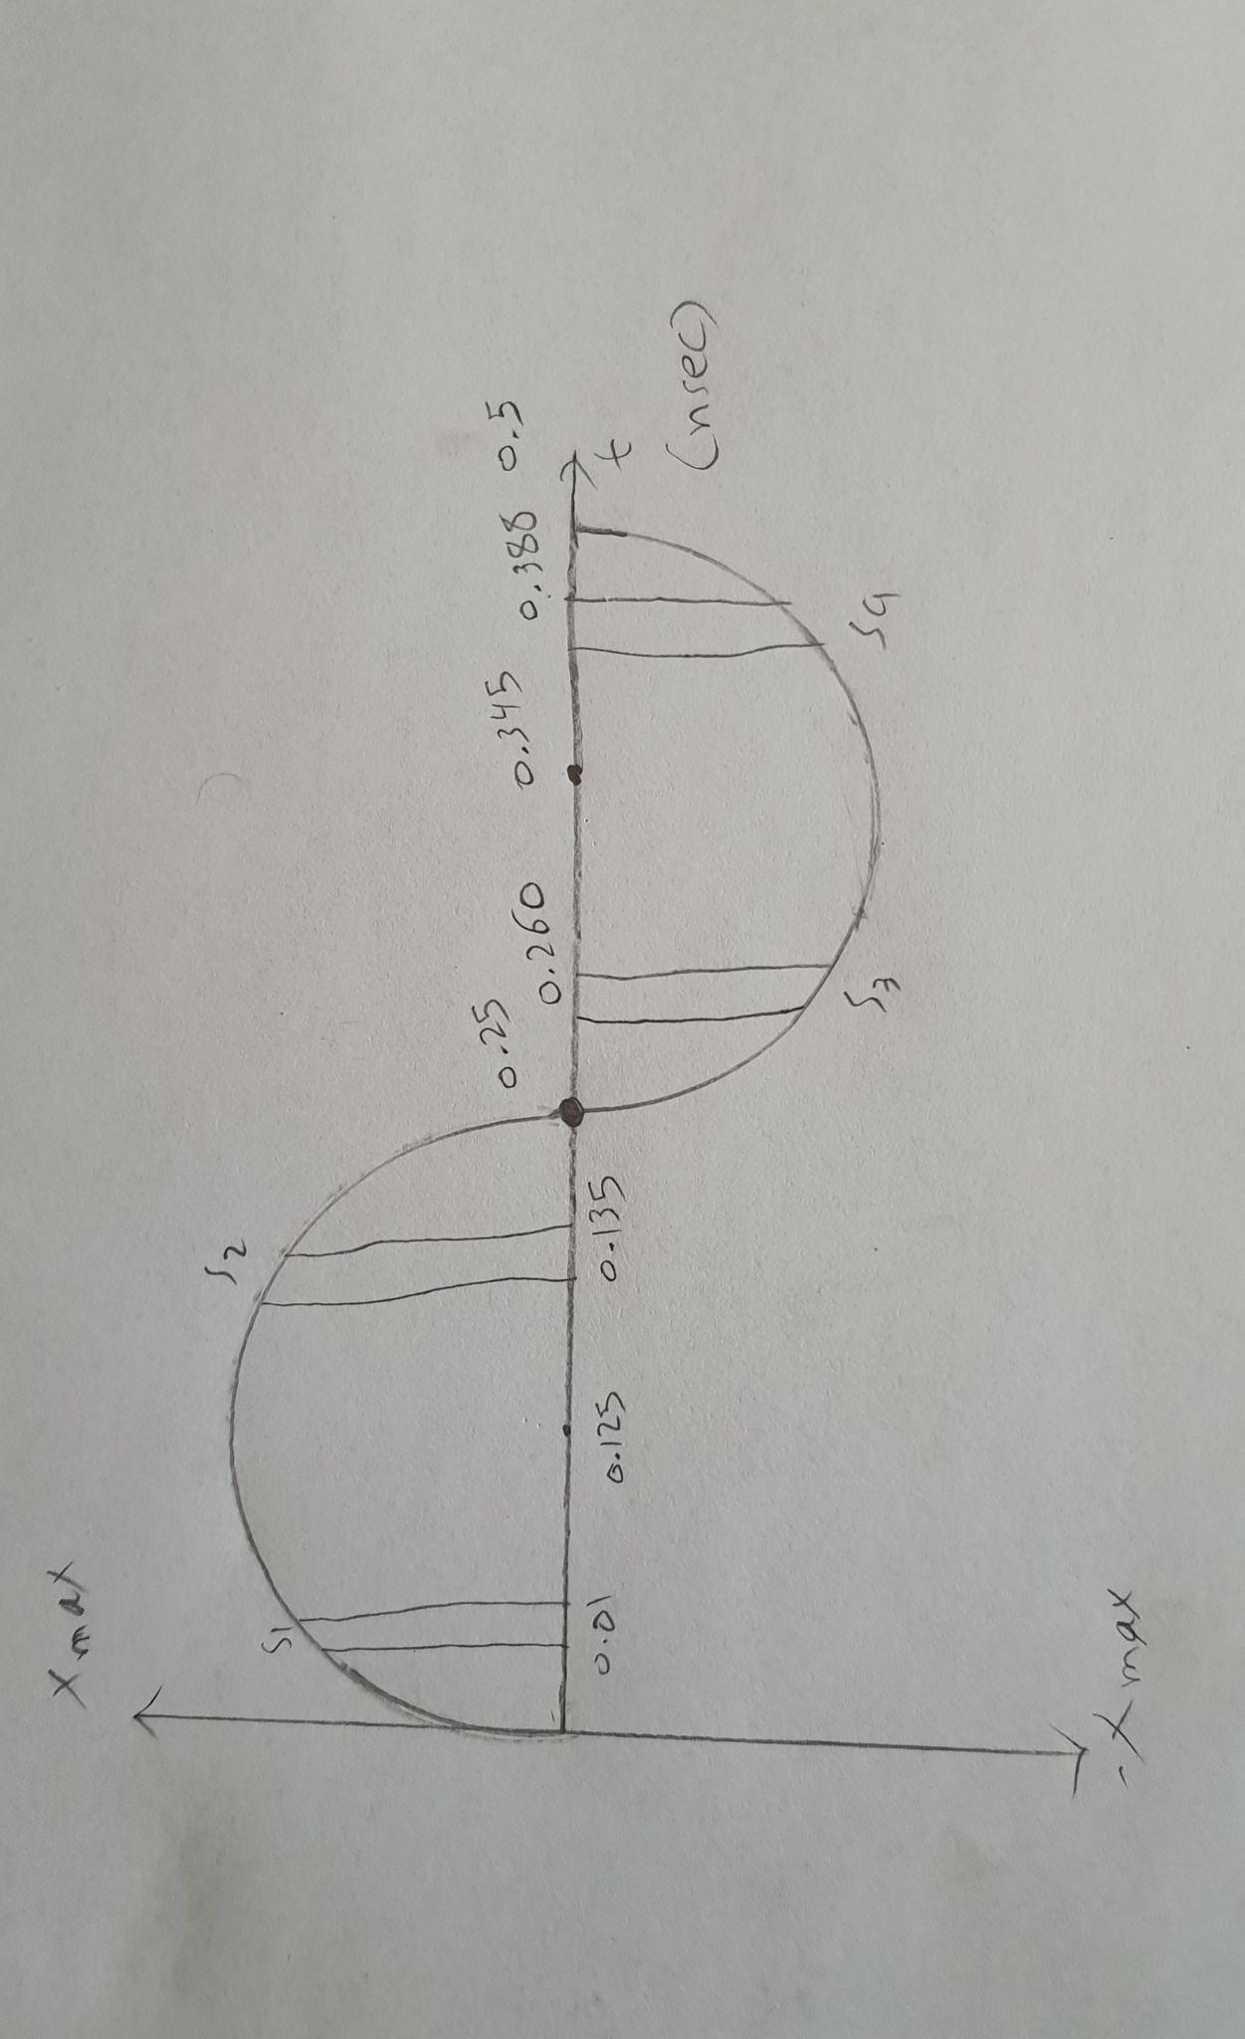
Sample value | Quantized value | Quantized error | Sample code
S₁=0.250 | +0.25 | 0.25-0.25=0 | 100
S₂=1.984 | +1.75 | 1.984-1.75 = 0.234 | 111
S₃=-0.250 | -0.25 | -0.25+0.25=0 | 011
S₄=-1.984 | -1.75 | -1.984+1.75 = 0.234 | 000

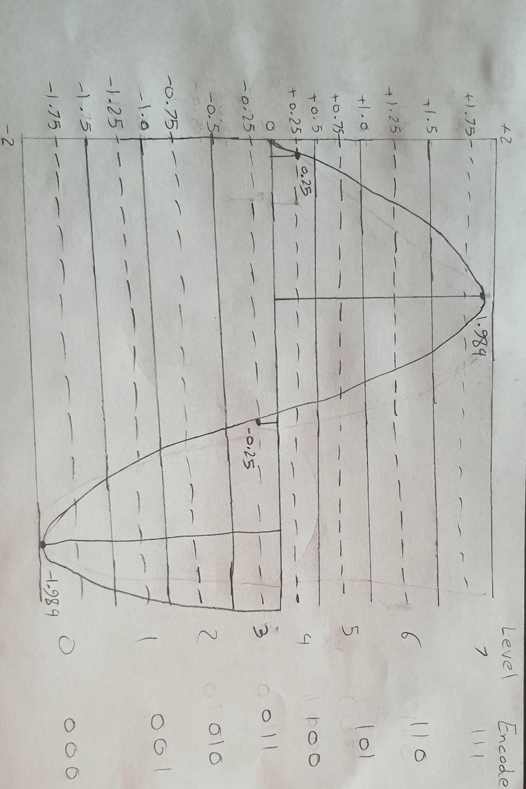

Q2/an analog signal of bandwidth 4kHz is converted to digital form by a PCM system and then transmitted over a transmission channel of supporting a transmission rate of 60bits/sec.
If the input analog signal has peak value of 2 volts and rms of 0.2v calculate the signal to noise raio in dB
Sol/
The maximum frequency of the signal is 4 kHz,
W = 4kHz
Therefore sampling frequency will be
f_{s} ≥ 2W
≥ 2 x 4 kHz
≥ 8 kHz
The signaling rate is given by equation,
r = v f_{s}
Putting values of r = 60 x 10³ bits/sec and f_{s} = 8 x 10³ Hz in above equation
60 x 10³ ≤ vx8x10³
v ≥7.5 bits
v = 8 bits
The rms value of the signal is 0.2V. Therefore the normalized signal power will be,
Normalized signal power = $\frac{(0.2)^{2}}{1}$
[ R = 1 for normalized power ]
P = 0.04w
The maximum signal to noise ratio is given by equation,
$\frac{S}{N}$ = $\frac{3P}{{x^{2}}_{max}}$ x 2^{2v}
Putting the values of p = 0.04, v = 8 and x_{max} = 1 in above equation,
$\frac{S}{N}$ = $\frac{3 x 0.04 x 2^{2x8}}{2}$ = 3,932.16 = 49.8dB
B-
Q1/ a 3-bit PCM is used to convert a sinusoidal signal given by:
x(t) 2 =2sin(2𝞹2500t). In to a binary form
The sampling is done at twice (2) Nyquist rate and first sample is taken at t=0.015msec Draw the signal and its samples and for each sample, find the value of:
- Samples value 2.quantized value
3.quantization error 4.sample code
sol/
f_{o} = 2k , A_{m} = 2 , ؞T_{o} = $\frac{1}{f_{o}}$ => $\frac{1}{2}$ k = 0.5msec, f_{m} = 2500t,
X_{max} = 2
f_{s} =2F_{N} =>2(2fm)=>f_{s}=4f_{m} => f_{s} =4x2.5=10k sample/sec
T_{s} = $\frac{1}{f_{s}}$ => T_{s} = $\frac{1}{10}$ = 0.1msec
T_{s} = 0.015 —> s₁ = 2sin(2𝞹2500*0.015*10⁻³) = 0.466
T_{s} = 0.015+0.1=0.115 —> s₂ = 2sin(2𝞹2500*0.115*10⁻³) = 1.944
T_{s} =0.115+0.115=0.230 —>
s₃ = 2sin(2𝞹2500*0.230*10⁻³) = -0.907
T_{s} = 0.230+0.115=0.345—>
s₄ = 2sin(2𝞹2500*0.345*10⁻³) = -1.520
؞ v=3,q=2^{v} =>q=2³ => q=8
Ꟙ=$\frac{2x_{max}}{q}$=> Ꟙ=$\frac{2x2}{8}$=0.5v
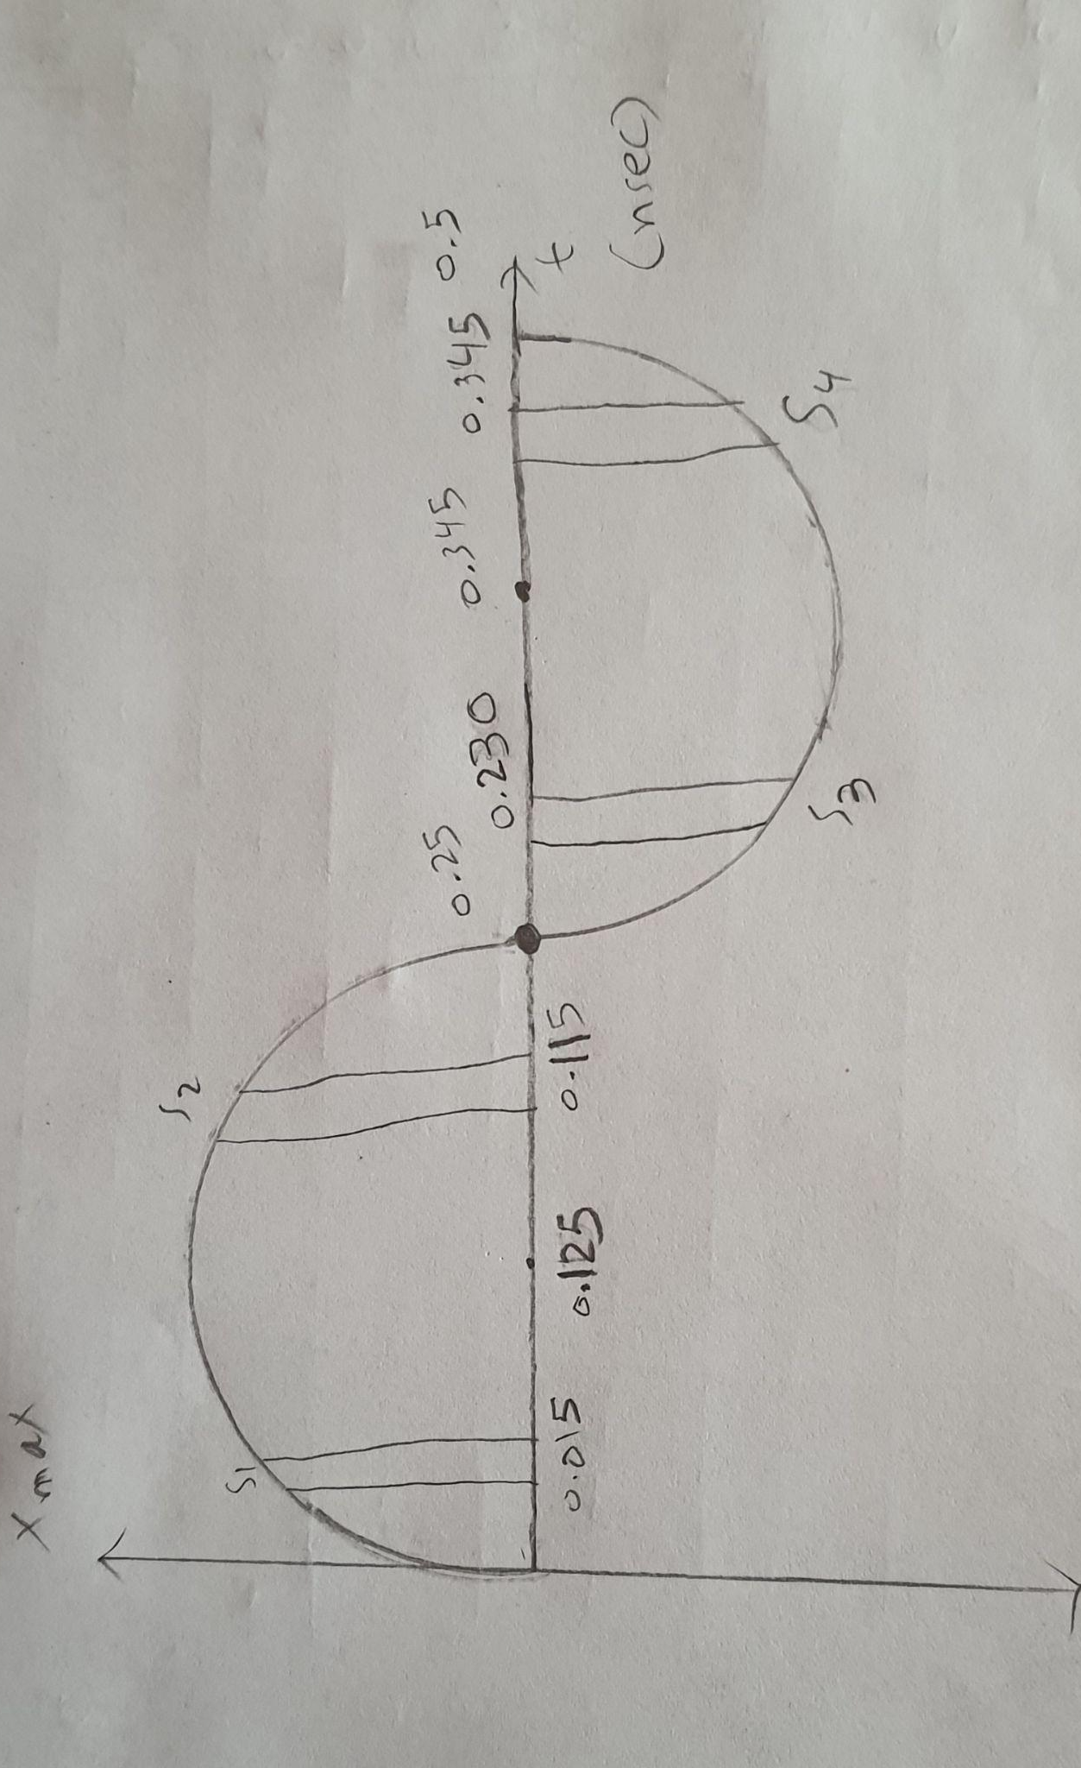
Sample value | Quantized value | Quantized error | Sample code
S₁=0.466 | +0.25 | 0.466-0.25=0.216 | 100
S₂=1.944 | +1.75 | 1.944-1.75 = 0.194 | 111
S₃=-0.907 | -0.75 | -0.907+0.75=-0.157 | 010
S₄=-1.520 | -1.75 | -1.520+1.75 = 0.23 | 000
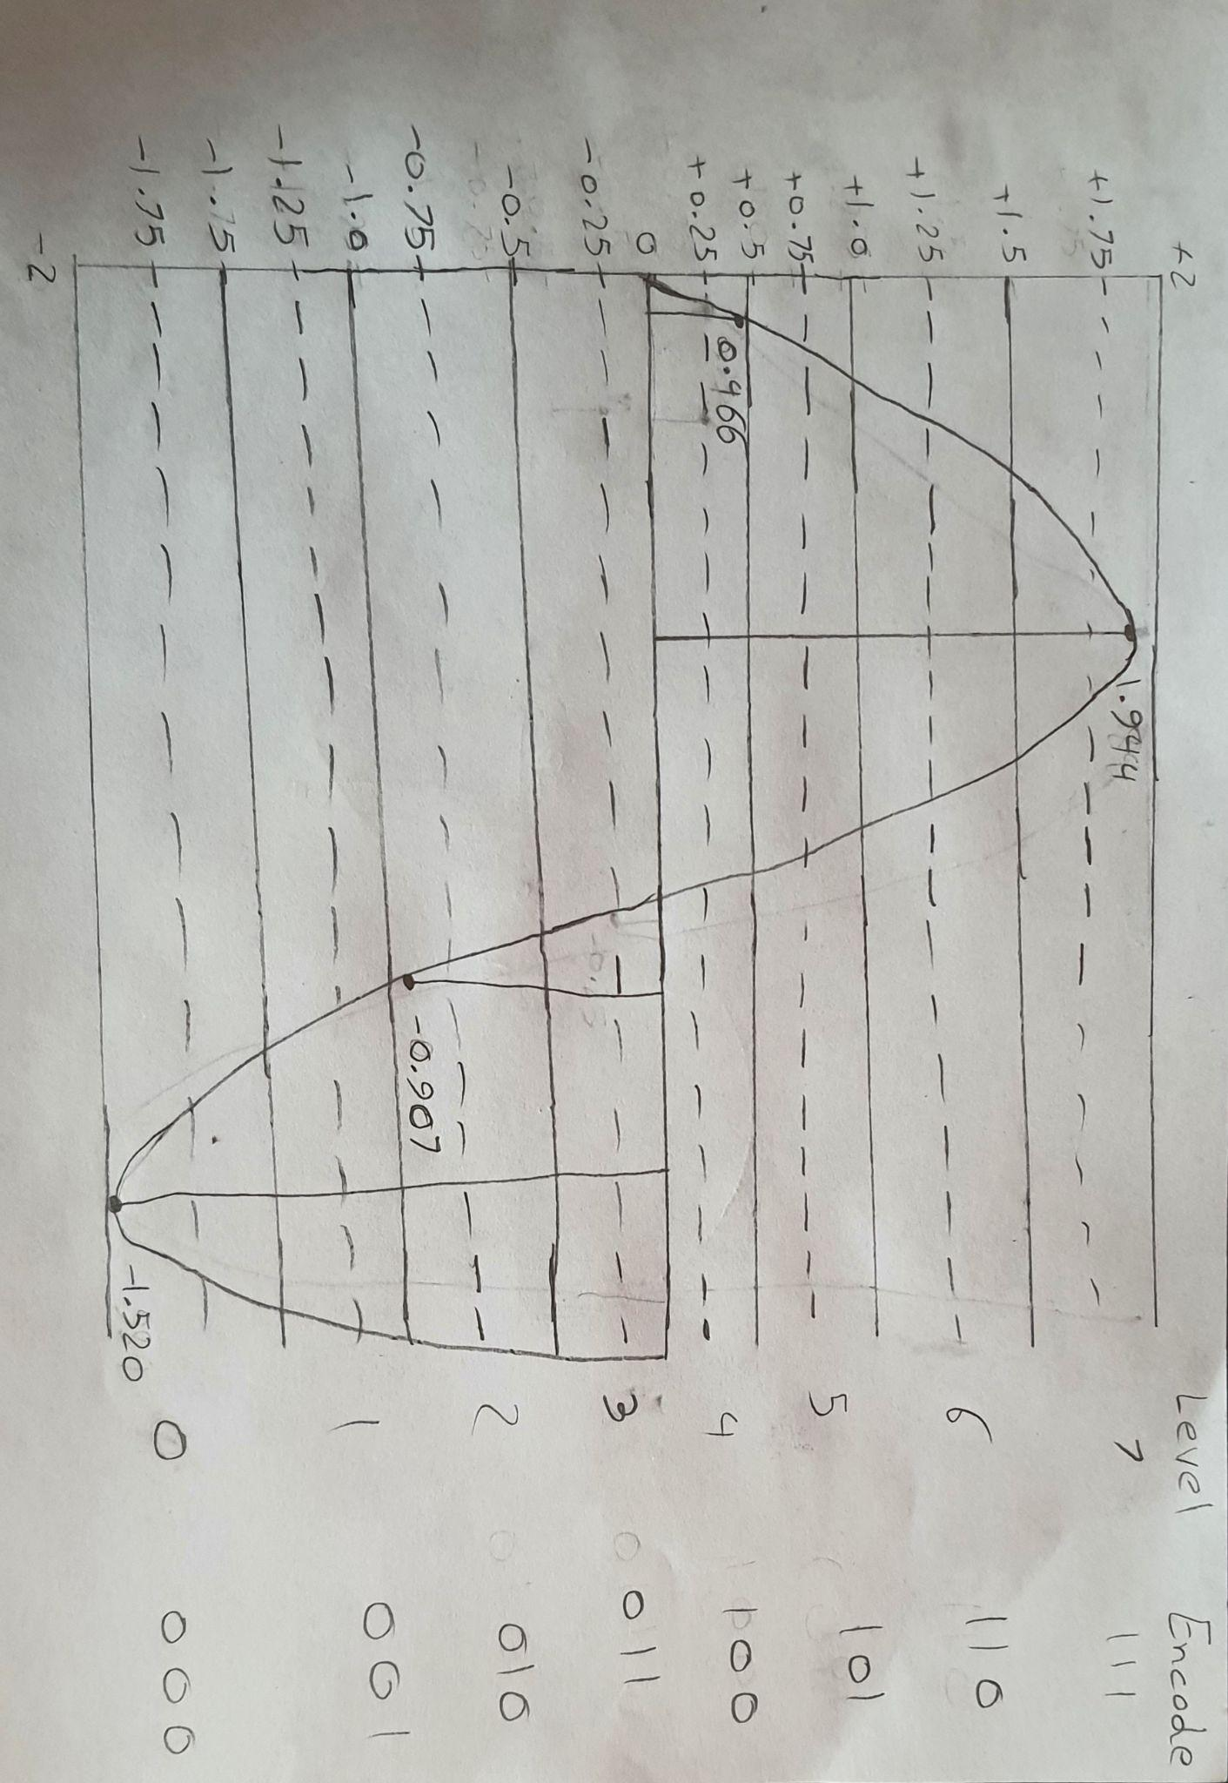
Q2/an analog signal of bandwidth 3.5kHz is converted to digital form by a PCM system and then transmitted over a transmission channel of supporting a transmission rate of 55bits/sec.
If the input analog signal has peak value of 2 volts and rms of 0.2v calculate the signal to noise raio in dB
Sol/
The maximum frequency of the signal is 3.5 kHz,
W = 3,5kHz

Therefore sampling frequency will be
f_{s} ≥ 2W
≥ 2 x 3.5 kHz
≥ 7 kHz

The signaling rate is given by equation,
r = v f_{s}
Putting values of r = 55 x 10³ bits/sec and f_{s} = 7 x 10³ Hz in above equation
55 x 10³ ≤ vx7x10³
v ≥7.857 bits
v = 8 bits

The rms value of the signal is 0.2V. Therefore the normalized signal power will be,
Normalized signal power = $\frac{(0.2)^{2}}{1}$
[ R = 1 for normalized power ]
P = 0.04w

The maximum signal to noise ratio is given by equation,
$\frac{S}{N}$ = $\frac{3P}{{x^{2}}_{max}}$ x 2^{2v}

Putting the values of p = 0.04, v = 8 and x_{max} = 1 in above equation,
$\frac{S}{N}$ = $\frac{3 x 0.04 x 2^{2x8}}{2}$ = 3,932.16 = 49.8dB

Chapter 10: Delta Modulation
We have seen in PCM that, it transmits all the bits which are used to code the sample, Hence the sampling rate, r and transmission channel Bandwidth are large, To overcome this problem DELTA MODULAION (DM) is used.

How it works:
- Delta Modulation(DM) transmits only one bit per sample.
- Present sample value is compared with the previous sample value, and the indication, whether the amplitude is increased or decreased is detected and sent.
- Input signal x(t) is approximated to step signal u(t) by the Delta Modulator.
- This step size is fixed

The difference between the input signal x(t) and staircase approximated signal u(t) confined to two levels, i.e. +δ and - δ, If the difference is positive, then the approximated signal is increased by one stape size δ and ‘1’ is transmitted or If the difference is negative, then approximated signal U(t) is reduced by δ and ‘0’ is transmitted,Thus for each sample, only one binary bit is transmitted.

The fig. in the next slide shows:
  - The analog input signal x(t) to Delta Modulator
  - The staircase approximated signal (u(t))
  - a Delta Modulator binary output
(للاطلاع)
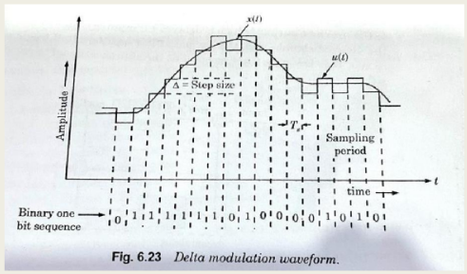
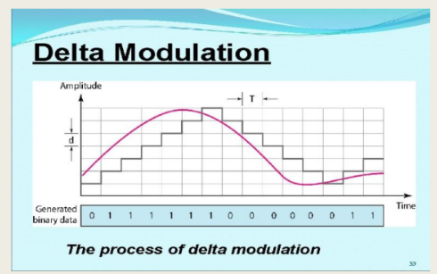
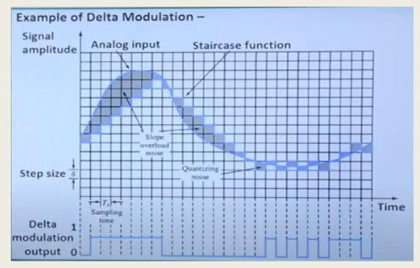

- The principle of Delta Modulation can be explained by the following set of equations
- The error between the sampled value of x(t) and last approximated sample is given:
e(nTs) = x(nTs ) – x^( nTs)
Where
e (nTs) = error at present sample
X (nTs ) = sampled signal value
x^ ( nTs) = last sample approximation of staircase waveform

If we assume u(nTs) as the present sample approximation of
staircase output,
Then
u(n-1)Ts = x^( nTs)
last sample approximation of staircase waveform

Let us define a quantity b(nTs) =δ . Sign [ e(nTs) ]

This means that depending on the sign of error e(nTs), the sign of step size δ is decided
In other words, we can write:
b(nTs) = + δ if x(nTs ) ≥ x^( nTs)
= - δ if x(nTs ) < x^( nTs)

Also, If b(nTs) = + δ binary “1” is transmitted
And If b(nTs) = - δ binary “0” is transmitted

DM – transmitter
The summer in the accumulator adds quantizer output (±δ)
With the previous sample approximation. This gives present sample approximation. I.e.
u (n T_{s}) = u(nT_{s} - T_{s}) + [±δ]
Or
= u[(n-1) T_{s}]+ b(n T_{s})
fig. below shows the transmitter of DM
(للاطلاع)
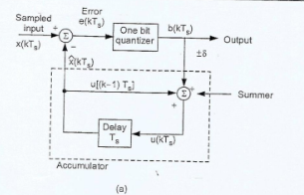
The previous sample approximation u [(n-1)T_{s}] is restored by delaying one
Sample period T_{s}. The sampled input signal x(nT_{s}) and staircase approximated signal x(nT_{s}) are subtracted to get error signal e(NT_{s}).
Depending on the sign of e(NT_{s}) one bit quantizer produces an output step + δ or + δ. If it is ‘+’, binary ‘1’ is transmitted, and if it ‘-’ then ‘0’ is transmitted.

(للاطلاع)
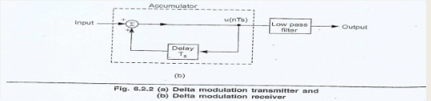
At the receiver shown in fig. 6.2.2 (b), the accumulator and low-pass filter are used. The accumulator generates the staircase approximated signal output and is delayed by one sampling period T_{s}. it is then added to the input signal. If input is binary ‘1’ then it adds + δ step to the previous output (which is delayed). If input is binary ‘0’ then one step ‘δ’ is subtracted from the delayed signal. The low-pass filter has the cutoff frequency equal to highest frequency in x(t). This filter smoothen the staircase signal to reconstruct x(t).

Advantages Of Delta Modulation(DM)
The Delta Modulation has certain advantages over PCM as under:
- since, the Delta modulation transmits only one bit per sample, therefore the signaling rate and transmission channel bandwidth is quite small for delta Modulation compared to PCM
- The transmitter and receiver implementation is very much simple for delta Modulation.
- There is no analog to digital conversion required in DM

Drawbacks (disadvantages)of Delta - Modulation
The delta – modulation has two major drawbacks as under:
- Slope overload distortion
- Granular or idle noise
(للاطلاع)
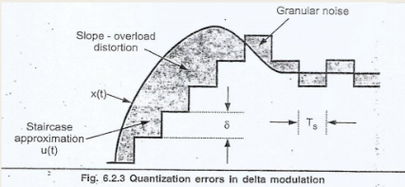
- Slope overload distortion(Startup error)
- This distortion arises because of large dynamic range of the input signal
- As can be observed from Fig. 6.2.3 in slide 14, the rate of rise of input signal x(t) is so high that the staircase signal cannot approximate it, the step size δ becomes too small for staircase signal u(t) to follow the step segment of x(t).
- Hence, there is a large error between the staircase approximated signal and the original input signal x(t).
- This error or noise is known as slope overload distortion.
- To reduce this error, the step size must be increased when slope of signal x(t) is high.
- Since the step size of Delta Modulator remains fixed, its maximum or minimum slopes occur along straight lines.
- Therefore, this modulator is also known as Linear delta Modulator(LDM)
2.Granular or idle noise
- Granular or idle noise occurs when the step size is too large compared to small variations in the input signal.
- This means that for very small variations in the input signal, the staircase signal is changed by large amount δ because of large step size.
- Fig. 6.2.3 shows that when the input signal is almost flat, the staircase u(t) keeps on oscillating by ±δ around the signal
- The error between the input and approximated signal is called granular noise
- The solution to tis problem is to make step size small
- The large step size is required to accommodate wide dynamic range of the input signal( to reduce slope overload distortion ) And small steps are required to reduce granular noise.
- Adaptive Delta Modulation (ADM) is the modification

Example – Delta Modulation (DM)
Ex.6.3.11: The input to the DM is m(t) 0.01 t. The DM operates at a sampling frequency of 20 Hz and has a step size of 2 mV. Sketch the delta modulator output △(t) and m(t).
Sol.:Fig. 6.3.7 shows the DM output. The signal m(t) is sketched for t =0 to 1 sec. The signal m(t) rises linearly with Time. The DM changes its output in steps of 2 mV when reconstructed signal ṁ(t) is less than m(t) output is increased by δ. When ṁ(t) is greater than m(t), output is reduced by δ. The change in ṁ(t) takes place at sampling instants. When ṁ(t) is increased by ‘δ’, modulator output is △(t) = 1. When ṁ(t) is reduced by ‘δ’, modulator output is △(t) = 0. The sampling frequency is f_{s} = 20Hz. Hence sampling duration will be T_{s} = $\frac{1}{f_{s}}$ = $\frac{1}{20}$ = 0.05 seconds. Fig. 6.3.7 shows m(t), ṁ(t) and △(t) for 0 to 1 sec with sampling durations of 0.05 sec
(للاطلاع)
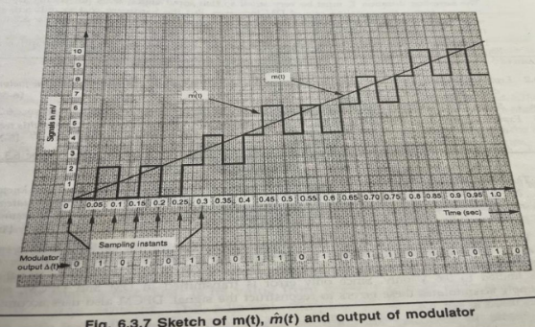

Chapter 11: ADAPTIVE DELTA MODULATION (ADM)
To overcome the quantization errors due to slope overload and granular noise, The step size is δ is made adaptive to variations in the input signal x(t).

- Practically in the steep segment of the signal x(t) , the step size is increased.
- While, when the input signal is varying slowly, the step size is reduced.
- Then the method is called Adaptive Delta Modulation (ADM)
- The adaptive delta modulators can take continuous changes in step size or discreet changes in step size.

ADM TRANSMITTER
- The logic for step size control( in the transmitter) is added and it used to increases or decreases step size according to certain rule depending one one bit quantizer output.
- For example if one bit quantizer output is high(1), then step size may be doubled for next sample. If one bit quantizer output is low, then step size may be reduced by one step
- Fig. in next slide, shows waveforms of adaptive delta modulator and sequence of bits transmitted.

ADAPTIVE DELTA MODULATION - TRANSMITTER
(للاطلاع)
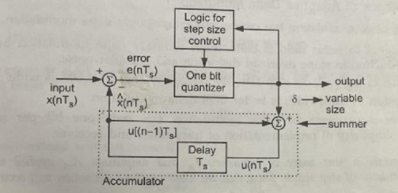
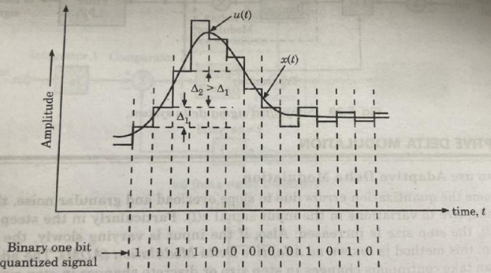
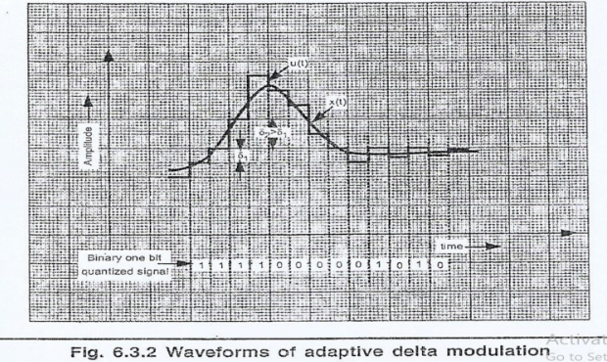
ADM RECEIVER
- In the receiver of Adaptive Delta Modulator, the first part generates the step size from each incoming bit.
- Exactly the same process is followed as that in transmitter. The previous input and present input decides the step size.
- It is then given to an accumulator which builds up staircase waveform.
- The low-pass filter then smoothens output staircase waveform to reconstruct the smooth signal.
(للاطلاع)
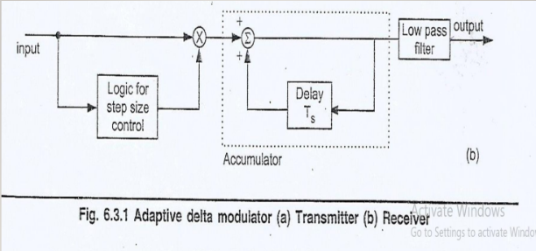

ADVANTAGES OF ADAPTIVE DELTA MODULATOR
- The signal to noise ratio is better than ordinary Delta Modulator because of the reduction in Slope overload distortion and Granular noise.
- Because of the variable step size, the dynamic range of ADM is wide
- Utilization of bandwidth is better than Delta Modulation
- Only one bit per sample is required ( same as in DM)
- Simplicity of implementation of transmitter and receiver ( same as in DM)

Ex.6.3.1:Consider a sine wave of frequency f_{m} and amplitude to a delta modulator of step size δ. Show that the slope overload distortion will occur if
A_{m} > $\frac{δ}{2πf_{m}T_{s}}$
Where T_{s} is the sampling period.
Sol: the input signal x(t) to the modulator is sinusoidal signal, i.e. x(t) = Am Sin(2$π$Fmt)
The slope of any signal is its first derivative with respect to time, and the slope is maximum when the Ist derivative is maximum.
؞ slope of input signal x(t) = $\frac{d}{dt}$x(t)
= $\frac{d}{dt}$ | Am sin(2$π$Fmt)| = Am.2$π$Fm.cos($π$Fmt)
And this slope is maximum when (Am.2$π$Fm.cos($π$Fmt)) is maximum, this happen when the term (cos(2$π$Fmt)) equal to its maximum value i.e. = I
؞ slope maximum of x(t) = Am2$π$Fm
The slope maximum of delta modulator = $\frac{Step size δ }{sampling period}$
= $\frac{δ}{T_{s}}$
Slope overload distortion will take place if slope of input signal is greater than slope of delta modulator, i.e.
Am.2$π$Fm > $\frac{δ}{T_{s}}$ or Am > $\frac{δ}{{2πFmT}_{s}}$
Ex.6.3.2:A delta modulator system is designed to operate at five times the Nyquist rate for a signal with 3 kHz bandwidth. Determine the maximum amplitude of a 2 kHz input sinusoid for which the delta modulator does not have slope over load. Quantizing step size is 250mV. Derive the formula that you use.
sol:In example 6.3.1 we have derived the relation for slope overload distortion which will occur if,
A_{m} > $\frac{δ}{{2πFmT}_{s}}$ by equation 6.3.1
؞ Slope overload will not occur if,
A_{m} > $\frac{δ}{{2πFmT}_{s}}$
The maximum frequency in the signal is,
W = 3 kHz
Nyquist rate = 2w = 2 x 3 khz = 6 khz
Sampling frequency = 5 times nyquist rate
F_{s} = 5 x 6 khz = 30 khz
Sampling interval T_{s} = $\frac{1}{f_{s}}$ = $\frac{1}{30 x 10^{3}}$
Step size $δ$ = 250mV = 250 x 10⁻³
=0.25V
Given that f_{m} = 2kHz = 2x10³ Hz
؞ putting these values in equation 6.3.4
A_{m} < $\frac{0.25}{{2πx2x10^{3}x\frac{1}{30 x 10^{3}}}_{}}$ => A_{m} < 0.6 volts
Ex.6.3.4:Find the singal amplitude for minimum quantization error in a delta modulation system if step size is 1 volts having repetition period 1 ms. The information signal operates at 100Hz.
sol.:The quantization error is minimum when slope overload distortion is absent. Then the quantization error is due to granular noise only. We know that the slope overload distortion is absent if,
A_{m} > $\frac{δ}{{2πFmT}_{s}}$
Here A_{m} is the signal amplitude
$δ$ is the step size. Given 1v
F_{m} is signal frequency.given 100Hz
T_{s} is sampling duration. Given 1ms
Hence signal amplitude becomes,
A_{m} < $\frac{1}{{2πx100x1x10^{-3}}_{}}$
Am < 1.6V
That is, the signal amplitude should be less than 1.6 volts to have minimum quantization error

Ex.6.3.5:Derive an expression for signal to quantization noise power ratio for delta modulation. Assume that no slope overload distortion exists.
Sol.:(i)To obtain signal power:
In example 6.3.1 we have derived that slope overload distortion will not occur if A_{m} > $\frac{δ}{{2πFmT}_{s}}$
Here A_{m} is peak amplitude of sinusoided singal
$δ$ is the step size
F_{m} is the signal frequency
T_{s} is the sampling period.
From above equation, the maximum signal amplitude will be, A_{m} > $\frac{δ}{{2πFmT}_{s}}$
Signal power is given as, p = $\frac{V^{2}}{R}$
Here V is the rms value of the signal. Here V = $\frac{A_{m}}{\sqrt{2}}$ . hence above equation becomes,
P = $\frac{{A_{m}}^{2}}{2}$ / R
Normalized signal power is obtained by takin r = 1. Hence, P = $\frac{{A_{m}}^{2}}{2}$
Putting for A_{m} from equation 6.3.6,
P = $\frac{δ^{2}}{{8π^{2}{{F_{m}}^{2}}^{}T^{2}}_{s}}$
Ex.6.3.7:A DM system is tested with a 10 kHz sinusoidal signal with 1V peak to peak at the input. It is sampled at 10 times the nyquist rate.
(i)what is the step size required to prevent slope overload?
(ii) what is the corresponding SNR?
sol.:Given data
Signal frequency, f_{m} = 10kHz
Signal amplitude, A_{m} = $\frac{1V}{2}$ = 0.5V
Nyquist rate = 2xf_{m} = 2x 10kHz = 20kHz
Sampling frequency, f_{s} = 10 x Nyquist rate
= 10 x 20 khz = 200khz
T_{s} = $\frac{1}{f_{s}}$ = $\frac{1}{200 x 10^{3}}$sec
(i) to obtain step size
From equation 6.3.4 we have,
A_{m} < $\frac{δ}{{2πFmT}_{s}}$
Under this condition slope overload will not occur, From above equation step size will be,
$δ$ > ${2πFmT}_{s}$A_{m}
Putting values in above equation,
$δ$ >$2π$x10,000x $\frac{1}{200 x 10^{3}}$x0.5
> 0.157v
Thus the step size greater than 157mV will prevent the slope overload.
(ii) to obtain signal to noise ratio signal to noise ratio of delta modulation system is given by equation 6.3.12 as,
$\frac{S}{N}$ = $\frac{3}{2π^{2}*Fm^{2}*Ts^{2}}$
This is post filtered signal to noise ratio. In this example value of ‘w’ is not given. Hence we will calculate signal to noise ratio from equation 6.3.7 and equation 6.3.10 as,

Putting values in above equation.
$\frac{S}{N}$ = $\frac{3}{{2π^{2}x(10,000)^{2}x\frac{1}{(200 x 10^{3})^{2}}}_{}}$
$\frac{S}{N}$ = 60.79.
$\frac{S}{N}$ dB = 10log₁₀(60.79)
$\frac{S}{N}$ dB = 17.83dB
Ex.6.3.10:in a single integration DM scheme, the voice signal is sampled at a rate of 64kHz. The maximum signal amplitude is 1 volt, voice signal bandwidth is 3.5kHz.
i)Determine the minimum value of step size to avoid slope overload.
ii)determine granular noise N_{o}
iii)Assuming signal to be sinusoidal,calculate signal power and signal to noise ratio.
iv)Assuming that noice signal amplitude is uniformly distributed in the range (-1,1) determine the signal power and signal to noise ratio.
sol.:The given data is,
F_{s} = 64kHz, A_{m} = 1V, W=3.5K=kHz.
i)to obtain step size
Slope overload will not occur if,
A_{m} < $\frac{δ}{{2πFmT}_{s}}$
Putting values in above equation with
T_{s} = $\frac{1}{64 x 10^{3}}$ and f_{m} = 3.5kHz
1< $\frac{δ}{{2πx3500x\frac{1}{64 x 10^{3}} }_{}}$
$δ$> 0.3436 volts
ii) to obtain granular noise power
Noise power is given by equation 6.3.11 as,
N_{c} = $\frac{WT_{s}δ^{2}}{3}$ = $\frac{Wδ^{2}}{3f_{c}}$
= $\frac{3.5x10^{3}x(0.3436)^{2}}{3 x 64 x 10^{3}}$
= 2.15 mW
iii)to obtain S/N ratio
Amplitude of the signal is 1V. For sinusoidal signal, the signal power will be
P = $\frac{{A_{m}}^{2}}{2}$ = $\frac{1}{2}$ w
Hence signal to noise ratio will be,
$\frac{S}{N}$ = $\frac{Signal power}{Noise power}$ => $\frac{S}{N}$ = $\frac{3}{2π^{2}*Fm^{2}*Ts^{2}}$
$\frac{S}{N}$ = 50.81
($\frac{S}{N}$)_{dB} = 10log₁₀ 50.81
$\frac{S}{N}$_{dB} =17.059dB

COMPARISON BETWEEN PCM, DM, AND ADM
No | Parameter of comparison | PCM | DM | ADM
1 | Number of bits | It can use 4,8,16 bit per sample | It uses only one bit for one sample | It uses only one bit for one sample
2 | Level and step size | The number of levels(q) depend on number of bits, level size is kept fixed | Step size is kept fixed and can not be varied | According to the signal variation, step size varies(i.e. adapted)
3 | Quantization error and distortion | Quantization error depends on number of levels used | Slope overload distortion and granular noise are present. | Quantization noise is present but other errors are absent.
4 | Transmission bandwidth | Highest bandwidth is required since number of bits are high | Lowest bandwidth is required | Lowest bandwidth is are absent.
5 | feedback | There is no feedback in transmitter or receiver | Feedback exists in transmitter only | Feedback exists in transmitter or receiver
6 | Complexity of implementation | System complex | simple | simple
قوانين فصل 11
The slope maximum of delta modulator = $\frac{δ}{T_{s}}$
Am = $\frac{δ}{{2πFmT}_{s}}$
P = $\frac{{A_{m}}^{2}}{2}$ / R
$\frac{S}{N}$ or P = $\frac{δ^{2}}{{8π^{2}{{F_{m}}^{2}}^{}T^{2}}_{s}}$
N_{c} = $\frac{WT_{s}δ^{2}}{3}$ or $\frac{Wδ^{2}}{3f_{c}}$
$\frac{S}{N}$ = $\frac{3}{2π^{2}*Fm^{2}*Ts^{2}}$
* SNR = $\frac{S}{N}$
Chapter 12: DIGITAL PULSE MODULATION
TECHNIQUES Review
General notes
- They are convert analog signal to digital (binary, 0.1 ) and make it suitable for modern digital communication systems.
- Because of this conversion, some noise (error) is permanently introduced in the result signal.
- This is because the analog to digital conversion is not ideal and perfect( there is some approximations)
- The main problems associated with Digital pulse Modulation techniques is that they need large channel Bandwidth.
- To reduce the Bandwidth, the number of bits required to represent samples of signal must be reduced.
- But if this happens, noise increase.
- A compromising between Bandwidth and noise is required in real applications.
- Pulse Code Modulation(PCM)
The first type of Digital Pulse modulation techniques is
Pulse Code Modulation PCM
In this type(PCM):
- The signal is sampled at Fs (Fs≥ 2Fm ) ,
- Quantized by comparison with (q) predefined levels
- Encoded to v bits per each q level
- These process leads to a noise or error called quantization error (ε)
- it has maximum value (εmax) =$\frac{δ}{2}$
- It has bit rate, r = v.Fs bit per second
- It has bandwidth, BT=1/2(V.Fs)
- In PCM, the error or noise is related to signal by Signal power/Noise power
- The general equation for this ratio is, maximum signal to quantization noise ratio:
$\frac{S}{N}$ = $\frac{3P}{{x^{2}}_{max}}$.2^{2v}
- Signal to quantization noise ratio for normalized values of power and amplitude of input signal
($\frac{S}{N}$)dB ≤ (4.8) + 6v)dB
- Signal to quantization noise for sinusoidal input signal is,
($\frac{S}{N}$)dB ≤ (1.8) + 6v)dB
- Delta Modulation(DM )
- We have seen in PCM that, it transmits all the bits which are used to code the sample.
- Hence signaling rate and transmission channel Bandwidth are large
- To overcome this problem Delta Modulation is used.
- Delta modulation transmits only one bit per sample.
- In DM, the present sample value is compared with previous sample value and according to this comparison, “1” is transmits if the difference is positive( present sample is grate the previous ) and “0” is transmits if the difference is negative ( present sample is less than the previous)
- That means only one bit is transmit for each sample.

Advantages of DM(compare with PCM)
- Delta modulation transmits only one bit for each sample. thus signaling rate and transmission bandwidth is quite small.
- The transmitter and receiver implementation

Disadvantages of DM
- Slope overload distortion(startup error): this arises because of large dynamic range of the input signal ( the input signal is more steep ) i.e. has high slope. To reduce this error, the step size should be increased when slope of input signal is high.
- Granular Noise ( Hunting ) : it occurs when the input signal varying slowly ( low input signal slope) To reduce this error, the step size should be reduced when slope of input signal is low.
- Thus large step size is required to accommodate wide dynamic range of the input signal ( to reduce slope overload distortion) and small steps. are required to reduce granular noise
- Adaptive Delta Modulation is the modulation to overcome these errors.
- Adaptive Delta Modulation ( ADM )
- To overcome the quantization errors due to slope overload and granular noise, the step size (δ ) is made adaptive to variations in the input signal.
- Practically, in the steep segment of the input signal, the step is increased. When the input is varying slowly, the step size is reduced.
- Then the method is called Adaptive Delta Modulation ADM

اسئلة صباحي شهر ثالث فرع B
Q1/ DM system is tested by a sinusoidal signal given by,
x(t) = 4 sin(2𝝅 12 x 10³t)
The sampling is done at ten times the Nyquist rate
- What is the step size required to prevent slope overload distortion.
- What is the corresponding SNR?
Ans:
x(t) = 4 sin(2𝝅 12 x 10³t)
Am=4, Nyquist rate = 10, Fm=12x10³Hz
F_{s}=Nyquist rate(2*fm) => F_{s}=10(2*12*10³) => F_{s}=240x10³
Ts = $\frac{1}{fs}$ => Ts=$\frac{1}{240x10^{3}}$ sec
S=? , SNR=?
A= $\frac{S}{2πFmTs}$
4=$\frac{S}{2π12*10^{3}*\frac{1}{240x10^{3}}}$
$S$ = 1.256V
SNR =
$\frac{S}{N}$ = $\frac{3}{2π^{2}*Fm^{2}*Ts^{2}}$

$\frac{S}{N}$ = $\frac{3}{2π^{2}*(12*10^{3})^{2}*(\frac{1}{240x10^{3}})^{2}}$
$\frac{S}{N}$ = 60.79

Q2/Select the right answer
DM | ADM
1.In Delta Modulation, what happens if the step size is too small?  - The output will be inaccurate  - The system will go into overload  - The output will be too noisy  - The output will be highly accurate | 1.Which of the following is a disadvantage of adaptive Delta modulation?  A)Complexity of implementation  B)High bandwidth consumption  C)inefficiency with low-frequency signals  D)Limited dynamic range
2.Which of the following is a limitation of Delta modulation?  - High bandwidth requirement  - Susceptibility to slope overload  - Complexity of implementation  - Low noise immunity | 2.Which of the following signals is Adaptive Delta modulation best suited for?  - Constant signals  - High-frequency signals  - Signals with varying slopes  - Purely digital signals
3.what is the primary purpose of delta modulation?  A)To increase data bandwidth  B) To simplify analog-to-digital conversion  C)To enhance audio quality  D) To reduce the power consumption | 3. What type of information is typically used to adjust the step size in adaptive Delta modulation?  A)The amplitude of the previous output  B) The average power of the signal  C)the rate of change of the input signal  D) the frequency spectrum of the input signal

اسئلة مسائي شهر ثالث فرع a
Q1/ DM system is tested by a sinusoidal signal given by,
x(t) = 2sin(2𝝅 10 x 10³t)
The sampling is done at Eight times the Nyquist rate
- What is the step size required to prevent slope overload distortion.
- What is the corresponding SNR?
Ans:
x(t) = 2sin(2𝝅 10 x 10³t)
Am=2, Nyquist rate = 8, Fm=10x10³Hz
F_{s}=Nyquist rate(2*fm) => F_{s}=8(2*10*10³) => F_{s}=160*10³
Ts = $\frac{1}{fs}$ => Ts=$\frac{1}{160x10^{3}}$ sec
S=? , SNR=?
A= $\frac{S}{2πFmTs}$
2=$\frac{S}{2π10*10^{3}*\frac{1}{160x10^{3}}}$
$S$ = 0.7854V
SNR =
$\frac{S}{N}$ = $\frac{3}{2π^{2}*Fm^{2}*Ts^{2}}$

$\frac{S}{N}$ = $\frac{3}{2π^{2}*(10*10^{3})^{2}*(\frac{1}{160x10^{3}})^{2}}$
$\frac{S}{N}$ = 38.9158

Q2/select the right answer

PCM | DM | ADM
1.What type of signal does PCM encode?  a)Analog  b)Digital  C)frequency-modulated | 1.in Delta modulation, the output signal is represented by:  a)A continuous signal  b)a series of discrete levels  C)a series of binary digits  D)an analog waveform | In ADM, the step size is adjusted based on:  a)the amplitude of the input signal  b)the previous output levels  c)the sampling frequency  d)the noise level in the system
2.PCM transmission requires:  a)less bandwidth than analog transmission  b)more bandwdith than analog transmission  c)equal bandwidth to analog transmission | 2.Which of the following is a limitation of Delta modulation?  - High bandwidth requirement  - Susceptibility to slope overload  - Complexity of implementation  - Low noise immunity | 2.what us the main advantage of adaptive delta modulation (adm) over standard delta modulation?  a)increased bandwidth  b)variable step size  c)reduced complexity  d)improved signal-to-noise ratio
3.The bit rate of a PCM signal is calculated as:  a)sampling rate x number of quantization levels  b)Sampling rate x Bits per sample  c)Quantization levels x sampling rate | 3.in Delta modulation, if the input signal increases, what does the output do?  a)remains constant  b)decreases  c)increases  d)fluctuates randomly | 3.what happens to the step size in adaptive Delta modulation when the input signal changes rapidly?  a)the step size decreases  b)the step size remains constant  c)the step size increases  d)the step size becomes zero

Q3/ a signal has peak to peak value of 2v, rms value of 0.25 V and maximum frequency of 4KHZ, is modulated by a PCM system and then transmitted a transmission channel supporting a transmission rate of 50k bits/sec.
Determine the maximum signal to noise ratio of this system.

اسئلة مسائي شهر ثالث فرع b
Q1/ DM system is tested by a sinusoidal signal given by,
x(t) = 4sin(2𝝅 12 x 10³t)
The sampling is done at Ten times the Nyquist rate
- What is the step size required to prevent slope overload distortion.
- What is the corresponding SNR?
Ans:
x(t) = 4 sin(2𝝅 12 x 10³t)
Am=4, Nyquist rate = 10, Fm=12x10³Hz
F_{s}=Nyquist rate(2*fm) => F_{s}=10(2*12*10³) => F_{s}=240x10³
Ts = $\frac{1}{fs}$ => Ts=$\frac{1}{240x10^{3}}$ sec
S=? , SNR=?
A= $\frac{S}{2πFmTs}$
4=$\frac{S}{2π12*10^{3}*\frac{1}{240x10^{3}}}$
$S$ = 1.256V
SNR =
$\frac{S}{N}$ = $\frac{3}{2π^{2}*Fm^{2}*Ts^{2}}$

$\frac{S}{N}$ = $\frac{3}{2π^{2}*(12*10^{3})^{2}*(\frac{1}{240x10^{3}})^{2}}$
$\frac{S}{N}$ = 60.79

PCM | DM | ADM
1.which error is introduced during the quantization process?  a)sampling error  b)quantization noise  c)aliasing | 1.In Delta Modulation, what happens if the step size is too small?  a)The output will be inaccurate  b)The system will go into overload  c)The output will be too noisy  d)The output will be highly accurate | 1.Which of the following is a disadvantage of adaptive Delta modulation?  A)Complexity of implementation  B)High bandwidth consumption  C)inefficiency with low-frequency signals  D)Limited dynamic range
2.Aliasing in PCM occurs when:  a)sampling rate is too high  b)sampling rate is too low  c)quantization levels are high | 2.Which of the following is a limitation of Delta modulation?  a)High bandwidth requirement  b)Susceptibility to slope overload  c)Complexity of implementation  d)Low noise immunity | 2.Which of the following signals is Adaptive Delta modulation best suited for?  a)Constant signals  b)High-frequency signals  c)Signals with varying slopes  d)Purely digital signals
3.bandwidth required for PCM increases with:  a)decreasing quantization levels  b) increasing sampling rate  c)decreasing noise immunity | 3.what is the primary purpose of delta modulation?  A)To increase data bandwidth  B) To simplify analog-to-digital conversion  C)To enhance audio quality  D) To reduce the power consumption | 3. What type of information is typically used to adjust the step size in adaptive Delta modulation?  A)The amplitude of the previous output  B) The average power of the signal  C)the rate of change of the input signal  D) the frequency spectrum of the input signal

Q3/ a signal has peak to peak value of 4v, rms value of 0.3 V and maximum frequency of 4KHZ, is modulated by a PCM system and then transmitted a transmission channel supporting a transmission rate of 60k bits/sec.
Determine the maximum signal to noise ratio of this system.

