- Quantum efficiency in photodetector indicates
A) The ability of a detector to convert incident light into electrons
b) The maximum light intensity the detector can handle
c) The physical size of the sensor
- Which of following describe the behavior of photo diode when reverse biased
A) It conducts light
B) It operates as a current amplifier
C) It becomes less sensitive to ligh
- The dark current in photo diode is refer to
A) Current in absence of light
B) Current when exposed to light
C) Current in a power outage
- What is the primary advantage of using lasers in optical communication?
A) Low-cost
B) High coherence and monochromaticity
C) Large size
- Which of the following statements about LEDs in optical communication is true
A) They have a very long response time.
B) They emit light in a narrow spectral range.
C) They are less efficient than lasers.
- What is the principle behind LASER operation?
A) Spontaneous emission
B) Stimulated emission
D) Reflection

Here is the extracted text from the image:
Q2) A silicon photodiode has a nominal quantum efficiency η, of 80% at a wavelength of 600 nm. If this photodiode is illuminated with monochromatic light at this wavelength with an intensity of P= 1 m. W/cm²,

Calculate:
- The number of photons incident on the photodiode per second (assuming normal incidence).
With, Incident photon /sec. (N), N= P/E
- The number of electrons generated in the photodiode per second due to the incident light.
- The total photocurrent produced if the charge of an electron is e=1.6x10⁻¹⁹ C
Given: h= 6.625 x10⁻³⁴ J.S (Planck Constant)
1. The number of photons incident on the photodiode per second (per unit area).
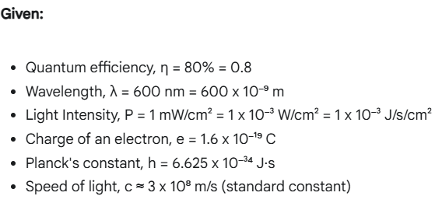
1. The number of photons incident on the photodiode per second (per unit area).
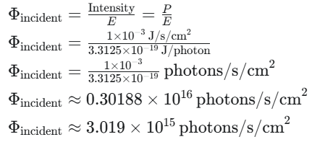
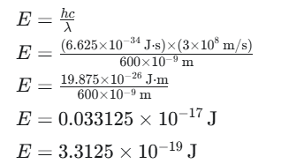

2. The number of electrons generated in the photodiode per second (per unit area).
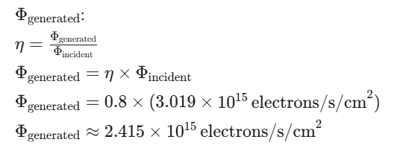

3. The total photocurrent produced (Photocurrent Density).
